GETTING TO INSEAD

From Roissy-Charles de Gaulle Airport
The airport is north of Paris and approximately 100 kms from Fontainebleau.

By taxi: Cost is approximately 102 € and travel time 1 hour 1/4.

By train: Journey time is 2 hours. Cost is approximately 22 €. Take the Metro train on line RER B3 to Gare du Nord. Change to line RER D (final destination: Malesherbes or Melun) to Gare de Lyon. Trains for Fontainebleau-Avon leave from Gare de Lyon: go to the "Guichet Banlieue" to buy your ticket. At the desk ask what final destination will be displayed on the departure board. It will be usually either Montereau, Montargis, Sens or Laroche-Migennes. Please see map below for details.
At Fontainebleau station take a taxi to INSEAD: the station at Fontainebleau/Avon is 3 kms from INSEAD (approximate cost: 9 €).

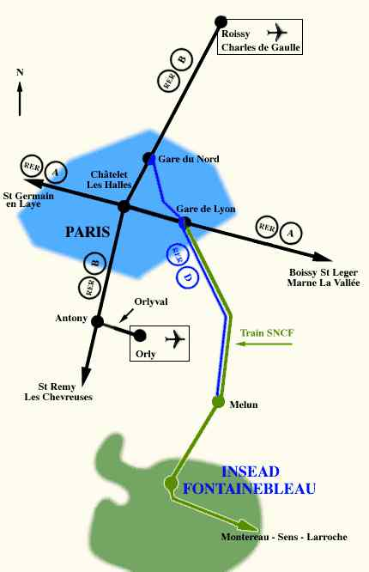 | From Roissy / Orly airports / Gare du Nord to Fontainebleau  by train

Train Times for Paris /Fontainebleau

Monday to Friday Saturday
Paris | 7.17 | 7.47 | 8.27 | 9.27 |  | 7.17 | 8.27 | 9.27
Fontainebleau | 7.55 | 8.26 | 9.06 | 10.05 |  | 7.55 | 9.04 | 10.05

From Orly Airport
Orly Airport is located south of Paris and is approximately 45 kms from Fontainebleau.

By taxi: Cost is approximately 70 € and travel time 45 minutes.

By train : Cost is approximately 20€. Journey time approximately 2 3/4 hours. Take the 'OrlyVal' from Orly airport to Antony, change to the RER line B (in direction of Aulnay-sous-Bois / Roissy - Mitry) to Chatelet Metro station in Paris, and then take the RER line A (in direction of Boissy-St-Léger / Marne-la-Vallée) to Gare de Lyon. Trains for Fontainebleau-Avon leave from Gare de Lyon: go to the "Guichet Banlieue" to buy your ticket. At the desk ask what final destination will be displayed on the departure board. It will be usually either Montereau, Montargis, Sens or Laroche-Migennes. Please see the map above for details.
At Fontainebleau station take a taxi to INSEAD: the station at Fontainebleau/Avon is 3 kms from INSEAD (approximate cost: 9 €).

From Gare du Nord

By taxi: Cost is approximately 90 € and travel time 1 hour.

By train : Take the Metro RER line D (final destination: Malesherbes or Melun) to Gare de Lyon. Trains for Fontainebleau-Avon leave from Gare de Lyon: go to the "Guichet Banlieue" to buy your ticket. At the desk ask what final destination will be displayed on the departure board. It will be usually either Montereau, Montargis, Sens or Laroche-Migennes. Please see the map above for details.
At Fontainebleau station take a taxi to INSEAD: the station at Fontainebleau/Avon is 3 kms from INSEAD (approximate cost: 9 €).

By car

When coming from Roissy and Orly airports, or from Paris, take the A6 motorway towards Lyon (see map below), take exit “Fontainebleau”: continue on RN 37 then RN7 to the town of Fontainebleau. At the first roundabout, continue straight ahead on Boulevard Kennedy then Boulevard de Constance. INSEAD is on your right, along the “Boulevard de Constance” (see second map below for arrival at Fontainebelau).

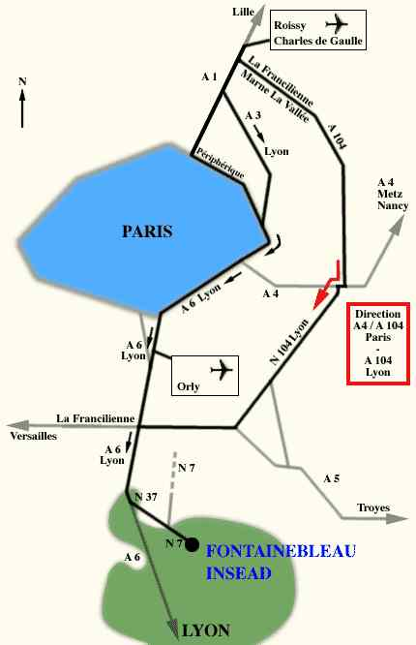 | From Roissy / Orly airports / Paris to Fontainebleau by car
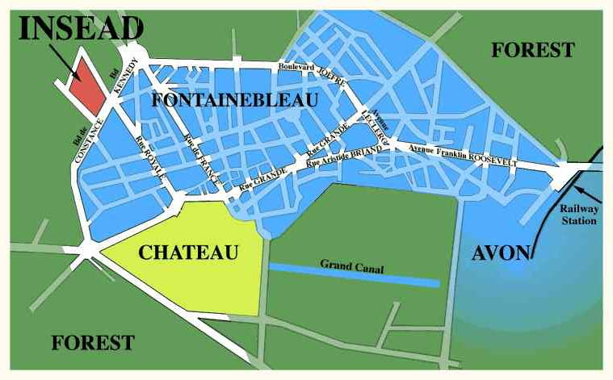 | Arriving at Fontainebleau

