Welfare State vs. Market Forces in a Globalization Era

by

Assaf Razin Efraim Sadka

The Eitan Berglas School of Economics the Eitan Berglas School of Economics

Tel Aviv University Tel Aviv University

Tel Aviv, 69978, Israel Tel Aviv, 69978, Israel

[razin@tauex.tau.ac.il](mailto:razin@tauex.tau.ac.il) [sadka@tauex.tau.ac.il](mailto:sadka@tauex.tau.ac.il)

and, Alexander Schwemmer

Department of Economics, Ludwig-Maximilians-Universität, Geschwister-Scholl-Platz Munich,

80539, Germany,

[alexander.schwemmer@outlook.com](mailto:alexander.schwemmer@outlook.com)

August 23, 2019

**Abstract**

Globalization radically changes income distribution and triggers intense international tax competition, and, consequently, entails the extensive restructuring of the welfare state. We analyze a parsimonious model of an open economy, in its trade and finance transactions with the rest of the world, governed by voter-majority-controlled welfare state.

We find that when the country is capital-abundant relative to the rest of the world, or when it exhibits strong saving propensity, a welfare state governed by the skilled-rich magnifies the intensity of globalization. In contrast, when the country is labor abundant relative to the rest of the world, or it exhibits slow saving propensity, a welfare state governed by the unskilled-poor would tends to magnify the intensity of globalization. The welfare state boost the utility of losers from globalization, regardless whether the skilled-rich or the unskilled poor govern its policies , or the factor supply and the saving propensity are the economy’s fundamentals.

**Introduction**

An interesting study by the political scientist Rogowski (1992) asks why countries differ so greatly in their pattern of political divisions, and ensuing political coalitions, when international trade expands. He argues that the owners of abundant primary factors of production in each country assert themselves politically more when trade globalization intensifies, while owners of scarce factors turn out to be politically defensive. To address these issues he utilizes a standard factor-proportion model (with land, labor, and capital). The model predicts one of three kinds of political cleavages: “class” coalition (labor against land and capital), “urban-rural” coalition” (land against capital and labor), or “red-green” coalition (land and labor against capital). Nineteenth century examples are: Germany’s “marriage of iron and rye”, Britain’s ”trade liberalism”, and the US “populism”. For a capital-rich and labor-abundant country, where land is scarce, expanding trade benefits both capitalists and workers, but harms landowners. Consequently, both capitalists and workers-the urban sector-favor free trade against the interests of landowners. This helps explain the British trade liberalism. When land and labor are scarce, expanding trade will benefit only capital, and agriculture and labor – the “Green” and the “red”- are expected to unite against trade openness. In “frontier” countries where land is abundant, only agriculture gain from free trade. American farmers try to expand their influence in a “populist” movement of an anti-urban streak.

In these 19th century episodes, however, the welfare state was nonexistent. Consequently, social safety nets could have played no role in lessening political cleavages arising from globalization. In modern times, however, open economies have already welfare-state institutions, put firmly in place. Welfare states are endowed with a tax-benefit arsenal in facing the forces unleashed by the trade-finance integration.[1]

The main mechanism, driving the welfare-state-globalization interactions, is international tax competition. Financial and trade integration typically lower the tax on the mobile factor, capital; thus eroding the tax bases associated with capital income, profits, and high-skill labor. The launching of the European Union (EU) provides a “natural experiment“. Accordingly, Caminada et al (2010) assemble a large set of EU welfare-state indicators. They look at a variety of indicators: of social protection, social expenditures, replacement rates of unemployment, ,social assistance, and poverty indicators.[2] Together, these indicators may provide a relatively broad picture of the evolution of social protection in the EU. They demonstrate that the initial level of public social expenditure prior to the creation of the EU has a negative effect on the on EU provision of public social services well after EU has been established. This indicates that countries with above average level of the social protection indicator at the pre-EU period, reduce the provision of social benefits after the launch of the EU; and, countries with below average level of the social protection indicator at the pre-EU period, raise the provision of social benefits after the launch of the EU. They also show that there is absolute convergence towards the bottom in social protection levels across EU countries, possibly because of tax competition forces.

The paper develops a parsimonious model of small open economy, with a standard welfare-state set-up, where the majority of the voter population govern social policies. The purpose is to shed light on the interactions between globalization and the generosity of the welfare, and its fiscal structure. The paper analyzes the trade-globalization effects, and financial-globalization effects, on the distribution of income, and the ensuing welfare-state provision of social benefits, and tax policies.. Our analysis suggests that the role of the welfare state in the presence of intensified globalization, and the welfare state’s voter attitudes toward openness, depend on rather familiar open-economy fundamentals, such as: (i) Factor abundance and the related factor intensity of the export good; (ii) Import or export of financial assets; and, (iii) High-skilled emigration.[3] Furthermore, and in connection to the gains-from-trade proposition, we analyze the degree to which the welfare state, governed by the majority of the voter population, is capable of spreading the gains from trade-globalization, and financial-globalization to various income classes, which are different in terms of both labor and capital income. Furthermore,

The organization of the paper is as follows. Section 1 briefly reviews the topic of border effects, and the trade globalization where the border effects diminish Section 2 briefly surveys the topic of international tax competition. Section three financial-arbitrage frictions and their effects on the direction, and intensity, of capital flows. Section 4 develops a parsimonious model of the welfare state, trade globalization, and financial globalization. Section 5 presents the model predictions about trade globalization and the welfare state. Section 6 the model presents the model predictions about trade globalization and the welfare state. Section 7 concludes.

**1. Border Effects in International Trade**

There exists large body of international trade literature on impediments to trade in goods due to border related friction cost: country specific standards, regulations, technical barriers to trade, together with product-specific information costs, increase border effects. By the Lerner’s Symmetry, any wedge between the domestic and the world prices applied to the importable good is equivalent to a wedge between world and domestic prices applied to the exportable good.

The “border effect” in international trade refers to a situation in which there is higher volume of trade within a country compared with the volume of trade across the country's borders. Gravity equations have been widely used to infer trade-flow effects of various institutional arrangements. They have been esspecially successful to explain the border-effect puzzle. McCallum (1995) estimates a conventional gravity model where bilateral trade between Canadian provinces, or between a Canadian province and US state, should depend on each of their province or state GDP has and distance from the country’s centers. His study uses 1988 data, just before the Canada–US free trade agreement was signed, Although trade economists were not surprised at the existence of a border effect, they find significant size of the estimated effect in McCallum (1995) perplexing. Anderson and van Wincoop (2001) study show why previous empirical studies have had an upward bias in the estimation of the border effect. Anderson and van Wincoop (2001) argue that border effects have an asymmetric effect on countries of different size, and in particular, have a larger effect on small countries. They show previous border-effect estimations suffer from omitted variables bias. They allow the omitted variables in, and find that national borders reduce trade between industrialized countries by still significant amounts of 20-50 percent. Chen (2004), and Chen and Novy (2011), identify industry-specific trade barriers that are responsible for border effects such as country specific standards, regulations, etc. Fouquin, and Hugot (2016), use a gravity theory-grounded measure to create a rich data set of bilateral relative trade costs. The trade costs are aggregated to obtain world indices, as well as indices along various trade routes. They find that the post-WWII fall of trade costs in recent times began in Europe before extending to the rest of the world.

The present paper focuses on the gradual process of diminishing border effects (that is, the increased intensity of trade globalization) on domestic factor prices and income inequality. For this purpose, our model applies a standard factor proportion (Heckscher-Ohlin) model, except that factors’ supply is endogenous in the model. The endogeneity of labor supply stems from the possibility of high-skilled emigration. The endogeneity of capital supply arises from the endogeneity of domestic savings. The model lends itself in a straightforward manner to an analysis of the effect of the world prices of final goods on domestic factor prices a la Stolper and Samuelson (1941). In addition, the model includes a reinforcing effect whereby the change in the domestic factor prices, triggers capital formation through savings a la Rybsczinski (1955). Increased trade globalization intensity means simply an exogenous reduction in the wedge between world prices and domestic final good prices. Naturally, this Stolper-Samuelson type changes in domestic factor price changes trigger a standard reallocation process of domestic factors of production across sectors and affect the prices of domestic factors of production. Furthermore, the ensuing changes in factor prices trigger changes in savings and capital formation. The induced changes in high-skilled emigration and capital formation lead in turn to changes in the factor supply. The latter work through the Rybsczinski mechanism on re-configuration of sectoral outputs, and thus, the volume of international trade.

**2. International Tax Competition**

Financial globalization triggers tax competition among countries, and the possibility of a “race to the bottom”.[4] As a result, the tax burden may shift from the highly mobile factors (e.g. capital and top-skilled labor) to the weakly mobile factors (e.g. low-skill labor). This shift has first-order implications for both the functional and the size distribution of income. A country that imposes high tax rates may push mobile factors (especially capital) abroad where the country cannot effectively tax them, eroding its own tax base and lowering domestic economic activity at the same time. It may significantly affect corporate financing and location decisions of both US, and European, multinational groups. In consequence, the enhanced competitive pressure could result in an erosion of foreign countries’ tax bases and an associated loss in tax revenue triggering a new wave of international tax competition. [5] Figure 1 gives evidence for the intensity of corporate tax competition following the launch of the European Union.

Figure 1: Hall-Jorgenson Effective Tax Rates on Corporate Income: Selected EU Countries

Notes:

Notes: Hall and Jorgenson (1967).

Assumptions: Equity finance, r = 4 %, inflation rate π = 4 %, δ = 20 %, Normal tax life = 10 years. Countries (from top to bottom): Finland, Sweden, Germany, Austria, UK, Belgium Denmark, France, Italy, Luxemburg, Spain, Portugal, Netherlands, Ireland. [6]

**3. Frictions in International-Finance Arbitrage**

We capture the degree of financial globalization by the ease with which capital flows from one country to another. We assume a pure source-based income taxation. This means that the country does not impose taxes on foreign-source income of its residents, but taxes foreigners on their income originating within the country. [7]

Capital income of residents and foreigners (from domestic sources only) is taxed at a flat rate $t_{k}.$ Therefore; the net return on investing into domestic capital is $1+r\left(1-t_{k}\right)$ for investors, where r is the domestic interest rate.

Assume that capital does flow internationally, but at some cost $δ_{k}>0$ per unit.[8] A domestic individual who invests abroad can thus gain only $1+\left(1-t_{K}^{*}\right)r^{*}-δ_{k}$, where $r^{*}$ is the world interest rate and $t_{K}^{*}$ is the tax rate, levied abroad under a source-based taxation. In a small, open economy context, the two (exogenous) variables $t_{K}^{*}$ and $r^{*}$ play an equivalent role, where the only relevant variable is $R^{*}=\left(1-t_{K}^{*}\right)r^{*}$, which is the net of tax international interest rate.

We assume that the cost of capital flows applies symmetrically to foreign investors, i.e. their return on investment in the domestic country is given by $1+\left(1-t_{K}\right)r-δ_{k}$, where investing abroad yields a return $R^{*}.$

The small open economy exports capital in case:

1. $\left(1-t_{K}\right)r= R^{*}-δ_{k}$,

which means that $\left(1-t_{K}\right)r-δ_{k}< R^{*}$, and therefore foreigners do not invest in the domestic economy.

Similarly, the small open economy imports capital in case:

1. $\left(1-t_{K}\right)r-δ_{k}= R^{*}$,

which means that $\left(1-t_{K}\right)r> R^{*}-δ_{k}$, and therefore the residents of the small open economy do not wish to invest abroad.

Remarkably, the foreign tax parameter, $t_{K}^{*}$, with which the domestic tax rate, $t_{K}$, competes, and the financial globalization parameter, $δ_{k}$, have similar effects on the small open economy when it exports capital; but the opposite effects when it imports capital. Specifically, when $t_{K}^{*}$ and $δ_{k}$ fall, then capital export is boosted in the capital-export case. This is because the net return abroad to domestic savers rises. Therefore simulating the tax competition effect on the welfare state economy of reduced $t_{K}^{*}$ is equivalent to the effect of a reduced $δ_{k}$; both indicate that the globalization forces intensify. However, in the capital import case, a fall in $t_{K}^{*}$ the net return abroad to foreign savers increases, and therefore capital imports by the domestic economy diminishes. A fall in $δ_{k}$ however raises the net return for foreign investors in the domestic economy, which boosts capital, imports. Therefore simulating the tax competition effect on the welfare state economy of reduced $t_{K}^{*}$ has the opposite effect of a reduced $δ_{k}$.

**4. A Parsimonious Model**

The paper’s focus is twofold: (i) the effects of globalization on the volumes of capital flows, the volume of trade, the emigration of high-skill labor, and income distribution. And, (ii) the role of the welfare state, as shaped by majority voting, in enhancing the welfare of many (rather than just a few) income groups in the presence of globalization and tax competition forces.

To put trade and financial globalization, tax competition, high-skilled emigration, and the generosity of the welfare state, all in a coherent analytical framework, we develop here a political-economy model, where the welfare state parameters (taxes and social benefits) are determined through majority voting[9]. It is a stripped-down model consisting of the essential (minimal) features, which allow us to analyze these issues.

To enable us to consider trade in goods we assume that there minimally are two tradable goods (x and y). In the absence of uncertainty and differentiated products, each sector will either export or import its standard product, but not both at the same time. World prices of x and y are exogenously given for our small open economy with good x serving as a numeraire, whose price is normalized to one, and the world price of y is denoted by p*.

There is an impediment to trade in goods. Specifically, goods can be exported, but again only at some border related friction cost (e.g., country specific standards, regulations, etc.). For concreteness of the notation, we consider y as an export good. A similar and straightforward notation applies when x is the export good.[10] We denote this cost per unit of price by $δ_{y}$, so that the domestic price of the export good y is

|  |  |  |
| --- | --- | --- |
| (3) | $p_{t} = \frac{p^{*}}{ \left(1 +{ δ}_{y}\right)}.$ |  |

In order to consider redistribution issues, which are at the heart of the welfare state, we assume that there minimally are two types of individuals -- low skilled-poor (indexed $u$) and high-skilled –rich (indexed $s$).There are two types of factors of production—capital (K) and labor (L). The workers have two types of skills—low (l) and high (h). Labor market productivity of the skilled individual is 1 and labor market productivity of the unskilled individual is $ρ_{}< 1.$

Each high-skill individual is endowed with ${\overline{x}}_{s}$ units of good x, and ${\overline{y}}_{s}$ units of good y , respectively, in the first period; a low-skill individual is endowed with only $θ<1$ units of the skilled endowements. Thus, an skilled-rich individual enjoys both higher initial endowment (“wealth”), and higher labor market skill than the unskilled-poor individual.

The overall size of the initial native-born population is normalized to one, where a proportion $λ$ of the population is of high skill and a proportion $1-λ$ is of low skill. We denote by $m_{s}≥0$ the number of high-skill emigrants. Note that when $λ<0.5$, then the low-skill form a majority and will be decisive in the voting process. When $λ-m_{s}>0.5$, assuming that emigrants do not participate in the political process, the high skill form the majority and are decisive in the voting process.

To consider saving and investment we assume that there minimally are two periods (1 and 2).

A representative firm produces good $g$ according to a constant-returns-to scale technology:

$\left(4\right) g=A_{g}F_{g}\left(K_{g},L_{g}\right)= A_{g}K_{g}^{α_{g}}L_{g}^{1-α_{g}}$, $g=x, y,$

where, $K_{g}$ is the input of physical capital, and $L_{g}$ is labor, measured in efficiency units, used in the respective production process. $A_{g}>0$ is a total factor productivity coefficient, and $α_{g}$ and $1-α_{g}$ are, respectively, the capital and labor shares in the sector producing $g$.

Capital is employed together with labor in the first period with output generated in the second period. We assume that labor is paid in the second period, at the end of the production process.

Capital ($K$) is a composite good, produced in the first period as of a variable mix of $x_{k}$ and $y_{k}$, according to:

(5) $K= {x_{k}}^{β}{y_{k}}^{1-β}$, where 0 < β <1.

To find the cost minimizing mix of x and y, of which a unit of capital (K) is composed of, one, has to solve the following problem:

$\min_{(x,y)}{(x_{k}+p_{1}y_{k} ) }$

subject to:

${x_{k}}^{β}{y_{k}}^{1-β}≥1$,

where $p_{t}$ is the domestic price of $y$ in period $t=1,2$.

Solving this problem yields also the unit price $p_{k}$ of capital as

(6) $p_{k} =Dp_{1}^{1-β}$,

where $D=(\frac{1-β}{β})^{β}+ (\frac{β}{1-β})^{1-β}$.

The labor supply in efficiency units ( $L^{S})$ is given by

|  |  |  |
| --- | --- | --- |
| (7) | $L^{S}= λ-m_{s}+\left(1-λ \right)ρ_{}$ $.$ |  |

Demands for labor and capital are given, respectively, by the marginal productivity conditions in both sectors. Note that because labor and capital move freely between the two sectors, then the factors of production earn the same remuneration across sectors, that is:

|  |  |  |
| --- | --- | --- |
| (8)  (9) | $$w = \left(1-α_{x}\right)A_{x}k_{x}^{α_{x}},$$ $w= p_{2}\left(1-α_{y}\right)A_{y}k_{y}^{α_{y}}$ |  |
| (10) | ${p }_{k}\left(1+r\right)= {α_{x}A}_{x}k_{x}^{1-α_{x}}$, |  |

(11) ${p }_{k}\left(1+r\right)=$ $p_{2}{α_{y}A}_{y}k_{y}^{1-α_{y}}$,

where $k_{g}$ is the capital- labor ratio in sector $g$, that is $k_{g}= \frac{K_{g}}{L_{g}}$; $w$ is the wage rare per efficiency unit, paid in the second period after the completion of the production process. Note that for simplicity we assume that capital fully depreciates at the end of the production process.

We denote by $c_{gi1}$ the consumption of good g = x,y by an individual of type i = u,s in period t = 1,2. All individuals have identical preferences, given by

|  |  |  |
| --- | --- | --- |
| (12) | $$u_{i} = ({c_{xi1}}^{a}{c_{yi1}}^{1-a} )^{b}({c_{xi2}}^{a}{c_{yi2}}^{1-a} )^{1-b} +dB^{γ},$$ |  |

where 0 < a < 1, 0 < b < 1, d > 0, $γ>0,$ and $B$ is a uniform social benefit (provided in an equal amount to all individuals), assumed (for simplicity) to be provided in the second period only. This social benefit captures the various ingredients that a welfare state provides, such as health services, education, in-kind transfers, etc. Note that the social benefit is not a perfect substitute to private consumption[11].

Individual budget constraints for period 1 and 2 are given, respectively, by:

|  |  |  |
| --- | --- | --- |
| (13) | $S_{i} = {\overline{x}}_{i}+p_{1}{\overline{y}}_{i}- { c}_{xi1 }- {p_{1}c}_{yi1 }$ $.$ |  |
| (14) | $$S_{i}\left[ 1+\left(1- t_{k}\right)r\right]+ ρ_{i} \left( 1- t_{l }\right)w= { c}_{xi2 }+ {p_{2}c}_{yi2 },$$ |  |

where, $S_{i}$ is domestic saving of individual i = u, s. Observe that when ${ \left(1-λ \right)S}_{u}+( {λ-m_{s})S}_{s}- p_{k}(K_{x}+ K_{y})$ is positive, then capital is exported and equation (1) is relevant; whereas when ${ \left(1-λ \right)S}_{u}+( {λ-m_{s})S}_{s} - p_{k}(K_{x}+ K_{y})$ is negative, then capital is imported and equation (2) is relevant.

We abstract from a tax on the initial endowments because these are in fixed supply at the beginning of the first period, and a tax on them is not distortive; it will tend to be extremely high. Furthermore, when the low-skill form the majority, they will tax them at a rate of 100%. For a similar reason, we abstract also from a tax on consumption (VAT) because it is equivalent to a tax on wages (which are taxed directly in our model), and a tax on the initial endowments (see, for instance, Frenkel, Razin and Sadka (1991)).

Consumption demands are then given by:

|  |  |
| --- | --- |
| (15) | $c_{xi1 }$ $= abI_{i}$ $.$ |
| (16) | $c_{yi1 }$ $= \frac{(1-a)bI_{i}}{p_{1} }$, |
| (17) | $c_{xi2 }$ = $a(1-b{)I}_{i}[1+\left(1-t_{K}\right)r]$,  and |
| (18) | $c_{yi2 }$ = $\frac{(1-a)(1-b{)I}_{i} (1+\left(1-t_{K}\right)r)}{p_{2}},$. |

where $I_{i}$ is a lifetime income (in present value) of an individual of type i = u, s, given by

(19) $I_{i}=\frac{ ρ_{i} w(1-t_{L} + ({\overline{x}}_{i}{+p_{i}{\overline{y}}_{i}) }_{}[ 1+\left(1-t_{K}\right)r ] }{1+\left(1-t_{K}\right)r}$,

where

(20) $ρ_{i}$ = ${{{\left(\right.}_{{}_{1 for i=s}}}^{{}^{ρ for i=u}}}_{}$

|  |  |  |  |  |  |
| --- | --- | --- | --- | --- | --- |
|  | |  |  | | |
|  | |  |  | | |
|  | |  |  | | |
|  | |  |  | | |
|  |  | | |  |

Finally, consider the government, which is active in a balanced-budget way only in the second period. Its budget constraint is:

|  |  |  |
| --- | --- | --- |
|  | (21) $\left(1-m_{s}\right)B=t_{l}wL+t_{k}rp_{k}{(K}_{x}+ K_{y}).$ |  |

Note that the government taxes capital income of both domestic residents and foreigners which originates in the domestic economy, $rp_{k}{(K}_{x}+ K_{y})$. This means that when saving of domestic residents exceeds domestic investment, $p_{k}{(K}_{x}+ K_{y})$, with the excess invested abroad, then this excess is not taxed at home. Converesely, when savings of domestic residents fall short of domestic investment, $p_{k}{(K}_{x}+ K_{y})$, with the shortage financed by foreigners, then this shortage is taxed by the domestic government.

Clearance in the goods market in period 1, and period 2, respectively, yields:

|  |  |  |
| --- | --- | --- |
| (22) | $$\left(1-λ\right)\left(c_{xu1 }+p_{1}c_{yu1})\right)+\left(λ-m_{s}\right)\left( c_{xs1 }+p_{1} c_{ys1}\right)+ p_{k}{(K}_{x}+ K_{y})={\left(1-λ\right)(\overline{x}}_{u}+ p_{1}{\overline{y}}_{u}{ )+ \left(λ-m_{s}\right)( \overline{x}}_{s}+ p_{1}{\overline{y}}_{s})+p_{k}{(K}_{x}+ K_{y})-[{ \left(1-λ \right)S}_{u}+( {λ-m_{s})S}_{s}]$$ and |  |
| (23) | $\left(1-λ\right)\left(c_{xu2}+p_{2}c_{yu2}\right)+\left(λ-m_{s}\right)\left(c_{xs2}+p_{2}c_{ys2}\right)+\left(1-m_{s}\right)B=F_{x}\left(K_{x},L_{x}\right)+p_{2}F_{y}\left(K_{y},L_{y}\right)+[ \left(1-λ\right)S_{u}^{}+\left(λ-m_{s}\right)S_{s}^{}- p_{k}{(K}_{x}+ K_{y})] I_{CF}$, |  |

where

(24) $I_{CF}$ = $∁_{{}_{1 + \left(1-t_{k}\right)r if \left(1-λ\right)S_{u}^{}+\left(λ-m_{s}\right)S_{s}^{} ≤ p_{k}{(K}_{x}+ K_{y}) }}^{{}^{1+ R^{*}- δ_{k} if \left(1-λ\right)S_{u}^{}+\left(λ-m_{s}\right)S_{s}^{} ≥ p_{k}{(K}_{x}+ K_{y}) } }$.

Note that when the country exports capital (that is, $\left(1-λ\right)S_{u}^{}+\left(λ-m_{s}\right)S_{s}^{}> p_{k}{(K}_{x}+ K_{y}))$, then it incurrs the cost of $δ_{k}$ on its capital exports. Conversely, when foreigners invest in the domestic economy (that is, $\left(1-λ\right)S_{u}^{}+\left(λ-m_{s}\right)S_{s}^{}< p_{k}{(K}_{x}+ K_{y}))$, then the country pays foreiners only $1 + \left(1-t_{k}\right)r$, because they are taxed on their income originating in the domestic economy; foreigners bears the friction cost $δ_{k}$ in this case. Note, however, that it follows from equations (13) – (14) that equation (22) is redundant, as it merely states that exports/imports of goods and capital are allowed.

Clearance in the labor market yields:

|  |  |  |
| --- | --- | --- |
| (1) | $$L^{S}=L_{x}+L_{y}.$$ |  |

We allow skilled individuals to emigrate abroad according to the following equation:

|  |  |  |
| --- | --- | --- |
| (26) | $$m_{S}=Z{\left(u_{S}^{*}-u_{s}\right)}^{z} with Z>0, 0 < z < 1.$$ |  |

where $u_{s}^{*}$ is the (exogenously given) utility level attained by s-individuals who reside abroad. Note that the number of emigrants depends positively on the foreign-domestic utility differential, $u_{S}^{*}-u_{s}$.

As for the welfare state features in the model, we assume that the tax-transfer policy (that is, the choice of ${ t}_{L }$, $t_{k }$ and B) are determined by majority voting. Because the individuals in each of the two skill groups are identical, the larger group determines policies, according to its own preferences.. Thus, when $λ$ is less than 0.5 (and so is $λ-m_{s}$), the u-individuals form the majority, and the tax-transfer policy is determined so as to maximize the u-individual utility level (that is, $u_{u}$). This regime is henceforth referred to as the u-regime. Similarly, when $λ-m_{s}$ (which is not an exogenous variable) is larger than $0.5$, the tax-transfer policy is determined by the s-individuals, to maximize their utility level, $u_{s}$. This regime is henceforth referred to as the s-regime.

The forces of trade and financial globalization are intertwined in their implications for income distribution and tax-transfer policies. To get a better insight into these interdependent effects we consider separately trade globalization and financial globalization.

We resort to numerical simulations in order to characterize these two regimes. In particular, we study how globalization (as proxied by the friction costs $δ_{k}$ and $δ_{y}$), and how tax competition (as expressed by the tax parameters $t_{k }$ and $t_{k}^{*}$) affect these two regimes.

**5. Trade globalization and Welfare-State Policies**

In this section we start with the study of trade globalization, income distribution and the welfare state. For this purpose, we shut off the channel of international financial flows in the model. Our focus is on the implications of trade globalization through these effects for income distribution and the ensuing political-economy benefits and taxes. As we shall see, these implications depends on: (i) the factor abundance of our small open economy and the related factor intensity of the export good; (ii) on whether or not there is complete specialization in the export good.[12]

**5.**1 **Capital-Abundant Economy**

Suppose that good y is more capital intensive than good x. Suppose further that our small open economy is more capital abundant relative to the rest of the world. This means that the world relative price of y (namely $p^{*}$) is higher than the domestic autarky relative price of good y.

Recall that we measure the degree of trade globalization by the parameter $δ_{y}$, which is an impediment to trade in goods (equation (1)). First, we examine how trade globalization affects the income distribution in the absence of the welfare state (that is, $t_{L}= t_{K}=B=0).$ Then, we examine how the welfare state responds to trade globalization under the two configurations of political power balance: (i) Skill-rich majority; (ii) Unskilled-poor majority.

With sufficiently high $δ_{y}$, the country is in autarky. Naturally, the autarkic relative price of the would-be export good lies below the world relative price. In this range, a decline in $δ_{y}$ does not affect the domestic prices, as long as the economy is still in autarky. When $δ_{y}$ continues to fall, the country opens up to trade in goods; it exports good y and imports good x. In this non-autarkic regime, a decline in $δ_{y}$ raises, as expected, the domestic price of the export good (y) toward the world price p* (see equation (3)). Figure 2(a) shows that as $δ_{y}$ decreases, the autarky ceases to exist first when the skilled form the majority in the welfare state[13]. As further declines, then the autarky collapses with the absence of the welfare state; Next, the autarky collapses last (in response to a decrease in $δ_{y}$) when the unskilled form the majority in a welfare state. As long as the impediment to trade is strong enough (that is, $δ_{y}$ is sufficiently high), the volume of exports is flat. As $δ_{y}$ declines and autarky ceases to exist, export rise in response to the increase in its domestic price, $p_{2} ,$ as shown in Figure 2(b). As $p_{2}$ rises, more labor and capital shift to the export sector (from the importable sector), until complete specialization in the export sector occurs (and the importable good is no longer domestically produced).[14] In accordance with Figure 2(a), complete specialization occurs first when the skilled form the majority in the welfare state. Second, is the no-welfare-state case, and last is when the unskilled form the majority in the welfare state. Regardless of the intensity of globalization, the volume of exports is largest when the skilled-rich form the majority, intermediate in the no-welfare-state case, and smallest when the unskilled-poor form the majority.[15]

Figure 2 (the capital-abundant case): Exports and Prices

(a) The domestic relative price of the export good,

(b) The volume of exports

Note: For parameter values, see Appendix.

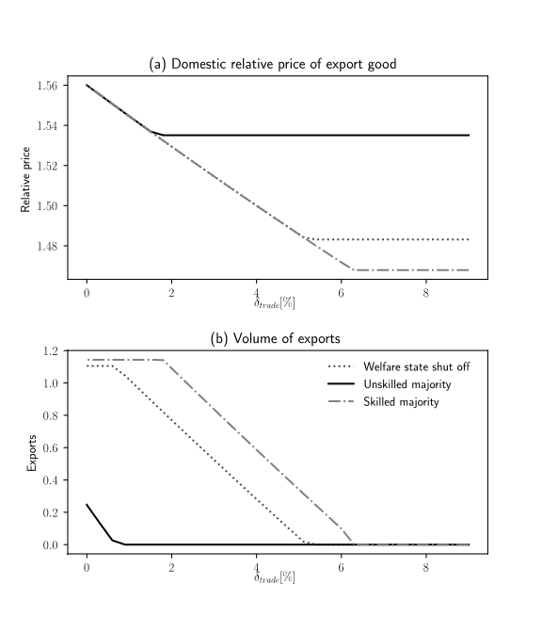

Panels (a) and (b) of Figure 2 suggest that when the export good is more capital intensive (relative to the import good) in a capital-abundant country (relative to the rest of the world), then: (i) the skilled-rich are most pro-globalization; (ii) the unskilled-poor are least pro-globalization; and, (iii) the case of no welfare state is in between.

Figure 3 describes the effect of increased trade globalization on the pre-tax factor prices. Parallel to Figure 1, the flat segments reflect autarky (for high values of $δ_{y}$). Once $δ_{y}$ falls below the autarky threshold, the return to capital rises and the wage falls in response to increased globalization, as predicted by the Stolper-Samuelson mechanism; see Figure 2(a), which shows that the relative price of capital-intensive good rises. When complete specialization occurs (and this happens for our parameter values only in the no-welfare regime, or when the skilled form the majority), then both factor prices rise as the degree of globalization intensifies. Note also that in the case of a one-good production the two-factor prices rise at the same rate—the rate of increase of the domestic price of the export good.

Figure 3(the capital abundant case): Pre-tax Factor Prices

(a) Wage

(b) Domestic return to capital

Note: For parameter values, see Appendix.

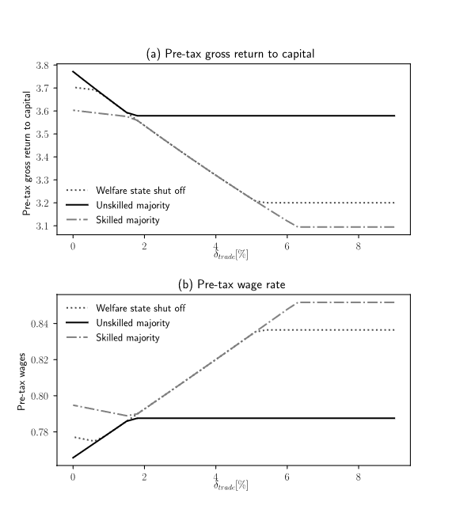

Figure 4 describes the effect of increased globalization on the taxes and the social benefit. There are several patterns to note. First, when the skilled form the majority, they levy taxes on labor only. Analogously, when the unskilled form the majority, they levy taxes on capital only. This pattern holds even though the two classes own both capital and labor. However, for our parameter values (the skill-premium $ρ$ and the wealth disparity), the skill-rich have higher stake in their capital income, whereas the unskilled-poor have higher stake in their labor income.[16]

A second related pattern is that both classes maintain the welfare state when they form the majority. In this regard, we note that the social benefit B is essential as it consists of some goods and services that the market does not provide (e.g., job security, health care, etc.). The third pattern is that, as the degree of globalization intensifies, the tax on labor (respectively, capital) rises when the skilled (respectively, the unskilled) form the majority, and then declines. Indeed each class has an incentive to raise the tax that hurts more the other class, but at some point, the distortion caused by the higher tax stops and reverses the rising trend. When the skill-rich raise the labor tax, the distortion stems from skilled emigration. When the unskilled-poor raise the capital tax, the distortion stems from both the skilled emigration and the reduced savings and capital formation.

Figure 4 (the capital-abundant case): Taxes and Social Benefits

(a) Capital

(b) Labor

(c) Social Benefit

Note: For parameter values, see Appendix.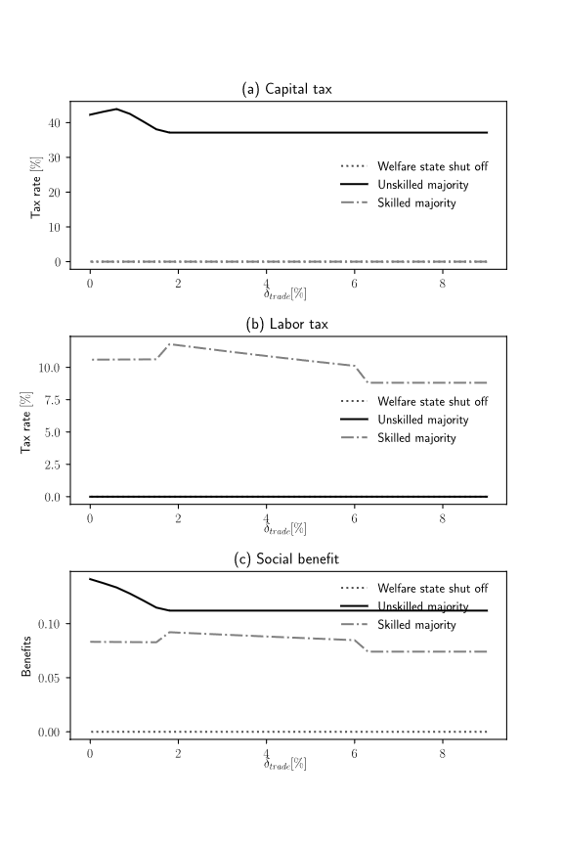

Figure 5 describes the effects of increased globalization on the well-being of the two classes. First, in the no-welfare state case, the skilled-rich gain and the unskilled-poor lose as trade globalization intensifies (recall that this is the capital-intensive export configuration). Naturally, a welfare state, which provides the social benefit B, raises utility for all, independently of who form the majority and of the degree of globalization. When the skilled-rich form the majority, increased globalization hardly affects the unskilled-poor (the welfare state institution therefore mitigates the adverse effect of the globalization forces per se on them), while benefiting the rich themselves. When the unskilled-poor form the majority, they not only no longer lose from increased globalization (as in the absence of a welfare state) - they actually gain. They manage to raise the burden on the skilled to raise their utility, as globalization intensifies.

Figure 5 Capital abundant case): Utilities

1. Unskilled-poor utility
2. Skilled-rich utility

Note: for parameter values, see Appendix.

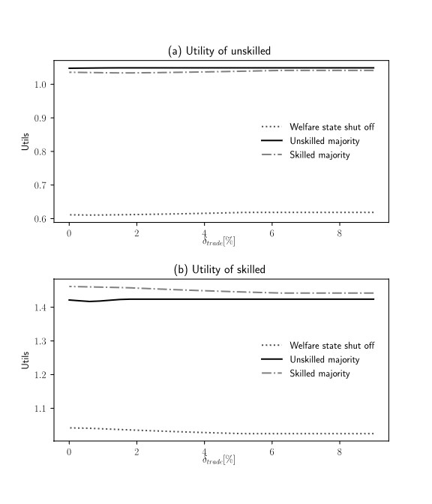

**5.2 Labor-Abundant Economy**

We turn now to a different set of parameter values that renders our small open economy to be a labor-abundant relative to the rest of the world. That is the autarky price of the export good which is now the labor-intensive good (good x) is below the world price of that good (1/p*).

As can be seen in Figure 2’, as the degree of globalization intensifies (that is, as $δ_{x}$ declines), the first departure from autarky occurs when the unskilled-poor form the majority. Next, is the case of no welfare state; and the last departure from autarky occurs when the skilled-rich form the majority. A mirror image is what happens to the volume of exports after the departure from autarky: it is the largest when the unskilled-poor form the majority; intermediate under the no- welfare-state regime, and smallest when the skilled-rich form the majority.

As in the capital-abundance case, also in the labor abundance case, when the skilled-rich form the majority, they levy taxes on labor only. Analogously, when the unskilled-poor form the majority, they levy taxes on capital only.

In contrast to the capital-abundance case, it is now the unskilled-poor who are the most pro-globalization; the skilled-rich are the least pro-globalization; and in the absence of a welfare state system, the economy’s posture toward globalization is in between.[17]

Figure 2’(The labor-abundant case): Exports and Prices

1. The domestic relative price
2. The volume of exports

Note: for parameter values see Appendix.

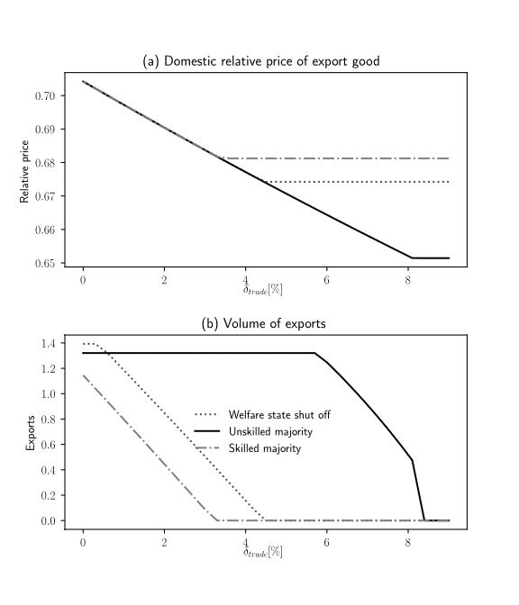

An interesting contrast arises when looking at the well-being of the two classes; compare Figures 5 and 5’. First, the gainers from intensified globalization in the absence of the welfare state (where only market forces without redistribution of income drive the equilibrium) are now the unskilled-poor, whereas the losers are the skilled-rich. For it is now the labor-intensive good which is exported, and consequently the wage rises and the return to capital falls with increased globalization. In both the capital-intensive export and the labor-intensive export cases, the welfare state, which provides the social benefit B, improves the well-being of the two classes, irrespectively of the intensity of globalization.

Figure 5’(The labor-abundant case): Utilities

Note: for parameter values: see Appendix.

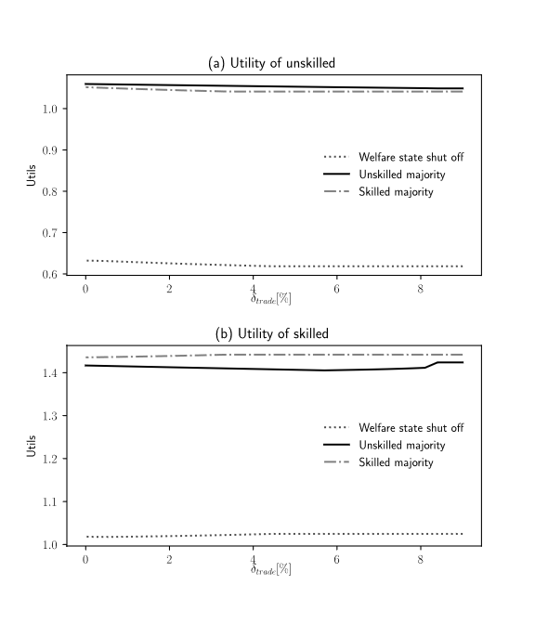

In the present case, when the unskilled-poor form the majority, then increased globalization ameliorates their well-being, as expected; whereas the skilled-rich are hardly affected (again, the existence of the welfare state mitigates the adverse effects of globalization on them). When the skilled-rich form the majority, they not only no longer lose from intensified globalization (as in the absence of the welfare state)—they actually gain by increasing the burden on the unskilled-poor.

**6. Financial Globalization**

We turn now to the case of financial globalization. As before, we capture the ease of globalization by the level of the friction cost $δ_{k}$. A lower level of $δ_{k}$ means a higher degree of financial globalization. Note that in the case of capital exports (corresponding to a positive sum of net foreign assets position), a decline in $δ_{k}$ raises the return to investing abroad, and thereby stimulates it (see equation (1)). In the case of capital imports (corresponding to a negative sum of net foreign assets position) , a decline in $δ_{k}$ raises the return to foreigners on their investment in our small open economy, and thereby accelerates it (see equation (2)).

**6.1 Capital Exports**

We consider first the case of capital exports.

Figure 6(a) suggests, as expected, that a decline in $δ_{k}$ increases unambiguously the export of capital. The mirror image of this graph is illustrated in Figure 6(b) where we can see that the higher volume of capital exports decreases the stock of domestic capital. This result holds no matter whether the skilled-rich or unskilled-poor form the majority; or whether the welfare state is present.

Figure 6: Capital Exports and Domestic Capital

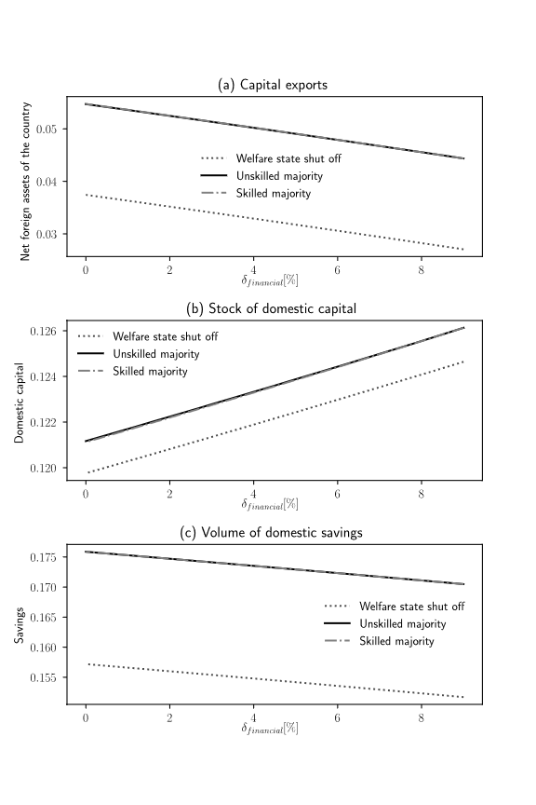

(a)Volume of capital exports

(b) Stock of domestic capital

(c) Savings; Note: For parameter values, see Appendix.

Interestingly, both the skilled-rich and the unskilled-poor increase the level of capital exports, relative to the case of no-welfare-state, for all levels of $δ_{k}$. As expected, with source based capital taxation in the welfare state, which exempts capital exported abroad from taxes, while levying taxes on capital invested at home, the incentive to export capital is amplified. One may wonder why, notwithstanding the fact that the welfare state encourages capital exports, the domestic stock of capital is nevertheless still larger in the presence of the welfare state, relative to the case of no-welfare-state. The reason is that the welfare state enhances wellbeing and boosts domestic saving (see Figure 6(c). Naturally, when the capital-labor ratio falls, as the result of capital exports, pre-tax return to capital return to capital rises and the pre-tax wage falls.

Figure 7 presents the effect of increased globalization on the taxes and the social benefit.

Both when the skilled-rich form the majority, or the unskilled-poor form the majority they levy taxes on both capital and labor. As globalization intensifies and the capital tax base shrinks, as a result of capital outflows, both types of majority raise taxes on labor and capital. The social benefit, B, being essential, consisting of some goods and services that the market does not provide(e.g., job security, health care, etc.) rise moderately as $δ_{k}$ falls and wellbeing is ameliorated . 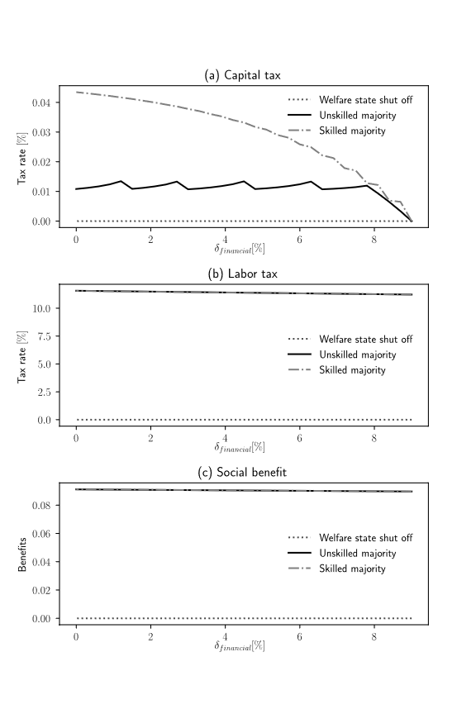

Figure 7 (The capital-export case): Taxes and Social Benefits

1. Capital tax rate
2. Labor tax rate
3. The volume of social benefits

Note: for parameter values, see Appendix.

Naturally, the welfare state, which provides the social benefit B, raises utility for all, independently of who form the majority and of the degree of globalization.

**6.2 Capital Imports**

We turn now to the case of capital imports.

Figure 8(a) suggests, as expected, that a decline in $δ_{k}$ increases unambiguously the imports of capital, in the absence of a welfare state (where market forces work alone). The mirror image of this graph is illustrated in Figure 8(b), where we can see that the higher volume of capital imports increases, naturally, the stock of domestic capital. Note also that when the stock of domestic capital increases, then the return to capital falls and the wage rate rises. Naturally, very high values of $δ_{k}$ deter capital imports altogether, and the small open economy is in a financial autarky. Note that as $δ_{k}$ falls the economy moves out of the autarky state first in the case of no welfare state; second, when the skilled-rich form the majority; and third, when the unskilled-poor form the majority.[18]

Interestingly, the unskilled-poor lower the level of capital imports more than the skilled-rich; the both reduce capital imports relative to the case of no-welfare-state. As expected, with source based capital taxation, which taxes capital imported from abroad, the incentive of foreigners to invest in the small open economy are dampened by the existence of the welfare state. One may wonder why the domestic stock of capital is nevertheless still larger when the skilled-rich form the majority, relative the no welfare state case, even though they discourage capital imports (see Figure 8(b)). The reason is that the welfare state in this case boosts domestic saving sufficiently (see Figure 8(c)) to compensate for the squeezed capital inflow.

Figure 8: Capital imports and the stock of domestic capital

1. The volume of capital imports
2. The stock of domestic capital
3. The volume of savings

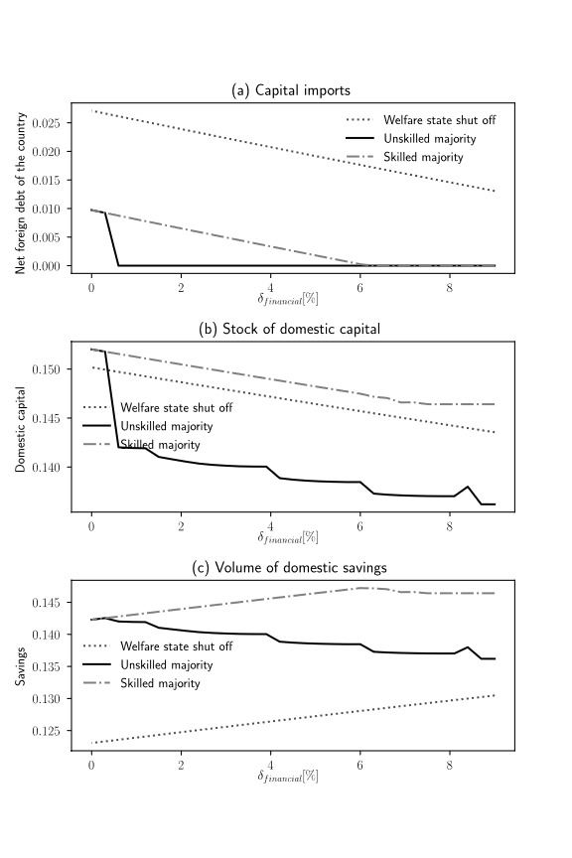

Note: For parameter values, see Appendix.

Figure 9 presents the rates of taxes and the volume of social benefits when the small open economy imports capital from the rest of the world. When the skilled-rich form the majority, they choose to impose no taxes on capital. They lower moderately the tax rate on labor as $δ_{k}$ falls. Interestingly, when the unskilled-poor form the majority, they increase the tax on labor (though still this tax is at a lower rate than when the skilled-rich form the majority), and lower sharply the tax on capital once they depart from financial autarky and start to import capital. When the skilled-rich form the majority the social benefit follows a similar pattern as the labor tax rate does (recall that they levy no tax on capital): as $δ_{k}$ falls, they lower moderately the volume of the social benefits.

Figure 9 (The capital import case): taxes and social benefits

1. Tax rate on capital
2. Tax rate on labor
3. The volume of social benefits

Note: for parameter values, see Appendix.

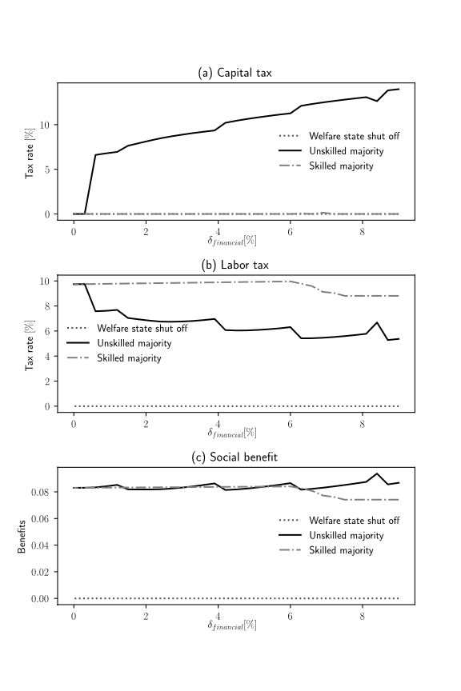

**7. Conclusion**

The paper highlights key trade-related and finance-related mechanisms, linking forces of globalization to the welfare-state fiscal structure. The Welfare state, which provides social benefit that are financed by levying labor and capital taxes, is governed by the majority of the voter population; thus reflecting their economic interests At the root cause of the interactions between the welfare state and globalization lies the world markets, which inflict intense pressures on the welfare state. Globalization pressures force significant fiscal changes for the economy to be able to compete in trade and capital markets internationally. Furthermore, they radically affect incomes from capital investments and and from labor sevices of various classes. Income-based olitical cleavages are shown to be grounded on trade-related and macro-related fundamentals, familiar from a standard open-economy model. They are: (i) The degree of trade border frictions, (ii) The degree of international finance frictions, (iii) The relative factor abundance that determines the capital intensity of the country’s exports; and, (iv) The domestic savings and productivity of domestic investment, which determines whether the country is a financial capital exporter or importer.

We find that when the country is capital-abundant relative to the rest of the world, or when it exhibits strong saving propensity, a welfare state governed by the skilled-rich magnifies the intensity of globalization. In contrast, when the country is labor abundant relative to the rest of the world, or it exhibits slow saving propensity, a welfare state governed by the unskilled-poor would tends to magnify the intensity of globalization. The welfare state boost the utility of losers from globalization, regardless whether the skilled-rich or the unskilled poor govern its policies , or the factor supply and the saving propensity are the economy’s fundamentals.

We demonstrate that the welfare state spreads out the gains from globalization from low skilled-poor to high skilled-rich, not only when the latter are the majority which determines redistribution policies, but also when the former form the majority.

**Appendix: Parameter Values**

**Cross regime common parameter values**

|  |  |
| --- | --- |
| α1 | 0.25 |
| Pα2 | 0.45 |
| β | 0.6 |
| Γ | 0.5 |
| γ | 0.05 |
| A1 | 5 |
| A2 | 5 |
| T | 2 |
| λ | 0.5 |
| tk* | 0.4 |
| Z | 0.05 |
| ζ | 2 |
| U* | 1.5 |
| ac | 0.5 |
| ak | 0.5 |
| xu | 0.5 |
| ρ | 1 |
| xs | 0.5 |

**Regime-specific parameter values**

|  |  |  |  |
| --- | --- | --- | --- |
|  | | |  |
| **Trade** | | |  |
| parameter | value | Figures |  |
| p* | 1.56 | K-specialization | |
| p* | 0.70422535 | L-specialization | =1/1.42 |
| δtrade | 0–9% |  |  |
| **Financial liberalization** | | |  |
| R* | 3.5 | K-export |  |
| R* | 3.02 | K-import |  |
| δfinancial | 0–9% |  |  |

**References**

Anderson, James E., and Eric van Win coop (2003), “Gravity with Gravitas: A Solution to the Border

Puzzle,” American Economic Review, vol. 93, no. 1 pp. 170-92.

Besley, Tim, Rachel Griffith and Alexander Klemm (2001). “Empirical Evidence

on Fiscal Interdependence in OECD Countries." Institute for Fiscal Studies.

Caminada, Koen, Kees Goudswaard, and Olaf Van Vliet, (2010), “Patterns of Welfare State

Indicators in the EU: Is there Convergence?” Journal of Common Market Studies, Volume

48, Issue 3, June 2010, Pages 529-556.

Chen. Natalie, (2004), “Intra-national versus international trade in the European Union: why do national borders matter?,” [Journal of International Economics](https://www.sciencedirect.com/science/journal/00221996), [Volume 63, Issue 1](https://www.sciencedirect.com/science/journal/00221996/63/1), May 2004, Pages 93-118.

Chen, Natalie, and Dennis Novy (2011), “Gravity, trade integration, and heterogeneity across industries,” [Journal of International Economics](https://www.sciencedirect.com/science/journal/00221996), [Volume 85, Issue 2](https://www.sciencedirect.com/science/journal/00221996/85/2), November 2011, Pages 206-221.

Diamond, Peter A., and James A. Mirrlees (1971), “Optimal Taxation and Public Production I: Production Efficiency,” The American Economic Review Vol. 61, No. 1 (March 1971), pp. 8-27.

Devereux, Michael P., and Rachel Griffith (2002). “The Impact of Corporate

Taxation on the Location of Capital: A Review." Swedish Economic Policy Review.

Devereux, Michael P., and Rachel Griffith, and [Alexander Klemm](javascript:;) (2002), “ Corporate

income tax reforms and international tax competition,” *Economic Policy*, Volume

17, Issue 35, 1 October 2002, Pages 449–495.

Frenkel, Jacob A., Assaf Razin, and Efraim Sadka, (1991), International Taxation in an Integrated World, Cambridge: MA, MIT Press.

Fouquin, Michel, and Jules Hugot , 2016. "Two Centuries of Bilateral Trade and Gravity Data: 1827-2014," CEPII Working Paper 2016- 14 , May 2016 , CEPII.

Goldstein Itay and Assaf Razin (2006), “An information-based trade off between foreign

direct investment and foreign portfolio investment,” *Journal of International*

*Economics*, Volume 7, Issue 1, September 2006, pp. 271-295.

Grossman, Gene, and Elhanan Helpman (1994),“Protection for Sale,“ The American Economic Review, 84 (4), 833-850.

Grossman, Gene, and Elhanan Helpman, (2001), Special Interest Politics, MIT Press.

Hall, Robert E. and Dale W. Jorgenseon (1967). “Tax Policy and Investment

Behavior." American Economic Review 57: 391-414.

Hillman, Arye (1982), „Declining industries and political-support protectionist motives,“ The American Economic Review, 72(5), 1180-1187.

Hines, James R. (1999). “Lessons from Behavioral Responses to International

Taxation." National Tax Journal 52: 304-322.

Krautheim, Sebastian, and Tim Schmidt-Eisenhor (2011), “Heterogeneous firms, ‘profit

shifting’ FDI and international tax competition,” [Journal of Public Economics](https://www.sciencedirect.com/science/journal/00472727)

[Volume 95, Issues 1–2](https://www.sciencedirect.com/science/journal/00472727/95/1), February, Pages 122-133.

Lassen, David D. and Peter Birch Sorensen (2002). “Fnancing the NordicWelfare

States: The Challenge of Globalization to Taxation in Nordic Countries."

A Report prepared for the Nordic Council of Ministers, June.

Levy, P. I., (1997), „A political-economic analysis of free trade agreements,“ The American Economic Review, 74 (5)506-519.

Magee, S. P., Brock, W. A., and L. Young, (1989), Black hole tariff and endogenous policy theory, Cambridge Books.

Mayer, Wolfgang, (1984), “Endogenous Tariff Formation,” American Economic Review 74:5, December 1984, pp. 970-985.

Mayer, Wolfgang, and J. Li (1994), „Interest groups, electoral competition, and probabilistic voting for trade policies,“ Economics and Politics, 6 (1), 59-77.

McCallum, J. (1995), ‘National Borders Matter: Canadian-U.S. Regional Trade Patterns’, American Economic Review, 85, 3, 615–23.

Razin, Assaf, Sadka, Efraim and Chi-Wa, Yuen, (1998). "[A pecking order of capital inflows and international tax principles](https://ideas.repec.org/a/eee/inecon/v44y1998i1p45-68.html)," [Journal of International Economics](https://ideas.repec.org/s/eee/inecon.html), Elsevier, vol. 44(1), pages 45-68, February.

Razin, Assaf, Efraim Sadka, and Chang Woon Nam (2005), The Decline of the Welfare

State: Demography and Globalization, MIT Press.

Rodrik, Dani, (1995), „Political economy of trade policy,“ Handbook of International Economics, 3, 1457-1494.

Rodrik, Dani (2011), The Globalization Paradox: Democracy and the Future of the World

Economy, W.W. Norton.

Rogowski, Ronald (1992) Commerce and Coalitions How Trade Affects Domestic Political Alignments, Princeton University Press.

Rybczynski, T. M. 1955. "Factor Endowments and Relative Commodity Prices." Economica 22: 336-341.

Schott, Peter K. (2003) “One Size Fits All? Heckscher-Ohlin Specialization in Global Production” American Economic Review, Vol 93, No 3, pp. 686-708.

Samuelson, Paul. 1939. “The Gains from International Trade.” The Canadian Journal of Economics and Political Science / Revue Canadienne d’Economique et de Science Politique. 5(2): 195-205.

Sorensen, Peter Birch (2002). “The Case for International Tax Coordination

Reconsidered." Economic Policy 31: 429-472.

Stolper, Wolfgang A., and Paul A. Samuelson (1941), “protection and real wages,” The Review of Economic Studies

Vol. 9, No. 1 (Nov., 1941), pp. 58-73

Razin, Assaf and Efraim Sadka (2017), “International Tax Reforms with Flexible Prices,” CEPR Vox-EU.

Razin, Assaf and Efraim Sadka (2018), “The Welfare State besides Globalization Forces,” NBER working paper No 24919.

1. There has been an already extensive international- trade literature dedicated to the political economy of commercial policy (e.g., tariffs), which is related to our paper. See Grossman and Helpman (1994, 2001), Hillman (1982), Levy (1997) Magee et al (1989) Mayer (1984), Mayer and Li (1994), and Rodrik (1995). Note that our focus in this paper, however, is on political-economy interactions between globalization (both trade-related and financial-related) and the welfare-state redistributive policies (e.g., labor and capital taxation, and the provision of social benefits. Rodrik (2011) invokes the concept of the political economy trilemma of the world economy, which argues that globalization, national sovereignty, and democracy (the political underpinning of the welfare state) cannot co-exist. There are pressures which operate to limit each one of the three: sovereignty and mass politics work to constrain globalization (e.g., the Bretton Woods world economy with capital controls), globalization and sovereignty constrain democracy (e.g., post 1978 China), and globalization and democracy lead to limitations upon sovereignty (e.g., European Union).
2. They linearly regress the annual growth rate of several social protection indexes of EU members on the level of the social protection indicator at the pre-EU period. They find that the coefficient of the social protection indicator at the pre-EU period is negative. The coefficient for absolute β‐convergence is found also to be negative. This an evidence suggests an absolute convergence (divergence) in social protection levels across countries.
3. High-skilled emigration itself might influence the attitudes of voters towards the generosity of the welfare state.
4. The Economist magazine put it succinctly: “Globalization is a tax problem for three reasons. First, firms have more freedom over where to locate. This will make it harder for a country to tax a business much more heavily than its competitors will. Second, globalization makes it hard to decide where a company should pay tax, regardless of where it is based. This gives them [the companies] plenty of scope to reduce tax bills by shifting operations around or by creating transfer pricing. Third, globalization nibbles away at the edges of taxes on Individuals. It is harder to tax personal income because skilled professional workers are more mobile than they were two decades ago."
5. Michael Devereux, Rachel Griffith and Alexander Klemm (2002) analyze the development of taxes on corporate income in EU and G7 countries over the 1980s and the 1990sthey establish that tax revenues on profitable investments had fallen. In particular, taxes on income earned by multinational firms are subject to tax competition forces. Additional evidence pertaining to international tax competition for relatively mobile portfolio investments, so that a country with more mobility has lower capital tax rates, is abundant. See empirical support for the hypothesis in Hines (1999), Sorensen (2002), Besley, Griffith and Klemm (2001), Devereux and Griffith (2002), and Lassen and Sorensen (2002), Razin, Sadka, and Nam (2004), and Krautheim and Schmidt-Eisenhor (2011).
6. Calculations based on the well-known work of Hall and Jorgenson (1967), who introduced the user cost of capital approach; applied to international data by King and Fullerton (1984). Figure 1 follows the formula for the effective tax rate on corporate income ($τ_{e}$), as refined by Auerbach (1983):

 $$τ_{e}=\frac{\left(r+δ\right)\left(1-τ_{s}z\right)-(r+δ)(1-τ_{s})}{\left(r+δ\right)\left(1-τ_{s}z\right)-δ(1-τ_{s})}$$

  where

    − Real cost of funds (real rate of return the firm must earn after corporate taxes by the instruction of its shareholders).

 $δ$   − physical rate of depreciation (assumed exponential)

 $τ_{s}$  − statutory corporate tax rate

    − Present value of depreciation allowances.
7. Under the source principle of international taxation only income from domestic sources is subject to a tax, whereas foreign-source income is exempt. Under the residence principle, in contrast, resident income is taxed on a worldwide basis. Razin and Sadka (2017) illustrate diagrammatically the efficiency disadvantage of the equilibrium under the source principle, compared to the residence equilibrium. Because (as in the Diamond-Mirrlees (1971); the production efficiency proposition) and M the consumption possibilities frontier shrinks under the source principle, relative to the frontier under the residence principle, the latter is more efficient. However, tax revenue collection tends to be larger under the former, because of the existence of tax havens and lack of sufficient international tax coordination. The tax-competition setup of source taxation is more pronounced in source-taxation than in residence taxation .Note, for instance, that tax competition has little influence on capital taxation under the residence principle with cross-country information sharing.
8. This cost may generate home bias of investment, as in the case of information asymmetry. See Razin, Sadka, and Yuen (1998). The parameter $δ_{k}$ captures (albeit in a reduced form) a group of frictions, contractual and informational. Such frictions, which affect the volume and the composition and the volatility of international capital flows, cause deviations from the “law of one rate of return”. As an example, foreign direct investors get more efficient outcomes than foreign portfolio investors do. The reason is that foreign direct investors have direct control over management. Thus, they are able to make a better-informed decision of how to run the business. However, the better information mires FDI investors with the “lemons” problem: If the investors’ liquidity in the source country dries up, forcing the investors to sell off their foreign subsidiaries, market participants would not know whether the subsidiary is liquidated because of the investors’ liquidity problems, or because of bad inside information about the profitability of the subsidiary. Consequently, the market will place a discount on assets sold by an FDI investor, who has the inside information, unlike the foreign portfolio investment, which has no inside information about profitability of the investment. The “law of one rate of return” is not applicable to foreign direct investment because of the “lemon problem”. See Goldstein and Razin (2006).
9. This is an extension of a model developed in (Razin and Sadka (2018).
10. By the Lerner Symmetry proposition, any wedge between the domestic and the world prices applied to importables, is equivalent to a wedge between world and domestic prices applied to exportables.
11. In our model, the redistribution made by the welfare state is in the form of an in-kind benefit.
12. Schott (2003) points to failure of existing attempts to ﬁnd support for the idea that a country’s endowments determine its production and trade. These attempts have traditionally focused on the overly restrictive, “one size ﬁts all” equilibrium of Heckscher-Ohlin (HO) trade theory. In this view all countries of the world producing all goods, so that both Japan and the Philippines, for example, are assumed to produce identical electronics and apparel goods using the same techniques. A second, far richer equilibrium is possible within the framework, however, in which countries specialize in the particular subset of goods most suited to their mix of endowments, so that relatively labor-abundant Philippines might produce labor intensive t-shirts and portable radios while capital-abundant Japan manufactures capital intensive semiconductors and satellites. Schott (2003) develops a methodology and provides evidence in support of a full-specialization, Heckscher-Ohlin equilibrium.
13. The levels of $δ_{y}$ for which there is autarky when the skilled form the majority in the welfare state does not appear in the figure.
14. With full specialization, the factor price ratio, w/r, becomes constant. That is with further changes in $δ_{K}$ w and r increase by the same proportions, and the intertemporal price that drives saving and capital formation is flat. Therefore, the output of exportable y reaches its upper limit and becomes flat as well. With full specialization, the value of output is py. From Cobb Douglas preferences, agents have constant expenditure shares. That is, price-weighted consumption of exportable is a fraction $∅$ of value of output ${pc}_{y}$ = $∅py$, implying $c_{y}$ = $∅y$. Therefore, if y reaches the upper limit and becomes constant with respect to further changes in $δ_{K}$, $c_{y}$ and exports, ${y- c}_{y}$, become flat as well.
15. In the parameter values employed in the simulations, there is no complete specialization when the unskilled form the majority in the welfare state even when there is no trade impediment ().
16. One may wonder why there are still tax and social benefit changes in the economy in the l autarky state as $δ_{k}$ falls, for the welfare state regime. The reason is that the pure market forces (indicated by the graph of when the welfare state is shut off) are leading to greater exports. The welfare state reacts in the presence of such market pressures by levying taxes and providing social benefits which exports for a range of values of $δ_{k}$, until its value is sufficiently low. At this point, the welfare state gives in to the “market forces” , and exports begin to rise.
17. Mayer (1984) analyzes endogenous commercial policies that the median voter chooses based on the capital and wage he/she is endowed with.
18. One may wonder why there are still changes in the economy in the financial autarky state as $δ_{k}$ falls, for the welfare state regime. The reason is that the pure market forces (indicated by the graph of when the welfare state is shut off) are leading to capital imports. The welfare state reacts in the presence of such market pressures by levying taxes and providing social benefits which curtail imports of capital for a range of values of $δ_{k}$, until its value is sufficiently low. At this point the welfare state gives in to the “market forces” , and capital start coming in.