Coping with nancial fragility: Dutch households in the Great Depression[1]

Oscar Gelderblom[2] and Tim van der Valk[3]

This version: June 24, 2021

Abstract

We analyze the nancial behavior of Dutch households during the Great Depression with household level data on income and expenditure from two contemporary surveys, one a representative sample of 598 households outside the country’s four major cities, the other a sample of 700 households whose breadwinner had been unemployed for at least six months. We nd that ve years into the Great Depression most Dutch households still managed to cope nancially. Their incomes were high enough to reduce consumption without immediately falling into poverty. Households also bene ted from previously created nancial bu ers and low levels of household debt. Only households facing long-term unemployment were fully dependent on the redistribution of income by local and central governments to make ends meet.

# 1 Introduction

The Wall Street crash of 1929 triggered a deep depression across the world wreaking havoc on the lives of ordinary people, who lost their jobs, homes, and businesses. Central governments responded to the crisis with large-scale employment programs, increased social spending, and emergency credit schemes. In most countries, however, this public e ort was limited in scope, and ultimately insu cient for households to maintain their pre-crisis living standards. As a result people had to nd additional ways to cope with the e ects of the economic slump. We know from social and economic histories of the Great Depression what their menu of choices looked like. Households could cut spending, increase home production; wear out clothing and furniture, take in lodgers; accept charitable giving; draw on previous savings; or borrow money from relatives, employers, or shopkeepers. But we do not know how important each of these coping strategies was for households to overcome the nancial consequences of the Great Depression (Fishback, 2017; MacKinnon, 1990; O’Connell, 2009; Schuster et al., 2020; Potts et al., 2006).

In this paper we analyze how Dutch households coped nancially during the Great Depression. The Netherlands were particularly hard hit with double digit unemployment gures between 1932 and 1938 (Kloosterman, 1985; den Bakker and van Sorge, 1991; den Bakker, 2019). At rst the central government opted for a hands-o approach, o ering direct support to export-oriented businesses only (Van Zanden, 1998). The state did increase its annual subsidy to local unemployment funds but the actual care for the unemployed remained in the hands of municipalities, church communities, trade unions, and mutual societies. (Nijhof and Schrage, 1984; Van Zanden, 1998; Hake, 1997; van Daalen and Smits, 1996; van Gerwen and van Leeuwen, 2000). But when the country’s economic outlook continued to worsen during 1934 and 1935 the central authorities changed tack. It took the country o the Gold Standard and started spending money on multiple employment, relief and educational programs. Still, the execution of the programs remained in the hands of the same public and private organizations, however, and only the most destitute received limited nancial support (de Rooij, 1979; Hendrikx and Gelderblom, 2021). More elaborate, national unemployment and health insurance schemes were designed in the late 1930s but they were not implemented until after the Second World War (Berger, 1936; Widdershoven, 2005; Nijhof, 2009; Van Leeuwen, 2016; Bertens, 2021).

With state support slow in coming and limited in scope, Dutch households had to nd other ways to cope with the crisis. Social and nancial historians have pointed to the pawning of clothes and other household items, and to the extension of credit by local shopkeepers, landlords, and charitable banks, but we do not know how important these di erent forms of credit were for individual households Regt1984, Wals2001, Dam2007. Especially in rural areas it was common for people to grow their own food, while urban dwellers turned to peddling, washing, and sewing for extra income. People also stayed with relatives to reduce rent payments and they received gifts from their relatives or religious community, but again there is no concrete measurement of the importance of each of these coping mechanisms (Hendrikx and Gelderblom, 2021; Leydesdor , 1987; Huberts, 1940; Tammes, 2012). This has led some historians to conclude that, absent a well-functioning welfare state, the unemployed simply could not cope with the crisis (Gerwen2000, p. 247-250).

There is also evidence, however, that a large part of the population was able to sustain their livelihood without outside help or any major change to their daily lives (den Bakker, 2019, pp. 379, 384, 387, 392). Figure 1 provides four basic metrics that re ect the nancial position of Dutch households between 1900 and 1940. Panel A shows the marked increase in real wages between 1910 and 1940 as a result of rising labor productivity (van Ark and De Jong, 1996) and (in the early the 1930s) declining retail prices (Keesing, 1947). This meant that households in The Netherlands, like those in many other European countries (Gazeley and Newell, 2012), spent an ever smaller share of their income on food, housing, and clothing. Contemporary budget surveys documented this growth of disposable income for blue collar workers and white collar workers (Panel B).This rise of living standards in turn led to a doubling of average household savings in the 1920s (Panel C). Taken together, these data suggest that a considerable part of the Dutch population may have had su cient nancial bu ers to cope with the Great Depression. Still, unemployment increased dramatically during the 1930s (Panel D), and for some it will have been very di cult if not impossible to make ends meet.

Figure 1: Figure 1. Income, Expenditure, Savings, and Employment of Dutch Households, 1900-1940)

**A** Real wages building labourer **B** Share of primary expenses

0

10

20

30

40

50

Guilders

0

%

20

%

40

%

%

60

80

%

%

100

Labour type

all

blue collar

white collar

1900 1910 1920 1930 1940 1900 1910 1920 1930 1940 year year

**C** Household savings per capita **D** Unemployment

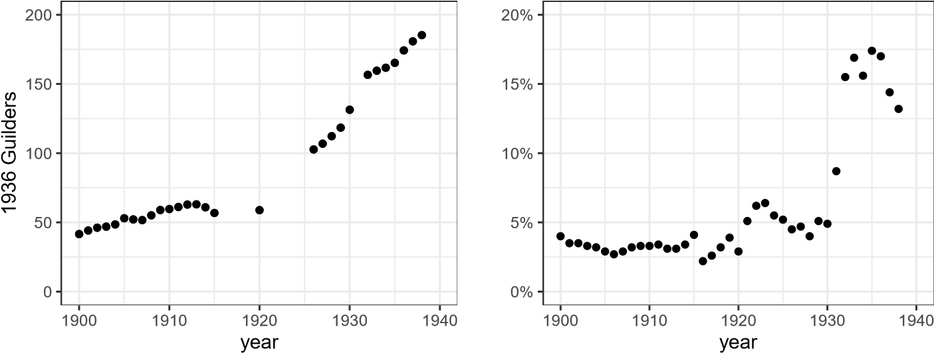

Source: Source: Real Wages: DeZwart et al. 2015; Primary Expenses: Sociaal Democratische Studie-Club 1912: 13, 15; Koninklijke Nederlandsche Landbouwvereeniging 1913; Directie van den Arbeid 1919; Statistische mededelingen, p. 40; Uitgaven 1923, pp. 99-101; Statistische mededelingen, p. 29, 32; Den Haag 1927, p. 3-4; Onderzoek naar Den Haag 1927 (27 hh), p. 30-31; Uitkomsten, p. vi; Onderzoek 1928, p. 3, 25; Statistische mededelingen nr 96; 598 huishoudens; Onderzoek (1940), pp. 8-9, 12; Household Savings: CBS Jaarcijfers van Nederland 1900: 91; 1910: 115; 1930: 135; 1916: 137; 1920: 127; 1927: 125; 1939: 155; 1948: 328. + ; Population gures from CBS, Population; Unemployment: (den Bakker, 2019, pp. 347-350)

The empirical challenge is clear. We know in general terms what kind of arrangements were available to households to deal with the crisis but we do not know to what extent Dutch households or, for that matter, those of other countries, relied on nancial and government support or rather went at it alone, for instance by cutting back consumption, seeking by-employment, or increasing home production. We also want to know to what extent households turned to their social network for assistance, whether their inner circle of relatives, neighbours and friends, or a wider circle of local shopkeepers, landlords, and employers.

To nd out how di erent groups of people in The Netherlands coped nancially during the Great Depression we analyse contemporary household level data on income and expenditure. In 1935 and 1936 the national bureau of statistics (Statistics Netherlands, henceforth CBS) carried out a survey among 598 households to measure their living standards.[4] The sample did not include households from the four biggest cities Amsterdam, Rotterdam, The Hague, and Utrecht because local surveys of living conditions were already available in three of them, including several smaller surveys of households whose breadwinner was unemployed. We compare the ndings on the 598 households with these local surveys and with data from a second, national survey commissioned by the Ministry of Social A airs and carried out in 1937 among 700 households whose breadwinner had been unemployed for at least six months in the preceding 2 years.

The remainder of this paper is organized as follows. In Section 2 we develop our analytic framework. Sections 3 and 4 introduce the sources and presents summary statistics for the households surveyed between 1932 and 1936. Section 5 measures household nancial vulnerability for the 598 households and assesses its determinants. Section 6 analyzes the di erent coping mechanisms used by nancially fragile households. Section 7 compares these ndings with the coping strategies of 700 unemployed households in 1937. Section 8 discusses our ndings and concludes.

# 2 Coping Mechanisms

To analyze how households cope with nancial insecurity we build on insights from modern household nance, development economics and social history. From this literature it is clear that the nancial decision making of households is about two things: the everyday management of income and expenditure and nancial planning for the future. For people with low, irregular incomes cash ow management is key (Hufton, 1976; Dercon, 2002; Collins et al., 2010; Banerjee and Du o, 2011; Morduch and Schneider, 2017). Making ends meet requires a constant adjustment of income to expenditure, reducing or postponing consumption, working additional jobs, taking out loans, and drawing upon whatever savings or insurance policies there may be. Households with higher and more stable incomes may be less concerned about their primary expenses but they will have to decide how much money they want to save, whether they want to borrow in anticipation of future income, or take out insurance to cope with unexpected costs or loss of income (Morduch and Schneider, 2017; Morduch, 1995).

In theory, households can choose to organize their nances all by themselves, making cash payments only and hoarding whatever surpluses they have to deal with unexpected future expenses. In practice, however, people often rely on others to organize at least part of their payments, loans, savings, and insurance. In OECD countries these services are mostly provided by either nancial intermediaries or the government but there is a very important third channel: the nancial dealings people have with relatives, neighbors, shopkeepers, employers, church communities, or private charities (Figure 2).

Figure 2: Schematic overview of the way in which households organize their nances

The form and function of each of these arrangements di ered between countries. Take, for instance, the organization of social security. In England poor relief was organized at the local level (Boyer, 2019); in Prussia the central state o ered a national pension scheme (Lehmann-Hasemeyer and Streb, 2018); in France, Belgium, and The Netherlands social welfare was left in the hands of employers, trade unions, and the church (van Gerwen and van Leeuwen, 2000; Wals et al., 2001; Dutton, 2002). When the Great Depression hit, national governments everywhere stepped up their support for households in distress, but important di erences remained. The New Deal in the US amounted to a greatly expanded federal e ort to support people nancially, employ, and educate them (Baicker and Katz, 1998; Fishback and Wallis, 2013); in Australia separate states and the federal government became involved (Fishback, 2012); in Canada and Europe most relief and work programs were grafted on existing social structures (Nijhof and Schrage, 1984; MacKinnon, 1990; Dutton, 2002; Boyer, 2019).

The supply of nancial services to households also di ered between countries. In the US, for instance, commercial nance was already important at an early stage.(Prasad, 2012; Fishback, 2020) In the late nineteenth century blue collar workers turned in large numbers towards private insurance companies for nancial support in case of illness, disability, and death, while salaried employees took out payday loans to smooth consumption (Easterly, 2009; Levy, 2012). In the 1920s this nancialization intensi ed when broad shifts of society starting buying consumer goods on credit (Olney, 1999; Hyman, 2012; Calder, 1999). Then, when Wall Street crashed in 1929 and many people lost their jobs in subsequent years, numerous households defaulted on their loans and commercial credit dried up (Mishkin, 1978; Romer, 1990; Olney, 1999; G rtner et al., 2013). At that point the US government stepped in with a system of loan guarantees to stimulate commercial banks to keep lending, while many households chose to deposit their money with the US Postal Savings Bank.(Hyman, 2012; Schuster et al., 2020)

Financial sector use was di erent in Europe (Eichengreen and Mitchener, 2004). New forms of consumer credit did appear in the second half of the nineteenth century but most governments took active steps to shield poor households from over-indebtedness. They kept the centuries old system of closely monitored public and private pawn shops in place, and everywhere savings banks were created by either philanthropic associations, rural cooperatives, or the national postal services (Dankers et al., 2001; Lehmann-Hasemeyer and Streb, 2018; Colvin, 2017). There was room in Europe for commercial companies to sell funeral and life insurance to households, but burial costs in particular were often insured by mutual societies (Van Leeuwen, 2016; Berg, 2018). Indeed, the grafting of nancial services on social networks was a dominant feature in European household nance before World War II (Guinnane, 2001; O’Connell, 2009; Deneweth et al., 2014).

We know much less about households’ use of social networks proper. There is ample evidence that local shopkeepers allowed customers to pay their bills only once a week or month, but whether this type of credit became more or less common during the crisis is unknown (Gelderblom et al., 2021). The same is true for rent payments. Under normal circumstances landlords were willing to accept some arrears, but historians have found evidence that during the Depression poor households kept moving from one place to the next to escape rent payments (Kok, 1999; Kok et al., 2005; Fishback et al., 2006; Potts et al., 2006). Indeed, the Depression may have accelerated the breakdown of social networks that accompanied industrialization. In the US looking for jobs elsewhere limited people’s ability to receive help from family and friends.(Fishback et al., 2006; Boustan et al., 2010). On the other hand, in Canada and England nancial support from relatives was often the only means to survive because poor relief was means tested.(MacKinnon, 1990; Boyer, 2019). This raises the question to what extent households in nancial distress were thrown upon themselves?

3 The First Crisis Surveys

June 2021: To be completed

# 4 Surveying the Budgets of 598 Households

When the Dutch government, after a lot of backwards and forwards about costs, nally commissioned CBS to document the living standards of Dutch households in April 1935, the bureau was fully prepared for the task (Centraal Bureau voor de Statistiek, 1937, 4-5). In previous decades CBS itself and local bureaus in Amsterdam and The Hague had already carried out several budget studies through surveys very similar to those used in modern-day research on ‘portfolios of the poor’ (Collins et al., 2010). The bureau engaged domestic schools, women’s associations, and labor unions to recruit households of blue and white collar workers that were either still working or had been without a job for less than 26 weeks. The households had to keep track of all incoming and outgoing cash ows during one year and received 10 guilders in exchange an amount equal to the weekly allowance of a poor household (Verwey-Jonker, 1942).

Figure 3: Geographical distribution 598 households

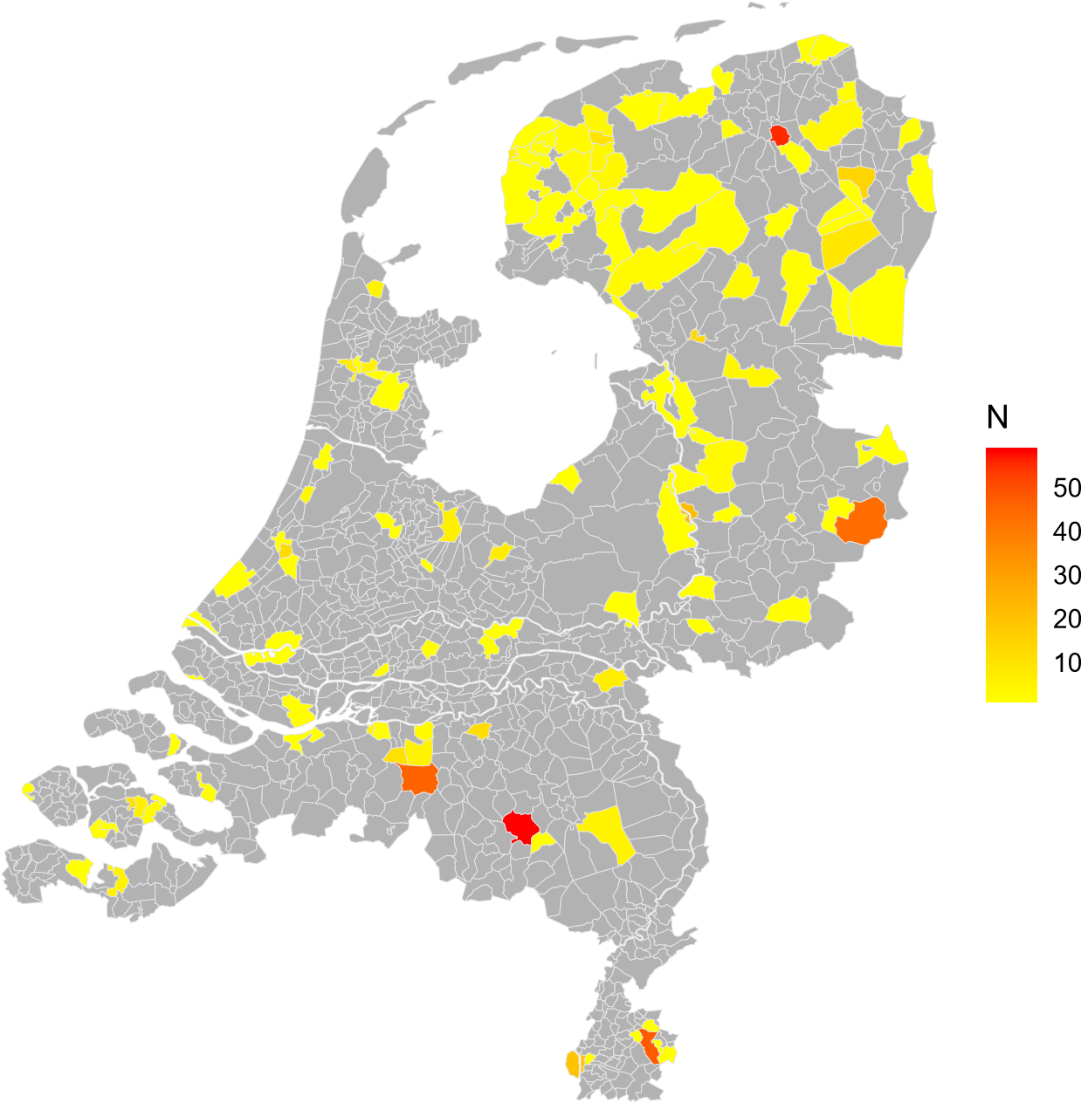

Note: GIS le from Boonstra (2007).

CBS attempted to obtain a representative overview of the costs of living for Dutch households but it did not include the country’s largest cities, because Amsterdam and The Hague were already carrying out their own budget surveys.(Bureau van Statistiek der Gemeente Amsterdam, 1937, 1938; Statistisch bureau der gemeente ’s-Gravenhage, 1940) The omission of the larger cities is Table 1: Income distributions compared

|  |  |  |  |  |
| --- | --- | --- | --- | --- |
| range | NL |  | Survey 598 CBS | |
| N | share | N | share |
| 800-1,400 | 595,384 | 0.46 | 154 | 0.31 |
| 1,400-2,000 | 349,502 | 0.27 | 162 | 0.32 |
| 2,000-3,000 | 180,867 | 0.14 | 101 | 0.20 |
| 3,000-5,000 | 97,444 | 0.08 | 55 | 0.11 |
| 5,000-10,000 | 43,846 | 0.03 | 22 | 0.04 |
| 10,000-20,000 | 12,492 | 0.01 | 6 | 0.01 |
| 20,000-30,000 | 2,730 | 0.00 | 0 | 0.00 |
| 30,000-100,000 | 2,084 | 0.00 | 0 | 0.00 |
| *>*100,000 | 207 | 0.00 | 0 | 0.00 |

Note: this table displays the income distribution of households in the entirity of the Netherlands (NL) based on income taxation records and the survey among 598 households. Note that no information is available for households with an income below 800 guilders.

clearly visible in gure 3, which displays the geographical distribution of the 598 household of the survey across the Netherlands: the densely populated west is relatively under-represented in the sample. Several medium-sized cities do feature the survey, however, with 42 percent of the households living in (the municipalities of) Groningen, Eindhoven, Heerlen, Tilburg, and Enschede.

Another intentional limitation of the survey was the exclusion of single household heads. In the Netherlands as a whole some 15 percent of all households had a single household head whereas this is only 2 percent in the survey. A similar picture is observed when considering the age distribution, where the elderly are clearly underrepresented (1 vs. 9 percent; CBS, jaarcijfers voor Nederland 1938). Because single households and the elderly are likely to be particularly vulnerable to nancial setbacks our estimates of nancial fragility are likely an underestimation.

To further gauge of the representativeness of the CBS survey we can compare the distribution of income to national gures derived from tax records. Table 1 reports the income distribution among the 598 households surveyed and the national income distribution. Middle income groups are slightly overrepresented in the sample, while lower income groups are clearly underrepresented, with 31 per cent against 46 per cent for the Netherlands as a whole.

This then raises the question how well those with an income below 800 guilders are represented in the sample and if we indeed have households that live close to the subsistence level. We know from contemporary work by VerweyJonker (1942) on the city of Eindhoven in the 1930s, that some 10 percent of all households earned an income below 800 guilders (including government support). This compares to 98 households, or 16 percent, in our sample. In Table 2: Household characteristics

|  |  |  |  |  |  |  |
| --- | --- | --- | --- | --- | --- | --- |
| Statistic Mean St. Dev. Min Pctl(25) Pctl(75) Max | | | | | | |
| Av. age | 38.242 | 8.577 | 22 | 32 | 43 | 79 |
| HH size | 4.864 | 2.122 | 2 | 3 | 6 | 15 |
| HC1 (d) | 0.074 | 0.262 | 0 | 0 | 0 | 1 |
| HC2 (d) | 0.291 | 0.455 | 0 | 0 | 1 | 1 |
| HC3 (d) | 0.308 | 0.462 | 0 | 0 | 1 | 1 |
| HC4 (d) | 0.121 | 0.326 | 0 | 0 | 0 | 1 |
| HC5 (d) | 0.193 | 0.395 | 0 | 0 | 0 | 1 |

Note: HC1 denotes elite, HC2 lower managers and professional, HC3 medium and lowers skilled workers, HC4 farmers and shermen, and HC5 unskilled workers. (d) denotes that the variable is a dummy.

all likelihood the gures for Eindhoven are probably a bit better than for the Netherlands as a whole because the city, home to the Philips company, was relatively prosperous at the time.

A nal limitation of the CBS survey is the deliberate exclusion of households whose breadwinner had been unemployed for more than 26 weeks in the preceding two years. This decision created a sample in which 66 households faced (partial) unemployment, with an additional 13 households whose breadwinner was employed in a public work programme. The average duration of unemployment in the sample is 23 weeks, which is considerably lower than the average duration of 23 months reported by Verwey-Jonker (1942) for Eindhoven in early 1939.[5] As long-term unemployment made up close to half of the population of the unemployed in Eindhoven, it is clear that the survey of 598 households gives only limited insight into the nancial coping mechanisms of the unemployed. On the other hand, a subsequent national survey of living standards among 700 unemployed households in 1937 revealed that their average annual income, including social bene ts stood at 874 guilders. In the CBS sample one out of ten households earned less than 800 guilders per year, so it does capture the nancial situation of the country’s poorest households. (cf. section 8).

The fact that broad groups in society are well-represented is also evident when recoding the various occupations into the Historical International Standard Classi cation of Occupations (HISCO) scheme (Mandemakers et al., 2018; Van Leeuwen et al., 2002). The classes run from higher managers and professionals (HC1), lower managers, professionals, clerical and sales personnel and foremen (HC2), medium and lower skilled workers (HC3), farmers and shermen (HC4) to unskilled workers (HC5).[6] Overall, it appears a wide variety of groups is represented in the sample.

# 5 The Financial Situation of the 598 Households

CBS modelled its new survey after previous budget studies but it added several elements to probe deeper into the nancial situation of Dutch households. In addition to standard questions about income and expenditure on food, rent, clothing, and other consumer goods, the bureau asked about home production, rent received from lodgers, the use of savings and loans, various types of insurance they paid for, and the support they received from within their social networks. Table 3 reports the main ow variables reported, income, consumption, savings and credit, as well as their composition.

Average income in our sample amounts to just over 2,200 guilders, although there is sizeable variation (cf. table 1). The largest share is captured by net income, which is a residual category that consists of wages and salaries earned plus money received through social networks and welfare arrangements. The social bene ts included compensation received by heads of household enrolled in one of the local or national employment programs.

In early 1938, for example, 2,874 of the 4,432 registered (partially) unemployed in Eindhoven received bene ts (Verwey-Jonker, 1942). The level of bene ts depended on location and varied between 7,50 and 12 guilders per week for a married couple and every family member added an additional 0,50 to 1,35 guilder per week. For a married couple with 3 children, which is the average household in our sample, unemployment bene ts thus ranged between 468 and 834 guilders a year (Commissie tot onderzoek van den gezondheids- en voedingstoestand der werkloozen, 1940).

Next to net income, the survey allows us to distinguish between ve further income categories. Income in kind refers to the proceeds of employment in goods, whereas the second category, support in kind, re ects both gifts from the social network and support in kind o ered by the state.4 The size of this support was relatively limited, however, as is also re ected in the analysis of income sources of the unemployed in section 8.

The third category, net implicit rent, captures the (implicit) bene ts the household captures by living in their house which is based on the rental value derived from the price of the house, minus any related costs including mortgage interest payments (or rent), taxes, insurance and maintenance. Mortgage capital repayments are part of credit ows (see below). Home production and rent paid by lodgers make up the nal two income categories. Note that there are no households that run an inn as their primary occupation.

Beyond these income sources, CBS documented household consumption, which can be summarized in ve main categories: food, shelter, clothing, leisure, and other.5 The summary statistics reported in Table 3 show that for the 598

possible to attribute them to a particular occupational class.

4Gifts from the social network were registered as support in kind only if the household considered itself in grave need of such support. Support in kind from the state often consisted of access to food and fuel against reduced prices (Commissie tot onderzoek van den gezondheidsen voedingstoestand der werkloozen, 1940). The di erence between the market value and the reduced price is added to support in kind.

5The food category include bread, beans, rice and ower, potatoes, vegetables, fruit, drinks, sugar, tea, co ee, chocolate, jam, spices, vegetable fat and oil, animal fat and oil, meat,

Table 3: Domestic accounts

|  |  |  |  |  |  |  |
| --- | --- | --- | --- | --- | --- | --- |
| Statistic Mean St. Dev. Min Pctl(25) Pctl(75) Max | | | | | | |
| Income | 2,216 | 1,797 | 712 | 1,270 | 2,387 | 19,553 |
| Net income | 1,942 | 1,878 | 2 | 1,010 | 2,197 | 19,553 |
| Inc. (kind) | 16 | 52 | 0 | 0 | 0 | 700 |
| Sup. (kind) | 7 | 19 | 0 | 0 | 0 | 160 |
| Impl. rent | 33 | 83 | 0 | 0 | 0 | 653 |
| Home prod. | 209 | 594 | 0 | 0 | 20 | 3,514 |
| Lodgers | 10 | 93 | 0 | 0 | 0 | 1,554 |
| Consumption | 2,176 | 1,620 | 739 | 1,281 | 2,402 | 19,835 |
| Food | 640 | 211 | 277 | 493 | 742 | 1,651 |
| Shelter | 512 | 294 | 125 | 334 | 598 | 2,704 |
| Clothing | 201 | 152 | 7 | 108 | 259 | 1,548 |
| Leisure | 104 | 140 | 0 | 35 | 111 | 1,676 |
| Other | 719 | 994 | 30 | 234 | 768 | 12,256 |
| Savings (net) | 52 | 519 | −2,213 | −47 | 59 | 6,164 |
| Credit (net) | −11 | 204 | −2,454 | −19 | 9 | 1,409 |

Note:

households as a whole, total consumption falls just short of total income. Food, shelter, and clothing make up 62 per cent of all expenses, with the remainder spent on a variety of items including leisure travel, gifts, taxes, insurance and contributions to the church, political parties, and other organizations.

The CBS survey of 1935 and 1936 stands out among earlier Dutch budget studies for the very detailed information on income sources and consumption patterns but also the description of nancial strategies. The savings reported in Table 1 capture net ows into a savings account whereas credit captures repaying credit. These data show that, during the survey period , households built up savings worth 52 guilders and take up credit worth 11 guilders. The di erence between income and consumption (40) matches the increase savings (52) minus the repayment of credit (11) except for a rounding error (1). The distribution of both credit and savings is heavily centred around 0, although all

sh, milk, cheese, eggs and bar visits. Shelter include rent, water, maintenance of the home, furniture, gas, electricity and fuels and cleaning. Clothing includes clothing and shoes. Leisure includes relaxation and smoking. Other includes expenses on domestic aid, plants and animals, physical care, healthcare, development, church, political organisations, travel, insurance, gifts, taxes and a residual category.

Table 4: Household wealth

|  |  |  |  |  |  |  |
| --- | --- | --- | --- | --- | --- | --- |
| Statistic Mean St. Dev. Min Pctl(25) Pctl(75) Max | | | | | | |
| Housing wealth | 2.34 | 4.72 | 0 | 0 | 3.0 | 30 |
| Land wealth | 6.34 | 20.20 | 0.00 | 0.00 | 0.10 | 168.70 |
| LI wealth | 0.83 | 1.01 | 0.00 | 0.22 | 1.16 | 11.18 |
| Pension wealth | 0.98 | 1.41 | 0.00 | 0.04 | 1.44 | 12.59 |

Note: this table displays various forms of household wealth in thousands of guilders. See the text for details on the calculation.

except for 23 (105) in the sample make use of savings (credit).

The CBS survey also documented payments of housing rent and insurance premiums and it included the amount of land owned. We can use data to infer the various types wealth owned by the 598 households. We consider the cash ows associated with housing and wealth as a perpetuity, and the cash ows associated with insurance products to run until the age of 60. We consequently calculate the net present value.[7]

Table 4 displays summary statistics for household wealth (measured in 1,000s). Housing wealth takes an average of just over 2,300 guilders. If we only look at home-owners (N = 158), the average stands at 8,851 guilders, which is roughly four times average yearly income (see table 3).[8] Land wealth takes the value of 6,581 guilders on average across all households, but close to 14,000 for those that own land (N = 282).

Life-insurance (LI) and funeral wealth stands at just over 830 guilders on average, where the gure for pension and old-age wealth is close to 1,000 guilders. All but 72 households have some form of insurance wealth reported.

# 6 Measuring Financial fragility

We can use the CBS survey of 598 households to calculate their nancial margin: the di erence between income and consumption that captures their ability to build up savings. A negative nancial margin is unsustainable in the long run (see Vatne, 2006; Johansson and Persson, 2006; Zaj¡czkowski and ochowski, 2006; Holl and Papp, 2007). Here we de ne nancial margin as the di erence between net income and expenses on food, shelter and clothing, that is the money that was left after consumption of life’s necessities. In our view this o ers a more adequate representation of a household’s nancial breathing room. We disregard alternative measures of nancial fragility such as the savings quote and the debt-service to income ratio because these potentially capture both Table 5: Financial margin

|  |  |  |  |  |  |  |
| --- | --- | --- | --- | --- | --- | --- |
| Statistic Mean St. Dev. Min Pctl(25) Pctl(75) Max | | | | | | |
| fm | 589 | 1,455 | −2,121 | 116 | 734 | 13,649 |

Note: this table provides summary statistics for the nancial margin (fm), which is net income minus expenses on food, shelter and clothing.

nancial fragility as well as coping mechanisms.[9]

Table 5 displays summary statistics for our measure of nancial fragility. The nancial margin after consumption of life-necessities is positive on average at just over 589 guilders. The variation is large, however, with the 25th and 75th percentile at 116 and 734 respectively. To add further perspective, the data collected in the separate studies for labourers’ families in Amsterdam and The Hague yield average nancial margins of 615 and 633 guilders respectively.[10]

To assess the determinants of household nancial fragility we run a series of regressions in the current section. We not only consider a series of socioeconomic characteristics of the household, but also exploit a series of household speci c conditions: death of a family member, the arrival of a newborn, healthcare expenses and unemployment. Table 6 displays the summary statistics.

As discussed in the previous section, some 12 percent of all households in the sampled faced unemployment in 1935 or 1936, for an average duration of 23 weeks (2*.*86 weeks*/.*12). Death of a family member was rare at 1 percent of all families experiencing this event, whereas 13 percent of all households saw a new family member being born. This is in line with the observation that families dominate the sample and the elderly are underrepresented. Healthcare expenditure as a percentage of net income plus home production functions as a proxy for illness, which appears particularly relevant in the absence of public health insurance. (Bertens, 2021, pp. 79-80).[11] On average, households spend 3 percent of their net income on healthcare expenses although there is a small number of more extreme values. Table 7 displays the regression results with robust standard errors.

Table 6: Household conditions

|  |  |  |  |  |  |  |
| --- | --- | --- | --- | --- | --- | --- |
| Statistic Mean St. Dev. Min Pctl(25) Pctl(75) Max | | | | | | |
| Unemployed (d) | 0.12 | 0.33 | 0 | 0 | 0 | 1 |
| Unemployed | 2.86 | 9.79 | 0 | 0 | 0 | 52 |
| Death (d) | 0.01 | 0.10 | 0 | 0 | 0 | 1 |
| Newborn (d) | 0.13 | 0.33 | 0 | 0 | 0 | 1 |
| healthcare | 0.03 | 0.03 | 0.00 | 0.02 | 0.04 | 0.46 |

Note:

In model (1) we rst include a range of household characteristics to explain the variation in the nancial margin. We nd a positive relationship with the average age of the household head(s), which may relate to higher income or wealth over the life-time, where the negative coe cient on household size seems to re ect the extra money spent on feeding and clothing children growing up.

The Hisclass variables are both economically and statistically signi cant and indicate that in particular farmers (HC4) were likely to display a lower nancial margin. The di erence between the three lower socio-economic groups (HC35) largely disappears, however, when we account for home production in our measure of nancial fragility (see table 11 in the appendix). The coe cients for medium and lower skilled workers (HC3) and unskilled workers (HC5) appear highly similar, while lower managers and professional (HC2) are relatively better o . The gap with the elite (HC1), however, is considerable for all other classes.

In model (2) we add location dummies for municipalities that are 1) more densely occupied and 2) industrial in nature, as opposed to more rural areas, the reference category. Here we nd a small positive e ect for the municipalities that contain the larger towns, which points at a higher overall level of income and wealth.

Indeed, the positive and marginally signi cant e ect of larger municipalities disappears as soon as we include measures of wealth in model (3). Similarly, the e ect of the Hisclass dummies halves across the board upon the inclusion of our wealth variables, pointing at signi cant variation within these Hisclass groups conditional on wealth. Housing wealth shows a positive and signi cant e ect on the nancial margin, which indicates reduced housing costs because of (partial) ownership of a premise and greater nancial resilience as a consequence. The e ect of land wealth, on the other hand, is negative, which may partially capture the illiquidity of the asset as well as the fact that many small farmers relied on their own plot of land to survive (Centraal Bureau voor de Statistiek, 1937). Life-insurance wealth does show a large and signi cant e ect and corresponds to an insurance against a large and unanticipated household-level shock making the household more resilient. Conversely, pension wealth allows households to smooth consumption in the long run but does absorb liquidity in the short-run which may make these households relatively more vulnerable.

|  |  |  |  |  |
| --- | --- | --- | --- | --- |
|  | (1) | (2) | (3) | (4) |
| Av. Age | 17*.*97∗ | 18*.*92∗ | 31*.*69∗∗∗ | 28*.*29∗∗∗ |
|  | (9*.*87) | (9*.*76) | (8*.*58) | (8*.*49) |
| HH size | −62*.*71∗∗ | −66*.*66∗∗ | −85*.*15∗∗∗ | −90*.*45∗∗∗ |
|  | (31*.*24) | (30*.*64) | (29*.*86) | (31*.*17) |
| HC2 (d) | −1*,*764*.*41∗∗∗ | −1*,*757*.*08∗∗∗ | −880*.*27∗∗∗ | −875*.*31∗∗∗ |
|  | (352*.*83) | (351*.*16) | (269*.*78) | (264*.*29) |
| HC3 (d) | −2*,*674*.*91∗∗∗ | −2*,*714*.*79∗∗∗ | −1*,*549*.*87∗∗∗ | −1*,*559*.*35∗∗∗ |
|  | (337*.*75) | (344*.*70) | (274*.*91) | (274*.*53) |
| HC4 (d) | −4*,*171*.*22∗∗∗ | −3*,*986*.*20∗∗∗ | −1*,*987*.*22∗∗∗ | −2*,*013*.*65∗∗∗ |
|  | (363*.*13) | (407*.*66) | (642*.*72) | (639*.*24) |
| HC5 (d) | −2*,*828*.*71∗∗∗ | −2*,*721*.*71∗∗∗ | −1*,*489*.*00∗∗∗ | −1*,*486*.*34∗∗∗ |
|  | (341*.*14) | (357*.*41) | (327*.*38) | (329*.*65) |
| Large (d) |  | 404*.*54∗ | 138*.*10 | 131*.*31 |
|  |  | (206*.*38) | (168*.*11) | (165*.*86) |
| Industrial (d) |  | 90*.*30 | 83*.*43 | 81*.*07 |
|  |  | (173*.*78) | (160*.*02) | (160*.*98) |
| Housing wealth |  |  | 39*.*01∗∗ | 39*.*34∗∗ |
|  |  |  | (16*.*33) | (15*.*68) |
| Land wealth |  |  | −11*.*99∗∗ | −12*.*04∗∗ |
|  |  |  | (5*.*89) | (5*.*85) |
| LI wealth |  |  | 1*,*278*.*50∗∗∗ | 1*,*359*.*10∗∗∗ |
|  |  |  | (427*.*53) | (432*.*09) |
| Pension wealth |  |  | −445*.*14∗∗ | −518*.*74∗∗ |
|  |  |  | (225*.*67) | (232*.*76) |
| death (d) |  |  |  | 510*.*30  (310*.*95) |
| Newborn (d) |  |  |  | −224*.*09 (138*.*39) |
| Healthcare (d) |  |  |  | −292*.*17∗∗∗  (87*.*39) |
| Unemployment |  |  |  | −3*.*99 (3*.*32) |
| Constant | 2*,*621*.*09∗∗∗ | 2*,*392*.*50∗∗∗ | 383*.*13 | 691*.*22 |
|  | (449*.*37) | (524*.*34) | (577*.*45) | (561*.*54) |

Table 7: Determinants of household nancial fragility

As a nal step we add a series of household conditions in model (4). We de ne a health shock dummy that takes the value of one in case our healthcare variable from table 6 is part of the top tercile and zero otherwise. We nd a relatively large and positive e ect for the death dummy, which may result from reduced consumption need while income is likely to remain fairly constant if the person was old. Note, however, that the coe cient is only marginally signi cant (p = 0.097). The arrival of a newborn has no e ect. We do nd a sizeable e ect negative e ect for a healthcare shock which may be due to both increased (healthcare) expenditure and reduced income due to an inability to work. The (continuous) unemployment variable does not render any signi cant e ect which may be due to the relative under-representation of those that face long-term unemployment (cf. section 4). In other words, these households appear capable of withstanding a temporary reduction in their income. What strategies these households employed to do so is the subject of the next section.

# 7 Coping with the Crisis

We can use the CBS data to measure the relative importance of several coping strategies. We can observe self-reliance through home production, room and board o ered to lodgers, and reduced consumption of the basic necessities food, shelter and clothing. Note that we disregard obtaining additional income as a coping measure given the high level of unemployment at the time which likely made nding a job extremely di cult (Knotter, 1999, pp. 215, 220-1). Aid from social networks is captured by support in kind, although the surveyors also subsumed food and fuel provided by the government under this heading.[12]Financial services provided by third parties is captured by households’ use of savings and credit.

Table 8 displays the use of these coping mechanisms by contrasting the various nancial ows that households used to nance consumption in the top ( = 0) and bottom ( = 1) tercile of the nancial margin. Following the original set-up of the survey, we break up savings and credit into out ows which build up wealth and in ows which nance consumption. All nancial ows are expressed as a percentage of total consumption and add up to one (except for a rounding error). The t- and p-values in the third and fourth column correspond to the null hypothesis that the consumption shares are equal for both groups.

Net income nances a much smaller share of consumption for those that are fragile, who instead rely to a much greater extent on home production. Here a farmer’s e ect seems to play a role in our measure of nancial fragility because including home production in our measure of income negates this di erence between fragile and non-fragile groups (see table 12 in the appendix). Support in kind was not very important for these households. While the di erence in the value of food and fuel received by the fragile and non-fragile group was statistically signi cant, its actual share in overall consumption was tiny. All of the other categories display relatively small di erences with the exception of savings, where we observe non-fragile households not only build up more savings (out ow), but also use less savings to nance consumption (in ow).

Table 8: Cash ows to nance consumption

|  |  |  |  |  |
| --- | --- | --- | --- | --- |
|  | = 0 | = 1 | t | p |
| Net income | 1.03 | 0.58 | 14.86 | 0.00 |
| Income in kind | 0.01 | 0.01 | -0.80 | 0.42 |
| Support in kind | 0.00 | 0.01 | -8.01 | 0.00 |
| Impl. rent (net) | 0.01 | 0.02 | -2.56 | 0.01 |
| Home prod. | 0.00 | 0.33 | -10.41 | 0.00 |
| Lodgers | 0.00 | 0.00 | 0.26 | 0.79 |
| Savings (out) | -0.08 | -0.03 | -3.12 | 0.00 |
| Savings (in) | 0.02 | 0.06 | -4.82 | 0.00 |
| Credit (out) | -0.02 | -0.01 | -1.76 | 0.08 |
| Credit (in) | 0.02 | 0.02 | -0.75 | 0.45 |

Note: this table compares how fragile ( = 1) and non-fragile households ( = 0) employ di erent cash ows to nance total consumption. An in ow of consumption or credit is used to nance consumption, an out ow builds up wealth. t denotes t-value and p denotes p-value of a regular t-test.

The di erences between both groups for repaying credit (out ow) and taking up credit (in ow) are relatively minor.[13]

Turning to the composition of consumption in table 9, we observe that food consumption in particular amounts to a much larger share of total consumption for fragile households, while leisure, but in particular the residual category, take up a large share for the non-fragile. This is consistent with the strong rise in real wages in the previous decade which may have allowed fragile households in the mid-1930s to scale back non-essential consumption to overcome the crisis although we cannot be sure because we only make observations in the

cross-section.[14]

Table 9: Consumption shares for fragile and non-fragile households

|  |  |  |  |  |
| --- | --- | --- | --- | --- |
|  | = 0 | = 1 | t | p |
| Food | 0.239 | 0.439 | -22.00 | 0.000 |
| Shelter | 0.237 | 0.247 | -1.63 | 0.103 |
| Clothing | 0.092 | 0.091 | 0.13 | 0.896 |
| Leisure | 0.053 | 0.031 | 8.59 | 0.000 |
| Other | 0.378 | 0.192 | 18.55 | 0.000 |

Note: this table displays a comparison of consumption shares for fragile ( = 1) and non-fragile households ( = 0). t denotes t-value and p p-value of a regular t-test.

# 8 The unemployed

Our analysis thus far suggests that Dutch households in the 1930s were wellequipped to deal with temporary income shocks through savings and homeproduction. This might come as a surprise given the severity of the crisis and, more particularly, the very high unemployment rate. It is important to note, however, that unemployment estimates concern the population at large. At the household level things looked di erent for two reasons. On the one hand, den Bakker (2019, 430) estimated that in 1938 only 69 per cent of the unemployed were breadwinners the remainder did not have that responsibility, among them many youngsters (de Rooij, 1979; Graaf, 1987). On the other hand, we know, both from the CBS sample of 598 households and from scattered references in the literature that there was a lot of partial unemployment. For instance, in Utrecht in 1937, only 45 per cent of the unemployed men had been without a job for more than a year (Nijhof and Schrage, 1984, 17). Agricultural labourers often found seasonal work in summer (Hendrikx and Gelderblom, 2021). In other words, the general unemployment gure of 20 per cent probably makes the crisis look worse than it was.

That said, workers who were unemployed for six months, a year, or longer faced very di cult nancial circumstances. Already in 1932 the city of The Hague surveyed the income and expenditure of ninety families of unemployed trade union members who lived on the dole (Onderzoek 1934). The next year Amsterdam’s statistical bureau carried out two budget surveys, one among 184 families of workers and civil servants; the other among 78 unemployed households (Statistische Maandberichten 1936; Bureau van Statistiek 1937). The Hague then put out a second survey in 1935 among 130 trade union members, non-a liated workers, and other poor households asking about their nances and health (Tweede onderzoek, 1937), and in that same year Utrecht asked 84 assisted families about their health, nutrition, and expenditure (Voedingstoestand 1935).

The results were the same in every city. Whenever a male breadwinner lost his job and was unable to nd a new one, household earnings declined so much that social bene ts became indispensable to secure the family’s livelihood. Cutting back spending, working menial jobs, running down stocks, gifts from Figure 4: The 598 vs. the 700 unemployed

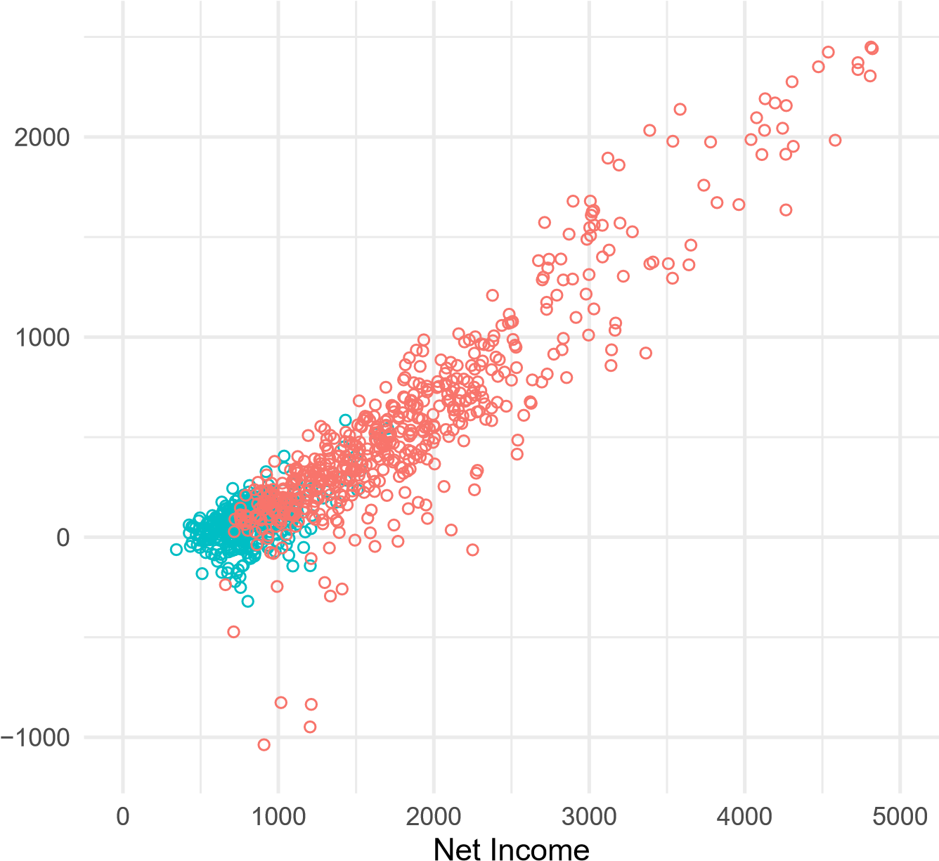

Financial margin

Data source 598 CBS 700 Unemployed

relatives, small loans none of these responses could make up for the loss of the man’s wage. What mattered were the bene ts received in cash and in kind: weekly payments of up to 12 guilders, supplemented by distributions of food and fuel. The numbers are very telling. In each of the four urban surveys the average income of unemployed households was below 1,100*** guilders, three quarters or more of which consisted of social bene ts. At less than 100 guilders, the average nancial margin of unemployed families in Amsterdam, The Hague, and Utrecht was very narrow.

Now that it was clear that social welfare was indispensable to sustain the livelihood of the long-term unemployed, and their families, in the country’s major cities, the government wanted to nd out whether the same was true in the rest of the country. In 1937 the Ministery of Social A airs commissioned a nationwide survey among 700 unemployed households i to investigate their health and nutritional intake (Commissie tot onderzoek van den gezondheidsen voedingstoestand der werkloozen, 1940).[15] The data collected is also of great use for the current investigation, however, because it contains a detailed breakdown of income and consumption, although the credit and savings categories are subsumed in the consumption categories. Savings and credit can be expected to be of relatively limited importance, however, because those that received unemployment bene ts did so on the precondition that they could not sustain themselves in another way.

The setup of the survey among the 700 unemployed is highly similar to that of the CBS study. The geographical spread is relatively large and municipalities of varying economic structure are represented. The largest cities are again disregarded, however, and family size is marginally above average. We know little of the occupation of individual households, although the survey argues it o ers a good representation of the overall economic structure of the Netherlands, including manufacturing and farming areas (Commissie tot onderzoek van den gezondheids- en voedingstoestand der werkloozen, 1940).

The selection of households occurred on three basic conditions. First, heads of household were required to be unemployed at some point during the past 2 years and at least for 6 months uninterrupted during the actual survey. In practice, this requirement proved too strict, especially for rural communities where households often managed to nd temporary farming work in the summer months. Temporary farming work paid particularly low wages that only marginally exceeded state support. Breaking this rst condition therefore does not detract from the hardship these households faced.[16] Second, the majority of income was to be derived from public insurance mechanisms, including public employment. Although limited alternative sources of income were allowed, the source thus provides a good indication of the standards of living of those relying on state support. Third, "decent" citizens were to be recruited for otherwise the quality of the data collected was expected to be poor.

Figure 4 displays a scatter plot of the nancial margin and net income for the CBS (red) and unemployed (green) dataset.[17] The data on the unemployed clearly add to our perspective on the lower end of the distribution of net income and the nancial margin.

Table 10 displays the income and consumption composition for the 700 unemployed in our sample, as well as the nancial margin. Considering total income, these households can clearly be placed at the bottom end of the income distribution (cf. gure 4 and table 3). The income composition is heavily geared towards public support programs at some 75 percent of total income on average. These households clearly relied on the social system for their most basic needs. Other income sources by the household head or other family members (HH income) only represent 151 guilders or 17 percent on average, which is in line with their unemployed status. As was the case for the CBS survey, gifts are largely unimportant, as is the case for the use of stocks that were amassed in the past.

In contrast to the CBS survey, total consumption exceeds total income on average (cf. table 3). The composition of consumption is more heavily geared Table 10: Domestic accounts 700 unemployed

|  |  |  |  |  |  |  |
| --- | --- | --- | --- | --- | --- | --- |
| Statistic Mean St. Dev. Min Pctl(25) Pctl(75) Max | | | | | | |
| Income | 874 | 217 | 445 | 734 | 972 | 1,893 |
| HH income | 151 | 207 | 0 | 0 | 250.4 | 1,382 |
| Social security | 654 | 184 | 116 | 535 | 777 | 1,226 |
| Gifts | 33 | 46 | 0 | 0.5 | 48.9 | 323 |
| Stocks | 36 | 47 | 0 | 2 | 56 | 262 |
| Consumption | 907 | 226 | 436 | 758.2 | 1,028 | 2,257 |
| Food | 450 | 140 | 171 | 350 | 536 | 868 |
| Housing | 245 | 73 | 46 | 191 | 294 | 523 |
| Clothing | 67 | 44 | 0 | 34 | 86 | 257 |
| Insurance | 60 | 31 | 0 | 38 | 78 | 172 |
| Other | 84 | 81 | 0 | 46 | 95 | 1,102 |
| Financial margin | 77 | 109 | −320 | 17 | 134 | 585 |

towards food compared to the CBS survey at close 50 percent of total consumption on average. Housing is the second largest consumption category at 27 percent of total consumption on average, which is close to the 23 percent of the CBS survey. The other consumption categories are relatively minor in scale which is consistent with the view that these households lived close to subsistence level.[18] This is very clear with respect to clothing and footwear: the unemployed spent 20 percent less than the 598 households, a trend picked up not just by welfare workers who started o ering sewing courses but also by the Socialist party, which organized the largest ever survey among 4,000 households in 1936, asking them about the quality and quantity of their clothing, bedding, and shoes.[19]The answers showed that the unemployed were not just cutting down on food but they were also wearing down their clothes and shoes.

Finally, the nancial margin is just over 142 on average, although substantial variation exists. The gure is higher than that in the major cities but still considerably lower than for the 598 households in the CBS survey. With social bene ts making up three quarters of the household income, it was abundantly clear that also outside the major cities cutting back spending and using up savings, working menial jobs, home production, gift giving, or any other traditional coping strategy was insu cient to cope with the crisis.

# 9 Conclusion

Five years into the Great Depression most Dutch households still managed to cope nancially. Their incomes were high enough to reduce consumption without immediately falling into poverty. Households also bene ted from previously created nancial bu ers, notably the money they had put in one of the country’s many savings banks. This nancial resilience was a structural feature of the Dutch economy, that is, a direct result of the rising labor productivity in previous decades. Exactly how important wage labor was to prevent nancial problems in the 1930s becomes clear when we compare households with and without earned income.

Among the 598 households surveyed by CBS in 1935 and 1936 some sixty households faced unemployment in the period studied. Importantly, their joblessness was temporary, with an average duration of only 23 weeks, which allowed them to pull through by spending less and mobilizing previous savings. This was very di erent for households whose breadwinner was unemployed for six months or more. A separate but equally detailed survey of their nancial behavior in the same period shows a very di erent reality. While most of them still earned some wages over the course of 1937 this income no longer su ced to pay for food, clothing, and shelter, and neither did the employment of other members of the household, home production, starting their own business, or gifts from others. These families only coped through a combination of government-sponsored work, social bene ts, and food- and fuel stamps.

The way Dutch households coped with the Great Depression shows the extent to which nancial institutions and welfare arrangements can reduce nancial vulnerability. For one thing, very few households carried signi cant debts, which meant less expenditure and more freedom to adapt their budgets. For another, in the years before the crisis, many households had used part of their excess earnings to build a nancial bu er. Besides this widespread preference of saving over borrowing, insurance was widespread among Dutch households. The premiums paid for various policies obviously added to their xed expenses, but they also o ered protection against the nancial consequences of private misfortune.

The history of Dutch households in the 1930s also shows that nancial solutions alone do not o er su cient protection in a prolonged economic crisis. Unemployment but also health problems will cause nancial di culties of such magnitude that social transfers are necessary to balance the budget of individual households. And while Dutch households continued to receive help from within their social networks, the historical evidence makes abundantly clear that only local and central governments were able to organize the redistribution of income necessary to cope with a deep economic crisis.

# References

Baicker, K. C. G. and Katz, L. F. (1998). The De ning Moment : The Great

Depression and the American Economy in the Twentieth Century, chapter A Distinctive System: Origins and Impact of U.S. Unemployment Compensation, pages 227 263. Chicago University Press.

Banerjee, A. V. and Du o, E. (2011). Poor economics: A radical rethinking of the way to ght global poverty. Public A airs.

Barten, A., Theil, H., and Leenders, C. (1962). Farmers’ budgets in a depression period. Econometrica: Journal of the Econometric Society, pages 548 564.

Berg, E. (2018). Funeral insurance: An inter-generational commitment device? Journal of African Economies, 27(3):321 346.

Berger, J. (1936). Van armenzorg tot werklozenzorg. NV de Arbeiderspers.

Bertens, R. M. (2021). Liberal Solidarity. Guaranteeing Access to Dutch Health

Care Under the Banner of Private Initiative, 1848-2015. PhD thesis, Utrecht university.

Boonstra, O. (2007). Nlgis shape les. DANS. retrieved from [https://doi. org/10.17026/dans-xb9-t677.](https://doi.org/10.17026/dans-xb9-t677)

Boustan, L. P., Fishback, P. V., and Kantor, S. (2010). The E ect of Internal Migration on Local Labor Markets:American Cities during the Great Depression. Journal of Labor Economics, 28(4):719 746.

Boyer, G. R. (2019). The Winding Road to the Welfare State: Economic Insecurity and Social Welfare Policy in Britain, volume 77. Princeton University Press.

Bureau van Statistiek der Gemeente Amsterdam (1937). Statistische Maandberichten over het jaar 1936, chapter De uitgaven van 184 gezinnen gedurende de periode 1 Maart 1934 28 Februari 1935. Amsterdam: J. Meulenho .

Bureau van Statistiek der Gemeente Amsterdam (1938). Statistische Maandberichten over het jaar 1937, chapter De stand der kosten van levensonderhoud bij arbeidersgezinnen en gezinnen van meergegoeden te Amsterdam in December 1937. Amsterdam: J. Meulenho 1938.

Calder, L. (1999). Financing the American dream: A cultural history of consumer credit. Princeton University Press.

Centraal Bureau voor de Statistiek (1937). Huishoudrekeningen van 598 gezinnen uit verschilende deelen van Nederland over de perioden 29 juni 1935 t/m 26 juni 1936 en 28 sept. 1935 t/m 25 sept. 1936 Deel I. Rijksuitgeverij disnt van de Nederlandsche staatscourant.

Centraal Bureau voor de Statistiek (1938). Huishoudrekeningen van 598 gezinnen uit verschilende deelen van Nederland over de perioden 29 juni 1935 t/m 26 juni 1936 en 28 sept. 1935 t/m 25 sept. 1936 Deel II. Rijksuitgeverij dienst van de Nederlandsche staatscourant.

Collins, D., Morduch, J., Rutherford, S., and Ruthven, O. (2010). Portfolios of the poor: how the world’s poor live on $2 a day. Princeton University Press.

Colvin, C. L. (2017). Banking on a religious divide: Accounting for the success of the netherlands’ rai eisen cooperatives in the crisis of the 1920s. The Journal of Economic History, 77(3):866 919.

Commissie tot onderzoek van den gezondheids- en voedingstoestand der werkloozen (1940). Voeding, gezondheid en nanciºele toestand van 700 werkloozen-gezinnen. Verspreid over geheel nederland. ’s-Gravenhage: Algemeene Landsdrukkerij.

Dankers, J. J., Linden, A. A. M., Vos, J. L. M., and Blaauboer, M. (2001). Spaarbanken in Nederland: ideeºn en organisatie, 1817-1990. Boom.

de Rooij, P. (1979). Werklozenzorg en werkloosheidsbestrijding, 1917-1940: landelijk en Amsterdams beleid. Amsterdam: Van Gennep.

den Bakker, G. and van Sorge, W. (1991). Het onbenut arbeidsvolume in het interbellum. Economisch-en Sociaal-Historisch Jaarboek, 54:2.

den Bakker, G. P. (2019). The Dutch interwar economy revisited: Reconstruction and analysis of the national accounts 1921-1939. PhD thesis, Utrecht

University.

Deneweth, H., Gelderblom, O., and Jonker, J. (2014). Micro nance and the decline of poverty: evidence from the nineteenth-century netherlands. Journal of economic development, 39(1):79 110.

Dercon, S. (2002). Income risk, coping strategies, and safety nets. The World Bank Research Observer, 17(2):141 166.

Dutton, P. V. (2002). Origins of the French welfare state: The struggle for social reform in France, 1914 1947. Cambridge University Press.

Easterly, M. (2009). Your job is your credit: creating a market for loans to salaried employees in new york city, 1885 1920. Enterprise & Society, 10(4):651 660.

Eichengreen, B. and Mitchener, K. J. (2004). The great depression as a credit boom gone wrong. Research in Economic History 22.

Fishback, P. (2017). How successful was the new deal? the microeconomic impact of new deal spending and lending policies in the 1930s. Journal of Economic Literature, 55(4):1435 85.

Fishback, P. V. (2012). Relief during the great depression in a ustralia and a merica. Australian Economic History Review, 52(3):221 249.

Fishback, P. V. (2020). Social insurance and public assistance in the twentiethcentury united states. The Journal of Economic History, 80(2):311 350.

Fishback, P. V., Horrace, W. C., and Kantor, S. (2006). The impact of new deal expenditures on mobility during the great depression. Economics - Faculty Scholarship. 16.

Fishback, P. V. and Wallis, J. J. (2013). The Great Depression of the 1930s: Lessons for Today, chapter What was new about the New Deal?, pages 290 327. Oxford, England: Oxford University Press.

G rtner, K. et al. (2013). Household debt and economic recovery evidence from the us great depression. EHES working papers in economic history.

Gazeley, I. and Newell, A. (2012). The end of destitution: evidence from urban british working households 1904 37. Oxford economic papers, 64(1):80 102.

Gelderblom, O., Jonker, J., Peeters, R., and de Vicq, A. (2021). Exploring modern bank penetration: Evidence from the early 20th-century netherlands.

unpublished paper, Utrecht University.

Graaf, W. d. (1987). Jeugdwerkloosheid en rationalisatie in de jaren dertig. Sociologische Gids, 34(1):31 61.

Guinnane, T. W. (2001). Cooperatives as information machines: German rural credit cooperatives, 1883-1914. The Journal of Economic History, 61(2):366 389.

Ha ner, M., Hoekstra, J., Oxley, M., and van der Heijden, H. (2009). Bridging the gap between social and market rented housing in six European countries? Number 33 in Housing and Urban Policy Studies. Amsterdam: IOS press.

Hake, B. (1997). The ‘pedagogy of labour’revisited: residential courses for young unemployed adults in the netherlands during the late 1920s and the 1930s. Studies in the Education of Adults, 29(2):200 211.

Hendrikx, D. and Gelderblom, O. (2021). Accounting for agricultural development? the case of the netherlands, 1840-1940. Unpublished working paper.

Holl , D. and Papp, M. (2007). Assessing household credit risk: evidence from a household survey. Technical report, MNB Occasional Papers.

Huberts, V. R. A. D. (1940). De Amsterdamse venters: een sociogra sche monogra e. Amsterdam: J. Van Campen.

Hufton, O. (1976). The Poor of Eighteenth Century France, 1750-1789. Oxford: Clarendon Press.

Hyman, L. (2012). Debtor nation: The history of America in red ink. Princeton University Press.

Johansson, M. W. and Persson, M. (2006). Swedish households’ indebtedness and ability to pay a household level study. Sveriges Riksbank Economic Review, 3:24 40.

Jord , s., Knoll, K., Kuvshinov, D., Schularick, M., and Taylor, A. M. (2019). The Rate of Return on Everything, 1870 2015. The Quarterly Journal of Economics, pages 1 74.

Jord , ., Schularick, M., and Taylor, A. M. (2017). Macro nancial history and the new business cycle facts. NBER Macroeconomics Annual, 31(1):213 263.

Keesing, F. A. G. (1947). De conjuncturele ontwikkeling van Nederland en de evolutie van de economische overheidspolitiek 1918-1939, volume 3. Nijmegen: Socialistische Uitgeverij.

Kloosterman, R. (1985). Werkloosheid in Nederland, 1920-1939.. HES Uitgevers.

Knotter, A. (1999). Levensloop en levenslot. Arbeidsstrategieºn van gezinnen in de negentiende en de twintigste eeuw., chapter ezinsarmoede-gezinsarbeid: de invloed van de gezinscyclus op de inkomsten van gezinnen van losse (haven)arbeiders in Amsterdam in de eerste helft van deze eeuw, pages 205 230. Nederlands Agronomisch Historisch Instituut.

Kok, J. (1999). Levensloop en levenslot: arbeidsstrategieºn van gezinnen in de negentiende en in de twintigste eeuw, chapter Migratie als gezinsstrategie in midden-Nederland, 1850-1940, pages 89 156. Nederlands Agronomisch Historisch Instituut.

Kok, J., Mandemakers, K., and Wals, H. (2005). City nomads: Changing residence as a coping strategy, amsterdam, 1890-1940. Social Science History, pages 15 43.

Lehmann-Hasemeyer, S. and Streb, J. (2018). Does social security crowd out private savings? the case of bismarck’s system of social insurance. European Review of Economic History, 22(3):298 321.

Levy, J. (2012). The Making of a Market: Credit, Henequen, and Notaries in Yucatan, 1850 1900. Penn State Press.

Leydesdor , S. (1987). Wij hebben als mens geleefd: het Joodse proletariaat van Amsterdam, 1900-1940. Amsterdam: Meulenho .

Lusardi, A., Schneider, D., and Tufano, P. (2011). Financially fragile households: Evidence and implications [with comments and discussion]. Brookings Papers on Economic Activity, pages 83 150.

MacKinnon, M. (1990). Relief not insurance: Canadian unemployment relief in the 1930s. Explorations in Economic History, 27(1):46 83.

Mandemakers, K., Mourits, R., Muurling, S., Boter, C., van Dijk, I., Maas, I., de Putte, B., Zijdeman, R., Lambert, P., van Leeuwen, M., et al. (2018). Hsn standardized, hisco-coded and classi ed occupational titles, release 2018.01. IISG, Amsterdam.

Mishkin, F. S. (1978). The household balance sheet and the great depression. The Journal of Economic History, 38(4):pp. 918 937.

Morduch, J. (1995). Income smoothing and consumption smoothing. Journal of economic perspectives, 9(3):103 114.

Morduch, J. and Schneider, R. (2017). The nancial diaries: How American families cope in a world of uncertainty. Princeton University Press.

Nijhof, E. (2009). Pensions and providence: Dutch employers and the creation of funded pension schemes. Enterprise & Society, pages 265 303.

Nijhof, E. and Schrage, P. (1984). Van bondslokaal tot steunloket: de vakbeweging als sociaal vangnet tijdens de economische crisis in nederland (1929-1935). Soaiotogisch Tijdschrift, 11(2).

O’Connell, S. (2009). Credit and community: working-class debt in the UK since 1880. Oxford University Press on Demand.

Olney, M. L. (1999). Avoiding default: The role of credit in the consumption collapse of 1930. The Quarterly Journal of Economics, 114(1):319 335.

Potts, D. et al. (2006). The myth of the Great Depression. Carlton North, Vic:

Scribe,.

Prasad, M. (2012). The Land of Too Much: American Abundance and the Paradox of Poverty. Harvard University Press.

Romer, C. D. (1990). The great crash and the onset of the great depression. The Quarterly Journal of Economics, 105(3):597 624.

Schuster, S. S., Jaremski, M., and Perlman, E. R. (2020). An empirical history of the us postal savings system. Social Science History, 44(4):667 696.

Statistisch bureau der gemeente ’s-Gravenhage (1940). Onderzoek naar de kosten van het levensonderhoud van arbeiders- en ambtenaarsgezinnen te ’sGravenhage in het jaar April 1937 t./m. Maart 1938. ’s-Gravenhage.

Tammes, P. (2012). hack, pack, sack : occupational structure, status, and mobility of jews in amsterdam 1851 1941. Journal of Interdisciplinary History, 43(1):1 26.

van Ark, B. and De Jong, H. (1996). Accounting for Economic Growth in the Netherlands since 1913. University of Groningen, Faculty of Economics, Groningen Growth and ....

van Daalen, R. and Smits, F. (1996). Solidariteit in amsterdam. steunverlening in het begin van de twintigste eeuw. Amsterdam Sociologisch Tijdschrift,

23(3).

van Gerwen, J. and van Leeuwen, M. H. (2000). Zoeken naar zekerheid: risico’s, preventie, verzekeringen en andere zekerheidsregelingen in Nederland, 15002000. Verbond van Verzekeraars.

Van Leeuwen, M. H. (2016). Mutual insurance 1550-2015: from guild welfare and friendly societies to contemporary micro-insurers. Springer.

Van Leeuwen, M. H., Maas, I., and Miles, A. (2002). HISCO: Historical international standard classi cation of occupations. Leuven Univ Pr.

Van Zanden, J. L. (1998). The economic history of the Netherlands 1914-1995: A small open economy in the’long’twentieth century, volume 1. Routledge.

Vatne, B. H. (2006). How large are the nancial margins of norwegian households? an analysis of micro data for the period 1987 2004. Economic Bulletin, 77:173 180.

Verwey-Jonker, H. (1942). Lage inkomens. Een statistisch onderzoek naar de verdeling vder inkomens benededn de belastinggrens in de gemeente Eindhoven. Assen: Van Gorcum & Comp.

Wals, H. et al. (2001). Makers en stakers: Amsterdamse bouwvakarbeiders en hun bestaansstrategieºn in het eerste kwart van de twintigste eeuw. IISG.

Widdershoven, B. E. M. (2005). Het dilemma van solidariteit: de Nederlandse onderlinge ziekenfondsen, 1890-1941. PhD thesis, Tilburg University.

Wiersma, J. T., Alessie, R., Kalwij, A. S., Lusardi, A., and van Rooij, M. (2019). Financial fragility: Evidence from dutch households. unpublished working paper.

Zaj¡czkowski, S. and ochowski, D. (2006). The distribution and dispersion of debt burden ratios among households in poland and its implications for nancial stability. In Proceedings of the IFC Conference on" Measuring the nancial position of the household sector", Basel, volume 2, pages 62 74.

|  |  |  |  |  |
| --- | --- | --- | --- | --- |
|  | (1) | (2) | (3) | (4) |
| Av. Age | 17*.*09∗∗ | 18*.*56∗∗ | 32*.*26∗∗∗ | 29*.*91∗∗∗ |
|  | (8*.*63) | (8*.*76) | (8*.*23) | (8*.*10) |
| HH size | −60*.*84∗∗ | −65*.*58∗∗ | −79*.*12∗∗∗ | −83*.*64∗∗∗ |
|  | (28*.*04) | (27*.*81) | (26*.*76) | (27*.*34) |
| HC2 (d) | −1*,*779*.*51∗∗∗ | −1*,*774*.*65∗∗∗ | −952*.*20∗∗∗ | −959*.*03∗∗∗ |
|  | (355*.*94) | (354*.*14) | (273*.*55) | (268*.*71) |
| HC3 (d) | −2*,*753*.*89∗∗∗ | −2*,*784*.*39∗∗∗ | −1*,*638*.*64∗∗∗ | −1*,*657*.*49∗∗∗ |
|  | (337*.*68) | (342*.*88) | (268*.*83) | (269*.*50) |
| HC4 (d) | −2*,*572*.*16∗∗∗ | −2*,*464*.*00∗∗∗ | −925*.*22 | −963*.*20 |
|  | (373*.*12) | (398*.*51) | (596*.*44) | (586*.*79) |
| HC5 (d) | −2*,*835*.*45∗∗∗ | −2*,*792*.*45∗∗∗ | −1*,*587*.*21∗∗∗ | −1*,*587*.*16∗∗∗ |
|  | (340*.*05) | (350*.*62) | (306*.*24) | (306*.*88) |
| Large (d) |  | 280*.*12 | −12*.*59 | −34*.*86 |
|  |  | (176*.*26) | (144*.*52) | (143*.*36) |
| Industrial (d) |  | 11*.*08 | −58*.*84 | −65*.*63 |
|  |  | (148*.*15) | (139*.*06) | (138*.*73) |
| Housing wealth |  |  | 33*.*44∗∗ | 33*.*37∗∗ |
|  |  |  | (15*.*98) | (15*.*38) |
| Land wealth |  |  | −4*.*55 | −4*.*34 |
|  |  |  | (5*.*84) | (5*.*58) |
| LI wealth |  |  | 1*,*116*.*17∗∗∗ | 1*,*157*.*77∗∗∗ |
|  |  |  | (389*.*32) | (390*.*40) |
| Pension wealth |  |  | −325*.*55 | −368*.*18∗ |
|  |  |  | (203*.*02) | (207*.*83) |
| death (d) |  |  |  | 432*.*64  (291*.*05) |
| Newborn (d) |  |  |  | −135*.*10 (119*.*93) |
| Healthcare (d) |  |  |  | −337*.*77∗∗∗  (82*.*36) |
| Unemployment |  |  |  | −1*.*15 (2*.*64) |
| Constant | 2*,*704*.*24∗∗∗ | 2*,*549*.*88∗∗∗ | 552*.*76 | 827*.*46 |
|  | (429*.*84) | (478*.*54) | (538*.*13) | (528*.*02) |

Table 11: Determinants of household nancial fragility (alternative fm)

Table 12: Cash ows to nance consumption (alternative fm)

|  |  |  |  |  |  |  |
| --- | --- | --- | --- | --- | --- | --- |
|  | 2 = 0 | 2 = 1 | | t | | p |
| Net income | 0.92 | 0.75 | | 4.98 | | 0.00 |
| Income in kind | 0.00 | 0.01 | | -2.02 | | 0.04 |
| Support in kind | 0.00 | 0.01 | | -8.33 | | 0.00 |
| Impl. rent (net) | 0.01 | 0.02 | | -0.94 | | 0.35 |
| Home prod. | 0.13 | 0.13 | | -0.25 | | 0.81 |
| Lodgers | 0.00 | 0.00 | | 0.14 | | 0.89 |
| Savings (out) | -0.09 | -0.01 | | -6.02 | | 0.00 |
| Savings (in) | 0.02 | 0.06 | | -4.39 | | 0.00 |
| Credit (out) | -0.02 | -0.01 | | -2.86 | | 0.00 |
| Credit (in) | 0.02 | 0.02 | | -0.68 | | 0.50 |
| Note: this table compares how fragile ( = 1) and non-fragile househo = 0) employ di erent cash ows to nance total consumption. An in ow o consumption or credit is used to nance consumption, an out ow bu wealth. t denotes t-value and p denotes p-value of a regular t-test.  Table 13: Consumption shares (alternative fm) | | | | | lds (  f ilds up | |
| = 0 | | = 1 | t | | p | |
| Food 0.239 | | 0.452 | -24.74 | | 0.000 | |
| Shelter 0.231 | | 0.260 | -5.10 | | 0.000 | |
| Clothing 0.093 | | 0.086 | 2.25 | | 0.025 | |
| Leisure 0.051 | | 0.034 | 5.97 | | 0.000 | |
| Other 0.387 | | 0.169 | 25.67 | | 0.000 | |

Note: this table displays a comparison of consumption shares for fragile ( = 1) and non-fragile households ( = 0). t denotes t-value and p p-value of a regular t-test. Alternative nancial margin (fm) considers home production as a source of income.

# A Household wealth

Housing wealth can be derived from the net implicit rent. The net implicit rent was calculated by CBS by taking the implicit rent from income taxes and deducting a series of costs associated with the house, including mortgage interest payments, taxes, insurances and maintenance.[20] We treat the net implicit rent as a perpetuity and divide by the going capital market rate of 3.32% in 1936 to arrive at net housing wealth (Jord et al., 2017; Jord et al., 2019).[21]

For land we take a somewhat di erent approach. For each household we have information on the number of hectares land owned that is used for farming and related purposes. We follow Barten et al. (1962) and link the number of hectares to the average rental value of agricultural land in the various provinces and divide by the capital market rate as before.

Finally, we reconstruct wealth amassed through insurance products. The source contains information on insurance premiums paid, which is the grand total of four main categories: 1) funeral and life-insurance, 2) pension premiums paid by the household (not the employer) and old-age insurance, 3) health and accident insurance, and 4) other insurances. Although the exact distribution of premiums paid across these four categories is not known for each individual households, we do have summary statistics on the distribution across these four main insurance types for seven income classes. See table 14. The average amount spent on insurance premiums in guilders per income class can be found in the bottom table. Note that these gures exclude farmers because of the, according to the CBS, disconnect between income and expenses.

From table 14 it becomes clear that low-income households spend a relatively large fraction out of their income on funeral and life-insurance. As households become richer, the relative share of funeral and life-insurance premiums starts to decline, whereas pension and old-age pension premiums become relatively more important. Health and accident insurance also declines as income rises.

For the current paper we focus on the two main ways through which households can amass wealth: funeral and life-insurance and pension and old-age insurance. We disregard health and accident insurance because it does not constitute the building up of wealth. We calculate the net present value (NPV) of the premiums paid as follows:

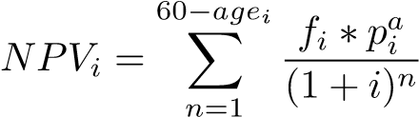*,* (1)

where 60 is the retirement age, *agei* is the age of the household head in household i, *fi* is the share of premiums paid towards pension and old-age insurance out of total premiums paid *pi*, and i is the discount rate which is set to 3.32% as before. Because we do not know whether any premiums were paid prior to the survey, this may result in an underestimation of the insurance wealth gures, especially for older households. Moreover, pension contributions by the employer are not known to us at this point also hinting at an underestimation.

Table 14: Insurance premiums paid per income class (shares of total)

|  |  |  |  |  |  |  |  |
| --- | --- | --- | --- | --- | --- | --- | --- |
|  | <1,400 1,4001,800 | | 1,800-  2,300 | 2,300-  3,000 | 3,000-  4,000 | 4,000-  6,000 | >6,000 |
| Funeral and life | 0.79 | 0.50 | 0.35 | 0.34 | 0.38 | 0.37 | 0.45 |
| Pension and old-age | 0.08 | 0.41 | 0.61 | 0.62 | 0.58 | 0.60 | 0.48 |
| Health and accident | 0.13 | 0.09 | 0.04 | 0.04 | 0.03 | 0.02 | 0.03 |
| Other | 0.00 | 0.00 | 0.00 | 0.00 | 0.00 | 0.01 | 0.04 |
| Total | 1.00 | 1.00 | 1.00 | 1.00 | 1.00 | 1.00 | 1.00 |
| Av. guilders per year | 43.11 | 87.67 | 157.21 227.69 243.23 326.54 666.69 | | | | |

Source: Centraal Bureau voor de Statistiek (1938)

Note: This table displays the distribution of premiums paid across insurance types for di erent income classes. The bottom row displays the average in premiums paid per income class in guilders per year.

We estimate *fi* based on the gures from table 14 as follows. We calculate average income for all the income classes. For all households below average income in the bottom income class (<1400) we set the share of premiums at 0.79 and 0.08 for funeral and life insurance and pension and old-age insurance, respectively. We then calculate by how much the share of premiums changes for every additional guilder of income between average income in the bottom two classes. We then linearly interpolate the premium share between 0.79 and 0.50, and 0.08 and 0.41 for both insurance classes, respectively. We repeat this exercise for the second and third income class. For income above average income in the 1800-2300 income class, but below the average of the highest income class, we set the share of premiums to a weighted average of these four income classes. This is because there appears to be relatively little variation in the share of premiums in higher income classes and the number of households gets relatively small. Above average income in the highest income class we set the gure reported by CBS, that is 0.45 and 0.48, respectively. The resulting premiums paid as a function of income can be found in gure 5.

Figure 5: Premiums spent and income: own calculations vs. CBS shares

1. Pension and old-age

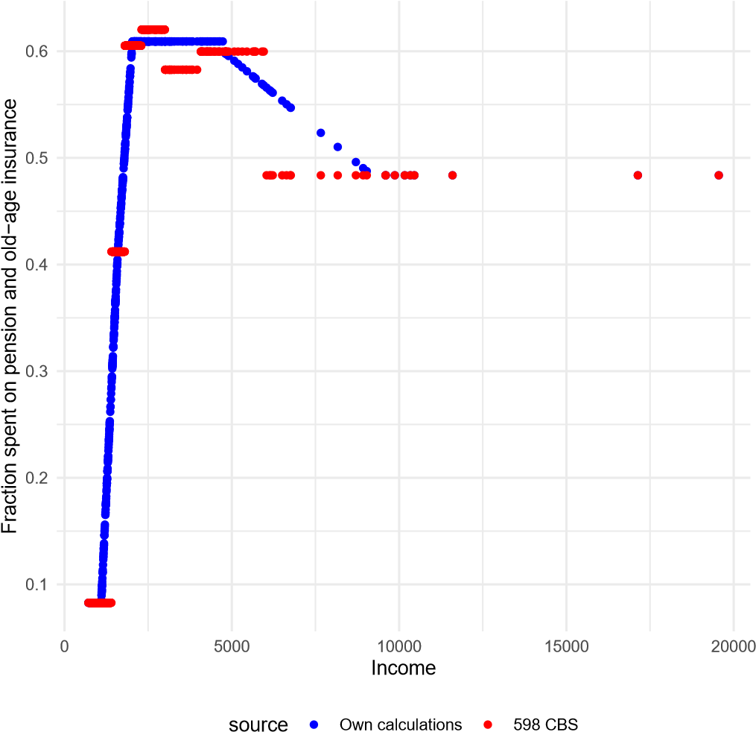

1. Funeral and life-insurance

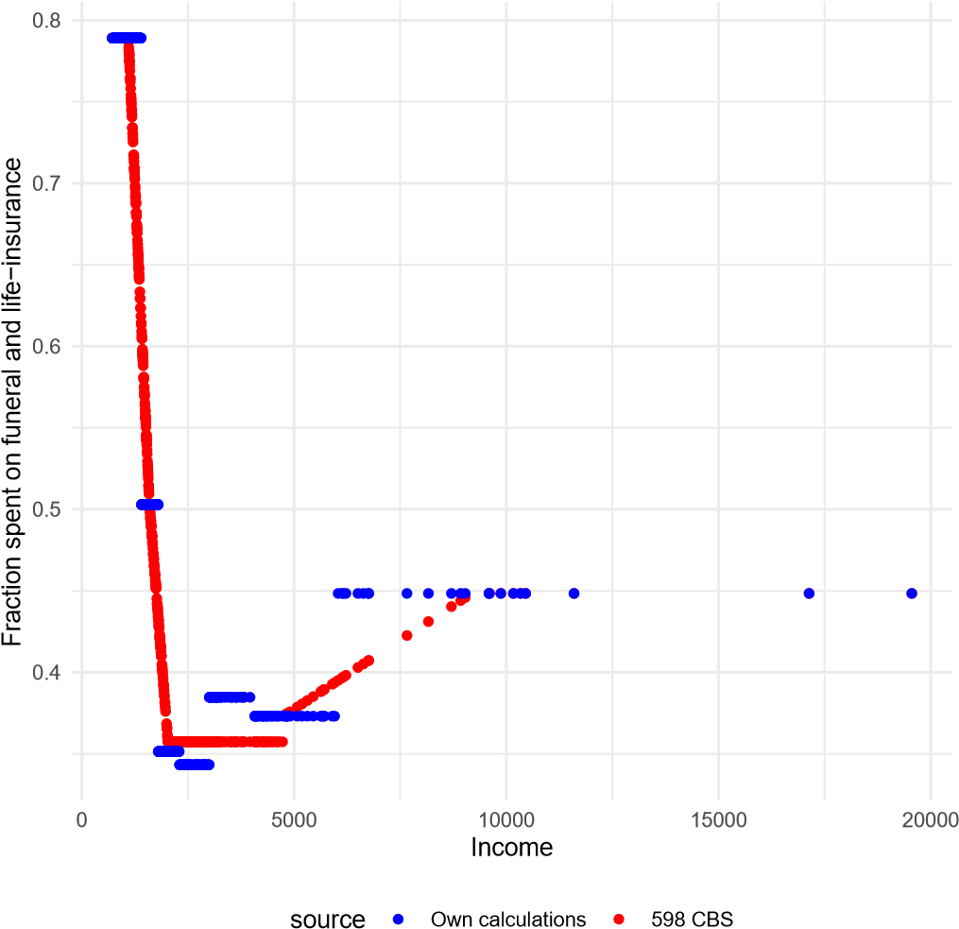

1. We thank Marc Gabarro, Tony Moore, Bas Machielsen and participants of the 2020 Financial and History Seminar at Radboud University (online) and participants at the Economics History Seminar at Utrecht University for comments and suggestions. Cuno Balfoort, Kelly Noonan, Sander Rozendaal, Catherine Simpson, Nelleke Tanis and Torbjorn Thomson provided excellent research assistance.
2. Utrecht University
3. Ministry of Finance, The Netherlands. Corresponding author: timvdvalk.work@gmail.com
4. The Dutch government was not unique in its e ort to survey household budgets during the Great Depression. (Ahearn2016) have documented the existence of household budget studies across Europe and the US since the late 19th century. Vanthemsche2019 has documented the conduct of budget surveys among the unemployed in Austria, Belgium, Poland, Czechoslovakia, Britain, France, and Italy between 1931 and 1936; In 1993 Robert Margo pointed to the Study of Consumer Purchases, a survey among 300,000 (!) households carried out in 1935 and 1936 by the US Department of Labor. Hausman (2016) has used this survey to analyse the nancial behavior of war veterans. [https://doi.org/10.3886/ICPSR08908.v3.](https://doi.org/10.3886/ICPSR08908.v3) Rosenstiel (2010) used a set of 21 US wide opinion polls held by the American Institute of Public Opinion with answers from 63,052 people about their wellbeing in 1936 and 1937. Roberts2016 documents the existence of two Depression surveys in Canada among a much larger number of regular surveys
5. It is, of course, possible for these 66 households that unemployment started before (or continued after) the start (end) of the survey.
6. Note that HC5 contains three lower-skilled farm workers. For eight households it was not
7. See appendix A for more details.
8. In 1947 the share of owner-occupied housing was 28 percent (Ha ner et al., 2009). In our sample it is 27 percent.
9. Other self-reported measures of nancial fragility, such as the capacity of an individual to come up with a certain sum of money within 30 days (Lusardi et al., 2011; Wiersma et al., 2019), naturally cannot be constructed.
10. For The Hague: expenditure on food, clothing, footwear, rent, fuel, gas, and electricity for 31 labourers’ families (arbeidersgezinnen) between April 1937 and April 1938./citetStatistisch1940, pp. 9,23; For Amsterdam: expenditure on food, clothing, footwear, rent, fuel, gas, and electricity of 75 ‘arbeidersgezinnen’ in 1937.Bureau van Statistiek der Gemeente Amsterdam (1938). In both cities the spread around the mean margin will have been considerable, as the data underlying the summary tables on expenditure consisted of strati ed samples of di erent income groups (In The Hague: <1,400; 1,400-1,800; >1,800 guilders; In Amsterdam: <1,400; 1,400-1,900, 1,900-2,900; 2,900-4,000). For comparison: the income and expenditure of 32 families of civil servants (The Hague) and 109 ‘well-to-do’ families of civil servants and free professionals (Amsterdam) yields nancial margins of 1,341 guilders and 5,431 guilders (sic) respectively.
11. We add home production to the denominator because otherwise we get very high fractions for those households that particularly rely on home production.
12. Purchases at reduced value were valued by taking the di erence between the market price and the price that was actually paid by the household.
13. Regression analysis (not displayed here) shows that predominantly farmers (HC4) and households in rural area’s employed home production. Wealth and other household characteristics render insigni cant, except for a small negative e ect of the healthcare dummy which is consistent with more limited physical capacity when ill. Regression analysis (not displayed here) with savings in ows as the dependent variable mostly renders insigni cant results except for the wealth variables. The healthcare shock variable is also signi cant pointing at the importance of nancial bu ers in the absence of a public healthcare system.
14. Cf. Costa (1999) who demonstrated that the purchasing power of lower income households in the US grew so strongly between 1919 and 1935 that they had been able to increase spending on recreational goods.
15. The survey provides weekly averages on a variety of income and consumption statistics for some 20 weeks in total, split over three period between February 1937 and September 1937.
16. If a breadwinner found a job during the course of the survey period, his household was replaced by one with similar characteristics.
17. The de nition of net income (and therefore the nancial margin) is di erent from above to ensure the data can be compared. Net income is de ned as income from employment (by all household members) and household rm, the system of social security, home production, gifts and lodgers.
18. A similar situation existed in England, where households receiving poor relief saw their disposable income rise to subsistence level, but not beyond. Boyer 2019, building on Hatton and Bailey 1998.
19. Inventaris1937; On the sewing courses: Tanis2021
20. Costs were not included if these were generally paid by renters. Mortgage capital repayments are part of the credit out ows.
21. The capital market rate varied between 3.35% and 3.00% between 1934 and 1938. Where our choice of the discount rate matters for the summary statistics here, it matters less in the later regression analysis since the coe cient will scale accordingly.