Exploring the evolution of living standards in Ghana, 1880-2000: An anthropometric approach

Gareth Austin*, Jörg Baten**, Alexander Moradi***
* London School of Economics
** Univ. of Tuebingen and CESifo
*** CSAE/GPRG , Univ. of Oxford
E-mail: alexander.moradi@economics.ox.ac.uk

Abstract
How did living standards in Ghana develop in the long run? The obvious constraint for a long-term perspective is the limited amount of good data and a consistent measure of human well-being. This is especially the case for the period of colonial rule. Using anthropometric techniques we explore the evolution of living standards and regional inequality in Ghana from 1880 to 2000.
Ghana provides an extremely interesting case study. Major economic and social changes took place in the late nineteenth and early twentieth centuries. The development of the agricultural export economy, already under way since the decline of the Atlantic slave trade, was consolidated by the adoption of cocoa, of which Ghana became the world’s leading producer. Cocoa farms, and European-owned mines, eventually attracted extensive migrant labour. Railways and lorries revolutionised transport. Medical knowledge spread. Our findings suggest that, overall, living standards improved during colonial times and that a trend reversal only occurred after the economic crisis in the 1970s. This fact is challenging prominent explanations of colonial legacy and allows insights into the institutional argument for growth.

Acknowledgments
We are grateful to the General Headquarters of the Ghana Armed Forces, Personnel and Administration and Director and Staff, Military Records for granting us access to records of the Gold Coast Regiment. We thank Moses Awoonor-Williams for excellent assistance in Ghana and especially David Killingray, who shared with us his expert knowledge on the Gold Coast Regiment. Data collection was funded by a British Academy Small Research Grant to the third author, the financial support is gratefully acknowledged.
Namawu Alhassan and Joana Acquah
Without support of the CSAE crucial to the susupport of Justin Sandefur and Francis Teal, who

- Introduction
Lack of ‘pro-growth’ institutions is a frequently cited cause for the disappointing economic trajectories of African countries since independence. But what factors influenced institutions at the first place? A growing literature stresses colonial legacies. Acemoglu et al. (2001) argued that places with a favourable health environment attracted European settlers who brought growth promoting institutions with them. In contrast, at places where white settlers could not survive, colonial powers set up extractive states. Several studies argued that the identity of the colonizer influenced later institutions and policy choices and found that former British colonies did comparatively better than former French ones (Bertocchi and Canova, 2002; Englebert, 2000; Grier, 1999; Price, 2003). Lange (2004) distinguished between the British colonies that were governed directly and those that were governed indirectly (through local rulers) and found negative legacies in the case of the latter. More recently, Nunn (2006) argued that Africa’s external slave trades have had adverse effects on the quality of the judicial system and rule of law in African countries after Independence. He concluded that the number of exported slaves significantly explains differences in GDP per capita in 1998. The colonial era also left many ethnically highly fractionalized states in Africa (Mamdani, 1996), a phenomenon which was argued to be associated with rent-seeking behaviour and corruption that, again, lowers economic growth (Easterly and Levine, 1997; Mauro, 1995).
The literature follows, by and large, the same methodology. Proxy variables that measure attributes or episodes in the (colonial) past are used to predict post-independence differences in levels of GDP per capita or economic growth. This approach can be criticized. Cross-country regressions do not explain changes over time as, by definition, they explain differences observed between countries. Moreover, the measures of colonial legacy can not change. If values in the dependent variable change, they must trigger a change in the relationship, and then, oddly, interpretations must be adjusted. Temporal inconsistencies can arise by a reversal of fortunes in the future. However, what accounts for the huge variation during the colonial era itself? Were colonial times really as bad for the indigenous population as commonly believed?
In this paper, we study the long-term development of one country in detail. We present quantitative evidence that this country’s experience in the late nineteenth and early twentieth century challenges the prevailing wisdom that colonial times were bad for colonial economies. We chose Ghana as our case study because of her most interesting history. A number of European powers established trading posts at the coast from 1481 onwards. They played a prominent role in the slave trade: from there, the slaves, which were captured in the Northern savanna zone or at the coastal South in wars or kidnappings, were shipped to the Americas. Nearly a tenth of all transatlantic slave departures occurred from the Gold Coast (Eltis, 2001: Table II). The external slave trade declined after the British withdrawal from it with effect from 1808. The British colonized the southern part of what is now Ghana in 1874, and extended their rule over the inland forest kingdom of Ashanti, and the northern savanna in 1896, adding part of the former German colony of Togoland during the First World War. The colonizers governed the country by indirect rule, through the chiefs. The country is located in the tropics with its particularly harsh disease environment (Curtin, 1989). The number of white settlers was close to nil. Like many other African countries, Ghana comprises a considerable number of ethnic groups, whose identities were far from simply colonial-era inventions (Lentz and Nugent, 2000). Judged by these short facts, the prominent explanations seem to be confirmed: With this history, Ghana is a poor country today.
In that context one might also expect a poor development during colonial times. However, Ghana was the most successful of the cash-crop exporting economies of tropical Africa. This was based on African farmers’ adoption of and investment in cocoa cultivation. Exports of cocoa beans rose from zero in 1890 to the largest in the world in 1910-11 (Hill, 1997). Szereszewski’s early attempt at historical national income accounting estimated annual average per capita growth in GDP as 1.8% between 1891 and 1911. Meanwhile non-traditional capital stock rose from £0.8 million at the end of 1890 to £13.8 million at the end of 1910, in 1911 prices (Szereszewski, 1965: 91). This does not fully reflect the significance of the capital formation, as its main component was the planting of cocoa trees whose peak yields lay ahead. More recent research has shown that the cocoa take-off emerged from a context of pre-existing market production in the late precolonial period, when the external slave trade gave way to palm oil exports from the coast, and kola nut exports from Ashanti to northern Nigeria (Abaka, 2004; Austin, 1995, 1996; Reynolds, 1974). This earlier growth was based partly on the internal slave trade which brought captives from the northern savanna were directed into commodity production in the south. The raiding and trading of slaves was suppressed by the incoming colonial authorities, though in Ashanti and the Northern Territories slave-holding was only prohibited in 1908 (Austin, 2005). Meanwhile the growth of the agricultural export economy was facilitated by a revolution in transport brought about by railways and lorries (Austin, 2007). A wage labour market developed with large numbers of labourers migrating to the cocoa farms and European-owned mines in the forest zone. Education spread (Gifford and Weiskel, 1971) and medical and hygienic knowledge became more advanced (Addae, 1997). Development, however, was very uneven across the country, and the rapid growth and structural change of the early colonial era was not matched over the rest of the period (Austin, 2003; Teal, 2002).
How did living standards develop in the long run? The obvious constraints on answering this question are the limited amount of good data and the need for a consistent measure of human well-being. Anthropometric methods provide a way to overcome these limitations. Human stature reflects biological components of human welfare (Komlos, 1989). Children’s bodily development responds very sensitively to deprivation and insults. The quality and quantity of nutrition affect bodily growth positively, whereas diseases and physical exertion absorb nutrients and therefore stunt growth. Final adult height represents the cumulative sum of increases in stature over the full duration of bodily growth. However, the years are not all equally important. Conditions during the early years of life largely determine the adult stature (Baten, 2000; Martorell and Habicht, 1986). In the first three years of life, the height stock of healthy and well-nourished children increases by about 45 cm on average (Kuczmarski et al., 2002). A growth shortfall at that age is likely to be large in absolute terms. Moreover, toddlerhood is a very critical and vulnerable period. The combination of high nutritional demand and exposure to pathogens after weaning make adverse environmental conditions very effective in growth faltering (Martorell and Habicht, 1986). Empirically, height deficits at early ages are unlikely to be regained and will be carried on up to maturity (Billewicz and McGregor, 1982; Hauspie et al., 1980). Recently, and for African populations only, also environmental influences at puberty were found to be significant predictors for adult height (Moradi, 2006).
It is worth mentioning that genetics does not play an important role at the population level. In egalitarian and homogeneous societies, heights of individuals vary for genetic reasons. However, in every society there are similar numbers of genetically tall and genetically short people so that low and high genetic potential cancel each other out when taking the average height of populations (Steckel, 1995). Evidence for the overwhelming influence of environmental conditions comes from anthropometric studies which found large height differences between rich and poor people of the same ethnic group, more so than between socioeconomic elites of different ethnic groups (Eksmyr, 1970; Eveleth and Tanner, 1990; Habicht et al., 1974). Ten-year-old girls from Accra, Ghana, for example, who went to an expensive international school, were found to have an average stature equal to that of US girls of same age. The privileged Accra girls, however, were six centimetres taller than girls of same age going to Accra’s state schools, who in turn were two centimetres taller than girls from rural areas in Southern Ghana (Fiawoo, 1979). Finally, we can rule out the notion that changes in mean height over such a period as short as 120 years could be caused by what was actually a rather constant genetic pool of populations (Bogin, 1999).
Mean adult heights illuminate the nutritional and health conditions a population cohort has faced. However, average stature should not narrowly be regarded as a proxy of net nutritional status. Stature can be rather broadly considered as a measure of the physical quality of life. A healthy life free of hunger is an important and universally accepted dimension of human welfare. Heights particularly reflect how well basic needs are met; they are determined by the manifold faces of poverty, such as hunger, low-nutrient diets, poor housing and sanitary conditions, contaminated food and water, no or limited access to medical care and child labour. There are several additional advantages (Steckel, 1995). The stature measure is applicable to diverse societies including those with modern economic structures and traditional production systems. Heights measure outcomes not inputs to human well-being and last but not least, the analysis of stature can be based on a large population coverage. Height data is available for groups we are interested in: the indigenous population of Ghana.
The paper is structured as follows. In section 2, we present the data source. In section 3, we describe differences in mean stature within Ghana and how well-being approximated by height has changed in the period 1880-1920. We examine factors that can possibly explain the observed spatial and temporal pattern. Section 4 adds Ghana’s experience of the second half of the twentieth century to the analysis. The final section concludes.

- Data
It proved extremely difficult to mobilize height data in sufficient quantity and quality for the colonial period. Finally, in attestation forms of the Gold Coast Regiment (GCR) we found a great source that allows height estimation for 1880s to 1920s birth cohorts. For identification purposes and as a measure of physical fitness the height of enlistees was measured on enlistment and recorded on attestation papers. Additional information include date of enlistment, age, previous occupation, father’s occupation, place of birth, the soldier’s signature (literacy), ethnicity and religion.
The GCR was the colonial army in the Gold Coast which later became Ghana. The regiment’s primary role was to maintain internal security of the colony. The troops were deployed in the interior, in 1900 when putting down the Asante uprising, for pacification of the Northern Territories, and, for occasional punitive expeditions (Killingray, 1991). The labour force was also used in road building. It was a small force numbering between 1200 and 1700 men (Killingray, 1982a). The rank and file were drawn from the indigenous population, as they were cheaper and less vulnerable to the African disease environment than Europeans.
GCR enlistees cannot be considered a representative sample of the Ghanaian male population. Universal conscription was never introduced. Recruiting was rather subject to supply and demand factors with the military a direct competitor to other forms of employment. Higher skilled men from higher social status faced higher opportunity costs and, therefore, were less likely to join. For Southerners, it was generally more profitable to grow cocoa or work in the mines. Non-economic factors played a role as well. After the 1900 uprising, Asante were regarded as potentially disloyal; alien men were trusted more. The fact that ethnic groups from the North dominated the rank and file generated antipathies and kept Southerners from joining the GCR (Killingray, 1982a: 203-212). Still, because the army’s personnel strength was small, always more recruits presented themselves than could be accepted, and the British could be rather selective (Killingray, 1985).
All this changed during the world wars when the GCR was rapidly expanded. Over 10,000 men enlisted in the regiment during WW1 while over 60,000 served in WW2. With the urgency for troops soldiers were drawn from a larger geographical area. In WW1, recruiting was extended to Ashanti (Killingray, 1982a: 264) and in WW2 a sophisticated system of district quotas was introduced. Recruiting took compulsory forms. The British authorities applied pressure on chiefs who in turn used direct compulsion to provide recruits (Killingray, 1982b). Formal conscription was introduced in 1941 for certain occupation like motor drivers and artisans. Overall, a large percentage of men was forcibly enlisted (Killingray, 1982a: 255) - a fact reflected in extremely high desertion rates (Killingray, 1982a: 286).
Our current data set comprises an almost complete sample of WW1 enlistees, some observations from the interwar period that were collected in an initial feasibility study and a sample of WW2 enlistees (Figure 1). The sample covers about 10,000 Africans so far – a huge data set which is unique in the field of African (economic) history.
In the following, we check whether our sample is geographically balanced. Using the place of birth from the attestation papers and consulting a geographical database, we could identify the exact longitude and longitude and therefore, region of birth (National Geospatial-Intelligence Agency, 2007). The sample of Ghanaian WW1 and WW2 enlistees is geographically balanced in that there are no substantial differences with the population share reported by the Census in 1931 (Figure 2). There is a slightly greater divergence for WW1, with a higher share of men from the Upper West and fewer men from the Western region and Volta (in the Southeast). For WW2, the district quotas seem to have worked well except for Western and Northern. Nevertheless, we are cautious about computing a national mean and instead focus on mean stature in the administrative regions.
In contrast, statistics presented by Killingray (1982a: 447-8) indicate a much higher share of Northerners for WW1 (69%). The years 1914 and 1915 are indeed characterised by a disproportionate share of enlistees born in the Northern Territories (NT). However, the absolute number of men enlisted in 1914/15 compared to 1917/18 is small, so that the geographically more balanced enlistment in 1917/18 has more weight overall (Figure 1). Moreover, official statistics give a breakdown by ethnic groups who were then assigned to the various regions, Gold Coast Colony (GCC), Ashanti, and NT. This method is not very accurate. For example, Grunshi, Hausa, Lobi, Moshi, and Zabarima, who represent a substantial share of the rank and file, were all recorded as recruits from the NT despite the fact that most of those men were born in what is now Burkina Faso, Niger and Nigeria (see also Killingray, 1982a: 266). Our GIS analysis might slightly underreport the number of genuine Ghanaian northerners (32%) as we had more difficulty locating birth places of NT ethnic groups (69% versus 83% for ethnic groups from the South).
The military used height as a measure of physical fitness and enlistees had to pass a minimum height requirement. As a consequence, men below a certain height threshold are underrepresented and the height samples are deficient on the left tail of the distribution (Heintel, 1996; Komlos, 2004). A stature of 5'2" to 5'4" was probably required over much of the period (Queen Victoria Regulations). Nevertheless, exceptions and adjustments occurred (Figure 3). In 1940, for example, the height minimum was officially lowered to 5'2" for NT recruits and 5'0" for Asantes (Killingray, 1982a: 213). Moreover, senior officers had scope to relax the requirement if, for example, insufficient men were being attested. In order to derive consistent mean height estimates we apply truncated regressions using a maximum likelihood estimator. Throughout this study, we choose 5'3" as the truncation point.
While the period 1880-1920 is the main focus of this paper, we also present evidence for changes in nutritional well-being in the second half of the twentieth century. The anthropometric data for the period 1940-2000 was derived from the Ghana Living Standard Survey 1987/88 and four Demographic and Health Surveys 1988, 1993, 1998/99, and 2003 which are representative for the time when the surveys were carried out (Macro; World Bank).

- Living Standards in Ghana, 1890s-1910s
The regional differences within Ghana, as well as the development over time before 1920 reveal interesting facts that we can document here for the first time. After presenting the main findings, we will discuss qualitatively which factors might have influenced the height differences. At the current stage of research, we cannot yet rigorously test possible explanatory variables against alternatives or specify the quantitative contribution of several influential factors.
Based on the previous descriptive discussion of sample characteristics, we decided to exclude recruits born before 1880 or after 1920 from this section, as sample sizes are too small yet. We also excluded extreme heights (<120 cm, > 200 cm). We excluded recruits younger than 21 and older than 50, and included dummies for the age groups 21 and 22, because final male height is often reached at a later age than 20 years when nutrition was poor (Bogin, 1999: 92). As the colonial state organised the whole northern savanna as a single administrative unit, while dividing the rest into two or three colonies, it is convenient for us to think in terms of a tripartite division: Northern Territories (NT), Ashanti, Gold Coast Colony (GCC) ignoring British Mandated Togoland. We classified individuals as “NT”, if they were members of an ethnic group living predominantly in the NT, as opposed to the central Ashanti forest region, and the GCC at the coastal south.
We control for possible selectivities by including dummy variables for the enlistment periods that we identified as being distinct (section 2). In particular, we distinguish between WWI, WWII, and pre-war recruitment (hence, the constant refers to interwar peacetime recruitment). During WWII, the selectivity of recruiting officers and selecting local chiefs was much lower. Perhaps we even have the "true" height level of the male population during this recruitment period, but certainly the WWII-recruitment height level is much closer to the true level than during any other of our recruitment periods. We find that peacetime selectivity in the NT was strongest (Table 2): Holding the year of birth constant, the height difference of WWII enlistees is a substantial 1.6 inches in the NT, given the demand difference between war and peacetime and, at the same, a constantly large supply of northern recruits due to the lower opportunity cost, and great willingness to join. The Asante, in contrast, the difference is the smallest, given that Asantes with tall heights and good health were very unwilling during peacetime to serve in the colonial army. The GCC ethnic groups were in the middle. Figure 4 displays the difference of adjusted and unadjusted height series. First of all, the adjusted series is much lower. Next, we see that the Gold Coast height advantage over the Asantes in the unadjusted series might have been caused by recruitment practices (only the poorest and shortest Asantes were willing to serve in the army).
From the coefficients of the three regional regressions, we can make two major inferences at this stage (Table 2, Figure 4):
- Northern recruits were on average taller than southern recruits.
- Height development in the three regions was, by and large, similar. Mean heights declined in cohorts born between the 1880s and late 1890s, followed by a strong recovery, which halted at the end of our series, during WWI. The gains in the first decade were substantial, about one inch (2.5 cm).
In the following, we will discuss qualitatively which factors might have influenced the height differences.

Explanations for the regional difference between North and South
Why did Northern recruits tend to be taller than Southern ones, especially in the later period? As higher incomes buys better diet and health, we would expect taller statures in the richer region. At the first glimpse, the taller stature in the north seems paradoxical: Everything points to the south as the richer region. The forest zone contained most of the natural resources that happened to be commercially valuable in the 19th and 20th world markets (Austin, 2005, 2006, 2007). The south had greater purchasing power in the mid-1890s as well as ever since, in aggregate and per capita. Heights do not always (positively) correlate with income poverty. The divergence arises if correlation between income on the one hand and nutrition and health on the other, which heights approximate, is weak. ‘Purchasing power’ should be taken literally: what could be bought on the market. But, though markets were much more important than the old stereotype of the subsistence economy, it is true that markets for food were at best not integrated, across (what became) Ghana as a whole (Austin, 1996; Hopkins, 1973). So it is possible that food consumption (defined in calories, proteins etc) was higher in the north, if it included more generous provision of items that were scarce in the south for natural-endowment reasons.
An obvious candidate for explaining the height advantage in the north would be a higher consumption of high-quality proteins in the north, especially in the form of meat, including offal, skins, and milk (Moradi and Baten, 2005). Yet the cattle hypothesis is not entirely convincing for early 20th century Ghana. Livestock diseases inhibited stock-rearing even in much of the north. Trypanosomiasis was present in part of the country and rinderpest spread in the late 1910s and 1920s (Patterson, 1980). Therefore, where northerners kept cattle, they did so on a small scale. Cardinall, the Gold Coast census officer, gives estimates of the number of cattle per 100 of the population in 1931 (Cardinall, n.d.: 102). In Ashanti, with its deadly environment for large livestock, the figure was 2.6, all of them presumably recently driven there for slaughter. Figures of the same order of magnitude are given for 4 of the 11 districts of the NT and Northern Section of Togoland: Mamprusi (3.3), Eastern Gonja (2.2), Western Gonja (3.1) and Krachi (1.5). Clearly, these districts were not primarily specialized on livestock. The districts with more than 10 cattle per 100 people in 1931 were Keta-Ada (down on the Accra plains, in the Gold Coast Colony), at 10.2; and in the north, Lawra-Tumu (12.9), Navrongo (19.0), Wa (15.3), Eastern Dagomba (10.9) and Western Dagomba (11.0). Interestingly, Cardinall concluded, ‘the population of the Protectorate [the N.T.s] although owners of cattle are not in any way breeders or herdsmen’ (Cardinall, n.d.: 103). Moreover, the cattle reared in the NT were small, a humpless breed, locally known as ‘Dagomba’ cattle (Deshler, 1963).
Overall, meat consumption was not high in Ghana, and consumption of beef was probably rare for most people. As late as 1931, the Gold Coast census officer calculated 10.78 lbs (4.89 kg) as the per capita meat consumption for the whole population of Ghana. He added ‘This compares favourably with other countries in Africa. But a closer analysis would show that the per capita consumption of meat is infinitely greater in the larger centres than in the rural districts where the people cannot be classified in any sense as meat-eaters.’ (Cardinall, n.d.: 104).
Nevertheless, the fact that the northerner did not specialize on large-scale cattle exports to the Kumasi and similar regions might mean that they could consume on a decent scale themselves. Overall, it remains highly likely that meat consumption was slightly more common per head, and more widely distributed socially, in northern Ghana as a whole than in the forest zone. The effect may have been strong enough to account for a part of the greater average height of northerners compared to forest-zone dwellers.
However, the main explanation for the Northerners height advantage may lie in the rest of the diet, and especially in northerners’ consumption of groundnuts (peanuts). The issue was not systematically investigated in the early colonial period. Given that the northern height advantage persisted, it is relevant to mention here the analysis offered by Purcell’s 1940 nutrition report. Purcell (1940: 140) wrote:
The dietetic contrast of chief importance are between the children of the north and the children of the forest. The smaller and weaker Akan child eats roast plantain in the morning and mid-day (and gets very little meat or fish with supper), whereas the northern child who [sic] eats whole grain millet flour in water in the morning, and raw groundnuts at mid-day. Thus, during the all important growing years, the diet of the N.T. child contains qualitatively superior protein and more calcium; although at times the N.T. child may experience seasons of hunger unknown to the forest child. In this way the contrast in stature and physique may be accounted for.
It is difficult to how far the area of the north selected for the 1940 survey was representative of the diet of the NT as a whole. As Destombes (2006) shows for a later period, the trajectory of different groups within the same district could vary considerably. Another query is whether groundnuts were as prominent in northern diets before 1920, as they were in 1940, but there is no reason to expect a change over the period.
We could also imagine that inequality played a role. Heights are subject to a decreasing marginal product, a property which means that the height gain from an additional unit of food or health is positive but it will decrease the higher the consumption of food and health already is (Steckel, 1995). Therefore, at a given endowment of nutrition and health resources inequality affects average height negatively. The premise of a social gradient in nutrition is justified in the south. In the Asante case, though both rich and poor seem to have eaten the structurally similar mush of pounded and boiled carbohydrate called fufu, the content of the sauce or soup with which it was consumed differed sharply. According to Bowdich, who visited Asante in 1817, ‘the food of the higher orders is principally soup of dried fish, fowls, beef or mutton ... and ground nuts stewed in blood. The poorer class make their soups of dried deer, monkeys flesh, and frequently of the pelts of skins’ (Bowdich, 1819: 319). We also know that in 1870 Ashanti, only slaves ate cassava which is nutritionally poorer than other staple sources of carbohydrate (Austin, 2005: 66). Thus, there was a social gradient in nutrition in Asante, with slaves at the bottom. In the savanna region, there was also a social gradient in nutrition, but the majority of northerners lived in politically decentralised societies, where we can assume that such inequalities were relatively slight.
Summing up, if the analysis of the 1940 nutrition report is relevant to the WWI sample, recruits from the north could have been taller because of eating more and/or better-quality protein in childhood, principally in the form of peanuts and to a lesser extent as animal proteins, given that markets were somewhat less thickly organized and inequality was lower.

Explanations for the decline 1880-1900
Heights of Northerners (and other regions as well) decreased between the 1880s and late 1890s. In fact, the earlier cohorts in the sample had been born during what was a particularly unfavourable era, in terms of violence, insecurity, drought and famines. For Northern Ghana, 1867 to 1896 was a period of intensified violence and slave raiding. Slave-raids brought death and injuries, break-up of households, destruction and looting of property and put a large burden on local economies, as insecurity discourages any saving and investment into the future. This began with the Asante monarch Kofi Kakari, after his succession in 1867, raising the annual tribute in slaves that the Asantes required from the Dagomba state. This led the Dagomba cavalry, aided by Zabarima mercenaries from Niger, to expand their slave raids on the Grunshi and other politically-decentralised communities (Wilks, 1989). While Asante’s northern tributaries threw off Asante control after Asante’s military defeat by Britain in 1874, the Zabarima ‘turned from mercenary work to the independent conquest of a swathe of territory between Wagadougou and Wa’. This generated a renewed flow of south-bound Grunshi captives until the colonial conquest in 1896 (Allman and Parker, 2005: 31-32, quote at p. 32). Additionally, during part of that time the invasion of what is now northern Ghana by Almany Samori Toure’s army occurred. Samori had assembled a major fighting force, with which he fought a sustained campaign against the French, ranging over a large area of West Africa, to the west and north of Ghana. But he sustained it partly by large-scale slave raiding and sale of war captives. In the early 1890s the slave markets of northern Ghana were flooded with captives from Samori’s troops (Austin, 2005).
Northern Ghana was also hampered by seasonal hunger and occasional famines, local and otherwise. It is hard to know how widespread particular famines were. But in the case of the Tallensi (who inhabit the Tong Hills and their environs, southwest of Bolgatanga in what is now Upper East Region), the mid-1890s saw prolonged drought leading to famine. ‘Many died of starvation and disease, and so many children were pawned or sold that fifteen years later colonial courts were still dealing with disputes over the ownership of those exchanged locally for food.’ (Allman and Tashjian, 2000: 35). If children experienced nutritional insults in the 1880s and 1890s, this would affect subsequent average heights for adults later.
Finally, in principle another reason for the decline could have been epidemiological. Africanist historiography hypothesized that the 1890s-1900s saw a spread of diseases brought by movement of armies during the colonial conquests and other wars. However, we would dismiss this argument. As a generalisation it is reasonably plausible for eastern and central Africa, but much less so for West Africa. The hypothesis is based on the assumption that there existed a ‘pathogenic equilibrium’, between bugs and their hosts, before the colonial occupation (Azevedo et al., 1978). This is not credible for West Africa, because the region had been heavily involved with the Mediterranean (via North African trade, the annual haj pilgrimage from Muslim parts of West Africa, and other Muslim interconnections) and Atlantic worlds beforehand. Therefore, it is unlikely that new pathogens were introduced by the soldiers involved. Again, the scale of fighting in the colonial conquest was occasionally fairly severe in parts of what became French West Africa, but the British conquests were quick, and the biggest war of the nineteenth century in Ghana was surely that of 1869-74.

What explains the recovery between about 1900 and 1913?
It is not surprising that the inhabitants of what were becoming the cocoa-producing areas became taller between around 1900 and 1913. Albeit in the GCC region, there was the lowest point in 1905-09. But even during WWI, heights were on a somewhat higher level then before 1900. Hence, we conclude that average heights rose in what had become the cocoa-growing areas: Ashanti, the Eastern Region of the Gold Coast Colony, and indeed Central Province of the GCC (part of which was in the cocoa belt). This is not surprising, for several reasons. First, in the case of Ashanti, greater peace and personal security followed the 1900 Kumasi revolt (Gillespie, 1955). Though Ashanti had not had to suffer slave raids within its territory, the 1869-74 war and the 1883-8 civil war both cost heavy Asante casualties, and the latter led to large-scale migration to the Gold Coast Colony. That emigration was largely reversed after 1900, in response to the restoration of internal order in Ashanti. There was no significant change in peace and security in the Gold Coast Colony.
Second, purchasing power increased, as there was better access to food produced locally (such as meat from hunters), food purchased from other parts of Ghana (fish from the coast), and from abroad. Part of the latter was beef from the Mossi cattle driven down from the French territory of what is now Burkina Faso (Patterson, 1980): but this probably had little effect as yet on most forest-zone farming households, because of the still high prices. Another part was the growth of food imports via the sea, as the government Blue Books show. The main driver of increased purchasing power was the wild rubber (1880s-90s) and then the cocoa economy: farming, trading, and transporting the beans; and supplying goods and services to the direct recipients of cash-crop income. The Eastern Province of the GCC was the earliest and largest cocoa-producer in this period; with Ashanti cocoa exports expanding fast in the decade to 1917.
At that time, there would have been no trade-off between cocoa cultivation and food-growing. Ghanaians planted tall food crops, plantain and cocoyam, to shade the young cocoa plants. It is true that in the longer run there was a trade-off, because once the cocoa trees get tall enough to form a shade canopy, not only weeds but also food crops cannot survive on the land. In this early period of rapid expansion of the area under cocoa, farmers who had mature cocoa farms were almost invariably planting new ones as well, so they continued to supply their own food staples. It is true also that cocoa-growing areas sooner or later became net importers of food. For example, in the 1920s rice started to be grown in Ejura district, north of the forest zone, for sale in the Kumasi market. But this does not mean that there was an absolute decline in food crop output from within the cocoa areas (Austin, 2005).
Meanwhile the North gained from the end of slave raiding and warfare, and to some extent from peaceful trade and from the beginning of free employment opportunities in the South. British policies doubtless contributed to these improvements. Moreover, major famines did not take place during this period. Hence, heights of those born before WWI recovered from the nadir.

Discussion: what we do not want to suggest is a long-run stability at a very low level during the pre-colonial period
In the previous analysis, we illuminated the change since the 1880s. However, we explicitly avoid any assumption that the situation revealed by our earliest data necessarily reflected a long-term equilibrium. The historiography shows that the various regions of what is now Ghana each experienced considerable change, of various kinds, over the 18th and 19th centuries. In northern Ghana, for example, the 1860s-90s saw a big increase in slave raiding and related violence compared to the several decades before. Hence, a part of the apparent improvement in physical welfare in the early 20th century can be interpreted as a return to pre-1880s (or 1860s) levels. Those, in turn, may or may not have been similar to, say, 18th century levels. To put it another way, ‘the pre-colonial period’ comprises many periods, however delineated; and our data illuminate the last of those, compared to what was to happen after colonization.

- Living Standards in Ghana, 1940-1980 and 1980-2000
The spatial pattern of height differences derived from GCR enlistees born after 1900 is surprisingly similar to what can be inferred from the stature of women born in the 1960s. Estimates of Moradi and Baten (2005) indicate that average stature of women was highest in the three Northern regions (160 cm) followed by the capital region Greater Accra (159.5 cm) and other coastal regions (158.5 - 159 cm), whereas women in the Ashanti region were the shortest (158 cm). From data of children born in the 1990s we derive a similar pattern except that the coastal regions and especially Accra could still improve their position relative to the northern regions where the situation deteriorated somewhat. This suggests that the roots of inequality between Ghanaian regions lie in the beginning of the twentieth century (Figure 4, lower panel).
While the spatial pattern was rather persistent, mean height varied significantly over time. We find that the cohort born in WW2 saw only a minor increase in average stature (scale on the right hand axis, Figure 5). However, mean height of women born in the 1950s to the late 1960s increased by 1.7cm – a rate that even outpaces the secular trend in the UK (Rosenbaum et al., 1985). In cohorts of the early 1970s, the post-WW2 upswing came to a halt and mean heights fell by 1.1cm. Overall, the trend of mean heights followed an inverted U. In this respect, Ghana’s experience is not exceptional. In most African countries, increases in average statures could be observed for cohorts born after 1950 which stopped in cohorts born in the late 1960s and early 1970s (Moradi, 2006).
Note that the height series of men did not run totally parallel to the one of women. Increases in average stature of men were indeed smaller in the post-WW2 period (Figure 6). Sex dimorphism is not the only cause of gender differences in stature, a fact, recently stressed by Moradi and Guntupalli (forthcoming). Height differentials can also reflect differential treatment of the genders and unequal allocation of resources. The twelve centimetre height difference between male and female cohorts born at the time of WW2 is in the order of the usual biological height advantage of men (7% as a percentage of male height). The eleven centimetre difference in birth cohorts of the late 1950s (6.4%), in contrast, clearly indicates a more favourable nutritional status of women. Therefore, in the 20 years following WW2 especially females could improve their nutritional lot - in absolute and relative terms. This conclusion is consistent with what can be observed in many African child populations in the last 20 years - girls tend to have a better nutritional status relative to boys (Klasen, 1996; see below).
Moradi (2006) studied the determinants of changes in heights in a panel analysis of 28 African countries. Besides national food supply and progress in health conditions, economic growth (at birth and puberty) turned out to be a very strong determinant of final adult height. Ghana’s economic development provides a good explanation for the changes in the population’s nutrition and health status (Figure 5). Over the 1950-1970 period, growth in per capita income averaged 1.2% (scale on the left hand axis). In the 15 years thereafter, Ghana was hit by an economic crisis with GDP/c falling by 2.4% per year. The trend of mean stature followed this pattern very closely.
For the last period 1985-2000, we draw on physical stature of children. Following WHO recommendations, we take the percentage of children who had a height-for-age significantly shorter than a healthy and well-nourished US reference population median of same age and sex (WHO, 1983). According to this measure, child undernutrition rates were high. About 26% of children below three years of age were stunted (Table 3). What is more, the period from 1985 to 2000 is characterized by stagnation. Only in the late 1990s did the percentage of stunted children briefly decrease - an improvement that was not sustained.

- Conclusions
In this study we used physical stature as a measure of net nutritional status and, more broadly, as a measure of how well basic elements of the physical quality of life were met. Records of the British colonial army in the Gold Coast provided us with very unique source of anthropometric data for the pre-colonial and colonial era; survey data complemented the later periods. Thus, for the first time was it possible to draw a long run trend that includes the experience of the pre-colonial, colonial and post-independence era. Our results indicate that the difficult situation of the 1880s and 1890s led to decreasing heights. In the first 15 years of the nineteenth century and between 1940 and 1970, height values improved substantially suggesting that Ghanaian peasantry flourished and poverty fell significantly. In the 1970s, when Ghanaians were hit by a severe economic crisis, mean adult heights decreased. The period from 1985 to 2000 is characterized by stagnation at high levels of (child) undernutrition.
Our results challenge the conventional wisdom that living standards did not improve significantly under colonial rule. For Ghana, it cannot be said that the colonial episode of the twentieth century was particularly bad. Quite the contrary, living standards improved dramatically and rapidly in the first decade of the twentieth century when cocoa cultivation took off. Similarly, the post-WW2 height series shows the strongest increment under British rule. Taking this together the colonial time shows a better record than the post-independence period. By no means would we argue that colonialism was good. Colonial exploitation implies lack of democracy and self-determination. Moreover, not all of the changes during the colonial era were the result of intention. Some were, however, like achieving political stability and the ending of slave raids, both of which improved the lot of many Ghanaians. A lot of the key institutions, such as on land tenure, were not ‘colonial’ but indigenous, selectively supported or modified by colonial rule (Austin, 2005). Still, the main agents of economic change in colonial Ghana were Africans themselves (Hill, 1997).
The findings also allow insights into the institutional argument for growth. Colonial institutions have not ‘prevented’ improvements in living standards. In fact, given the importance of property rights and political stability colonial institutions were rather ‘pro-growth’ in Ghana’s case. Moreover, it is also difficult to maintain the notion of the “persistence of (at least certain) institutions”. Development in Ghana was characterised by ups and downs. Therefore, institutions (or their effects) can change rather quickly. Political stability is a case in point. At the beginning of the twentieth century the British were quick in generating political stability which eroded as quickly after Independence. In 1966, nine years after Independence, occurred the first in a series of four military coups in Ghana (1966, 1972, 1979, 1981). The colonial experience of Ghana is also at variance with the rather ahistorical arguments found in the colonial literacy literature. If slave trade destroyed social capital with long-lasting effects that show up in GDP per capita in 1998, why did this not play a role in the first 70 years of the twentieth century? If ethnic fractionalisation produces rent seeking behaviour, then why was it not very effective under British control?
In future research, we seek to more rigorously test the hypotheses discussed above. We also plan to use GIS techniques to test the influence of infrastructure, like proximity to railroads and main roads, and, at a more disaggregated scale, whether cocoa growing areas disproportionately benefited. The data from the Gold Coast Regiment makes it also possible to study the influence of vaccinations, literacy and occupational background at the individual level. Finally, we need to place Ghana’s experience into an international context comparing it with the progress in the UK, South East Asian and Latin American countries at that time.
Figure 1 Year of enlistment and year of birth
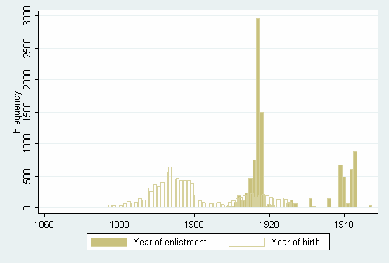
Note: N=9829. Age at enlistment varied between 7 and 50 years, the vast majority 90% of the soldiers were between 18 and 30 years.

Figure 2 Place of birth of Ghanaian WW1 and WW2 enlistees
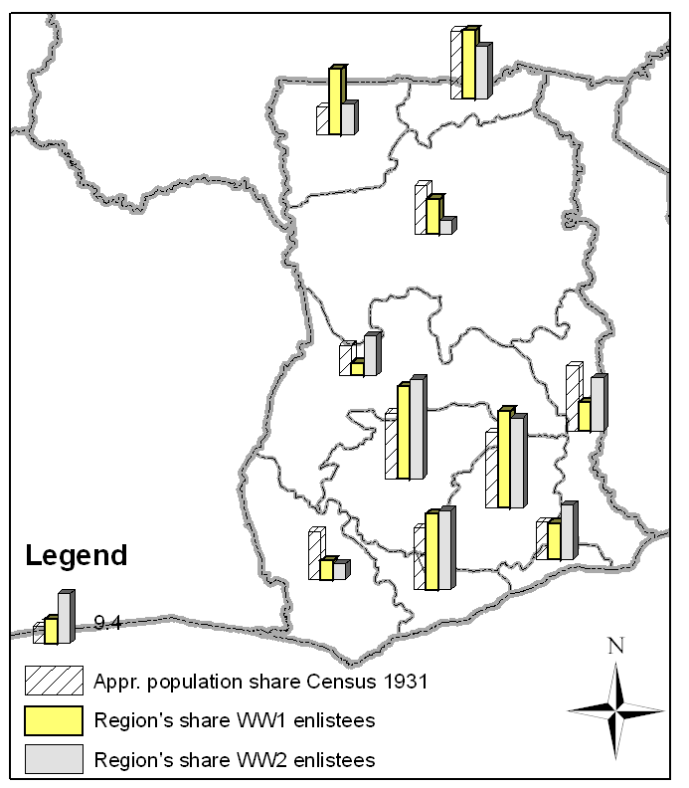
1
10
8
4
5
9
2
6
3
7
Note: N(WW1)=2289, N(WW2)=1660. The consensus is that the Census of 1931 suffers from underreporting, but that all regions are affected to a similar degree.
1: Western, 2: Central, 3: Greater Accra, 4: Brong-Ahafo, 5: Ashanti, 6: Eastern, 7: Volta, 8: Northern, 9: Upper West, 10: Upper East.
Figure 3: Height distributions of WW1 & WW2 enlistees
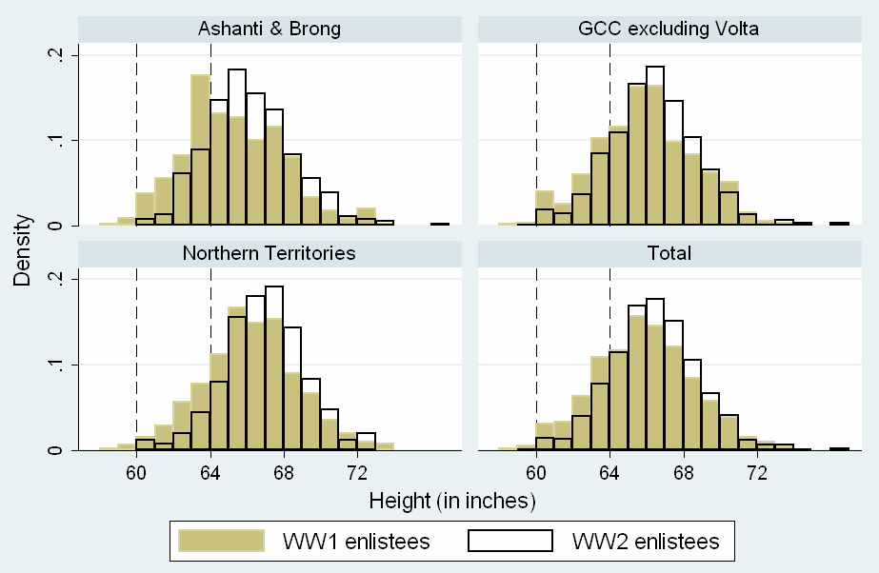
Note: N(WW1)=2354, N(WW2)=1450. Individuals were assigned to the regions using the place of birth. Mean year of birth of WW1 (WW2) enlistees: 1893 (1917).

Figure 4: Heights in Ghana, birth cohorts 1880-1919 (upper: raw estimate, lower: adjusted for selectivity)

Figure 5: Economic development and nutritional status in Ghana, birth cohorts 1940-1980
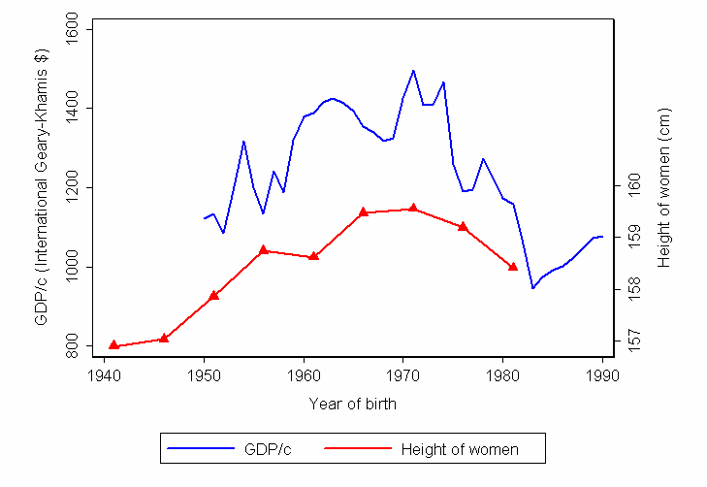

Sources: Maddison 2001, GLSS 1987/88 and GDHS 2003.

Figure 6: Height trends of the genders in Ghana, birth cohorts 1940-1960

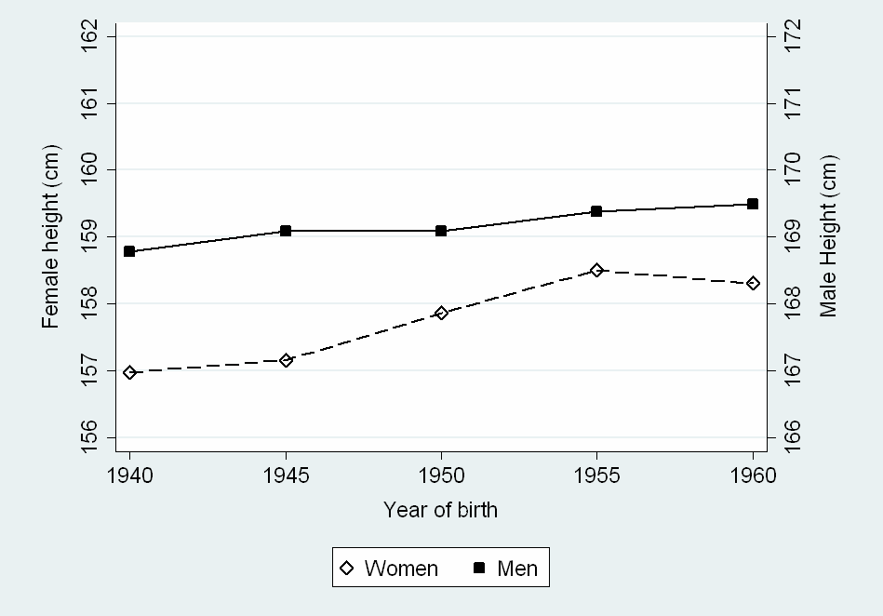
Note: The data is drawn from the Living Standard Measurement Study surveys GLSS 1988/89 (World Bank). About 60% of the individuals in the GLSS survey were remeasured in a second round. Inconsistencies between the first and second rounds (sex, age > 5 years, height > 10 cm) as well as extreme outliers were excluded; remaining minor deviations were averaged. In total, the Ghanaian mean heights are based on 8138 native born individuals between 25 and 49 years of age.
Table 1: Occupation before joining the GCR (in %)
 | Pre-WW1 | WW1 | Inter-war | WW2
Unskilled | 12.0 | 14.0 | 24.2 | 8.8
Farmer/  Semiskilled | 79.2 | 68.6 | 67.6 | 62.9
Skilled | 2.8 | 10.9 | 3.9 | 18.0
Semiprof | 6.0 | 5.2 | 3.7 | 8.7
Prof | 0.0 | 1.3 | 0.6 | 1.6
N | 284 | 5698 | 673 | 2544
Note: Classification according to Armstrong (1972).

Table 2: Trend estimates of heights in Ghana, 1880-1919
. truncreg ht age21 age22 b1880 b5_1895 b5_1900 b5_1905 b5_1910 b5_1915 prewar ww1 ww2 if age>20 & yob>1879 & yob<1920 & country=="GCC" & htcm>120 & htcm<200 & age<51 , ll(63)
(note: 213 obs. truncated)
Truncated regression
Limit: lower = 63 Number of obs = 1141
upper = +inf Wald chi2(11) = 13.54
Log likelihood = -2434.6532 Prob > chi2 = 0.2594

------------------------------------------------------------------------------
ht | Coef. Std. Err. z P>|z| [95% Conf. Interval]
-------------+----------------------------------------------------------------
eq1 |
age21 | -.2837884 .586485 -0.48 0.628 -1.433278 .8657011
age22 | -.1666643 .4837821 -0.34 0.730 -1.11486 .7815312
b1880 | -.22731 .2696623 -0.84 0.399 -.7558384 .3012183
b5_1895 | -.2597721 .4998026 -0.52 0.603 -1.239367 .719823
b5_1900 | -.9451611 1.42031 -0.67 0.506 -3.728917 1.838594
b5_1905 | -1.69018 1.293168 -1.31 0.191 -4.224742 .8443818
b5_1910 | -.4770599 1.224697 -0.39 0.697 -2.877422 1.923302
b5_1915 | -.5043004 1.226391 -0.41 0.681 -2.907983 1.899382
prewar | -1.205415 1.390663 -0.87 0.386 -3.931065 1.520235
ww1 | -2.14714 1.216385 -1.77 0.078 -4.53121 .2369301
ww2 | -1.401892 .9551647 -1.47 0.142 -3.273981 .4701961
_cons | 68.41082 1.214361 56.33 0.000 66.03071 70.79092
-------------+----------------------------------------------------------------
sigma |
_cons | 2.59986 .0853955 30.44 0.000 2.432487 2.767232
------------------------------------------------------------------------------

. truncreg ht age21 age22 b1880 b5_1895 b5_1900 b5_1905 b5_1910 b5_1915 prewar ww1 ww2 if age>20 & yob>1879 & yob<1920 & country=="NT" & htcm>120 & htcm<200 & age<51, ll(63)
(note: 90 obs. truncated)
Truncated regression
Limit: lower = 63 Number of obs = 1122
upper = +inf Wald chi2(11) = 57.94
Log likelihood = -2411.7986 Prob > chi2 = 0.0000

------------------------------------------------------------------------------
ht | Coef. Std. Err. z P>|z| [95% Conf. Interval]
-------------+----------------------------------------------------------------
eq1 |
age21 | -.3154466 .3585368 -0.88 0.379 -1.018166 .3872726
age22 | -.1314872 .2592613 -0.51 0.612 -.63963 .3766556
b1880 | .5430789 .265885 2.04 0.041 .0219538 1.064204
b5_1895 | -.1697776 .3111732 -0.55 0.585 -.7796658 .4401107
b5_1900 | -.481842 .5792512 -0.83 0.406 -1.617154 .6534695
b5_1905 | .3258084 .6204913 0.53 0.600 -.8903322 1.541949
b5_1910 | .9658749 .6015769 1.61 0.108 -.213194 2.144944
b5_1915 | .5244202 .6575908 0.80 0.425 -.7644341 1.813275
prewar | -.7888728 .5868623 -1.34 0.179 -1.939102 .3613562
ww1 | -1.245199 .4782086 -2.60 0.009 -2.182471 -.3079272
ww2 | -1.56101 .3675682 -4.25 0.000 -2.281431 -.84059
_cons | 67.95088 .4836704 140.49 0.000 67.0029 68.89886
-------------+----------------------------------------------------------------
sigma |
_cons | 2.365446 .0660237 35.83 0.000 2.236042 2.49485
------------------------------------------------------------------------------

. truncreg ht age21 age22 b1880 b5_1895 b5_1900 b5_1905 b5_1910 b5_1915 prewar ww1 ww2 if age>20 & yob>1879 & yob<1920 & country=="Ashanti" & htcm>120 & htcm<200 & age<51, ll(63)
(note: 124 obs. truncated)
Truncated regression
Limit: lower = 63 Number of obs = 653
upper = +inf Wald chi2(11) = 20.07
Log likelihood = -1327.725 Prob > chi2 = 0.0444

------------------------------------------------------------------------------
ht | Coef. Std. Err. z P>|z| [95% Conf. Interval]
-------------+----------------------------------------------------------------
eq1 |
age21 | -1.599924 .8871365 -1.80 0.071 -3.33868 .1388313
age22 | -1.734789 .8027242 -2.16 0.031 -3.308099 -.1614782
b1880 | .9090729 .3626444 2.51 0.012 .1983031 1.619843
b5_1895 | .740343 .8555591 0.87 0.387 -.936522 2.417208
b5_1900 | -1.18994 2.531925 -0.47 0.638 -6.152422 3.772542
b5_1905 | -.7031277 2.404383 -0.29 0.770 -5.415632 4.009377
b5_1910 | -.1500039 2.321953 -0.06 0.948 -4.700947 4.400939
b5_1915 | -.2178839 2.337347 -0.09 0.926 -4.798999 4.363231
prewar | -2.847568 4.141734 -0.69 0.492 -10.96522 5.270082
ww1 | -1.235131 2.290389 -0.54 0.590 -5.72421 3.253949
ww2 | -.5341037 1.621875 -0.33 0.742 -3.712921 2.644714
_cons | 66.61821 2.298125 28.99 0.000 62.11397 71.12245
-------------+----------------------------------------------------------------
sigma |
_cons | 2.510835 .118276 21.23 0.000 2.279018 2.742652
------------------------------------------------------------------------------

Table 3: Percentage of undernourished (stunted) children, aged 0-35 months
Year of Survey | Boys | Girls | Total
1988 | 29.7% | 23.7% | 26.7%
1993 | 27.8% | 23.9% | 25.9%
1998 | 21.1% | 19.0% | 20.1%
2003 | 29.7% | 23.7% | 26.7%
Source: Ghana Demographic and Health Surveys 1988, 1993, 1998/99, 2003 (Macro).
References

For a more positive assessment of the record, see Sender and Smith (1986) and Sender (1999).
Nunn (2006) could not find an effect on GDP/c in 1960. Apparently, instead that the effect dies out, it just emerged in the last 50 years.
Following convention, we use ‘Ashanti’ to refer to the kingdom or administrative region; ‘Asante’ to refer to its people.
The index of ethno-linguistic fractionalisation, which gives the probability that two randomly selected individuals will not belong to the same ethnic group, is 73% (Taylor and Jodice, 1983). The index refers to the situation in the early 1960s.
Warrants of declared deserters, printed in the Government Gazette, contained exactly the information from the attestation papers.
In WW1, the GCR fought against German forces in Togo, Cameroon and Tanganyika. In WW2, they were deployed in Italian Somaliland, Abyssinia and against the Japanese in Burma. See Killingray (1982a) for a comprehensive history of the GCR.
The percentage of WW2 soldiers who deserted and were still at large in November 1947 amounted to 10%, 20% and 40% in NT, Gold Coast Colony and Ashanti, respectively (Killingray, 1982a: 444-5).
At Military Records, Burma Camp, the records are ordered according to the soldiers’ regimental number. Regimental numbers did not run consecutively. After a soldier has left the GCR (retirement, desertion, death, etc.) his regimental number could be allocated to a new enlistee. Our sampling rested on the following procedure. First, the Gold Coast Regiment Enlistment Books were consulted. These, in chronological order, list the name and regimental number of every new enlistee. This made it possible to identify the regimental number of men, who were enlisted in the period of interest. Finally, army personnel looked up the files and photocopied the attestation papers. Only on a few instances have we missed some enlistees, e.g. if the file could not be found under the regimental number or the attestation paper has mouldered away. It is planned to collect a complete sample from the peace periods, 1901-1913, 1919-1938, and 1946-1955. The sample of WW2 soldiers will be increased.
At the next stage of research, we seek to quantify the extent of the selection effect. We plan to make use of desertions. We will also look at wage differences to other forms of employment.
Only after completion of the data collection, will we construct sample weights.
That is useful in some contexts, but we need to remember that the main regional distinction was dual: northern savanna/southern forest. The coast was economically different from the inland parts of the forest zone in some respects, and there is a savanna area near the coast (the Accra plains). There was fishing, and export-import trading, and before mechanized transport palm oil production for the world market was confined to a few dozen miles from the sea. But in general, the majority of the inhabitants of the GCC lived under very similar natural-resource and indeed economic conditions to those of Ashanti; and were culturally similar too. Indeed the 1940 nutrition survey (cited below) used a village in the GCC, rather than Ashanti, as the basis of its study of ‘Forest country’ diet.
There was a biological and pathological reason why the local cattle were small. When the colonial government established a veterinary laboratory, it reached the conclusion that ‘the majority of the country’s live-stock [sic] was or had been infected by trypanosomiasis.’ Though not fatal to these animals, attacks from the disease restricted their growth (Great Britain 1936: 26).
The cattle imported into the forest zone for the meat trade of the colonial era were supplied by specialist pastoralists in Burkina Faso.
As far as the savanna/forest comparison is concerned, this was based on a survey of 60+ households in an Akim village and of a similar number in Mamprussi and Lawra districts in the north.
Including the Asante invasion of Eweland and then the coast, and the British campaign leading to the burning of Kumasi. That war involved a few major battles, and the Asante army enduring a long sojourn in the field (against the Ewes) where they caught an epidemic disease.
The biological height advantage of men over women slightly increases with stature. Moradi and Guntupalli (forthcoming) recommend expressing the height difference as percentage of male height instead. Dimorphism in stature averages 6.9% approximately.
In contrast to interferences of colonial governments in the (white) settler economies of Kenya and Rhodesia (Mosley, 1983).

