Refinancing Europe’s Higher Education with Deferred and Income-Contingent Fees:
An empirical assessment using Belgian, German & UK data

Sept 06

V. Vandenberghe* & O. Debande**

ABSTRACT

In the EU context, arguments for refinancing Higher education via higher tuition fees largely rest on the capability i) to preserve the profitability of the educational investment ii) to offer deferred and income-contingent payments. Using income survey datasets on Belgium, Germany and the UK we first estimate how graduates’ private return to the educational investment is likely to be affected by higher private contributions. We then evaluate the effect of income-contingent and deferred payment mechanisms on lifetime net income and their capability to account for graduates’ ability to pay, considering different ways of financing the cost of introducing income-contingency. Our analysis reveals that – without significant variations between countries with unharmonised higher education institutional structures – increasing individuals’ contribution to higher education costs through income-contingent and deferred instruments i) does not significantly affect the private rate of return; ii) allows for payments indexed on ability to pay iii) and can be implemented in ways that minimize the risk of adverse selection.

Keywords: Higher Education Finance, income-contingent loans, risk pooling and risk shifting
JEL classification: I28 ; H520.

I. Introduction

Whether tuitions fees should be increased to support Europe's higher education sector effort to strengthen its quality and maintain its attractive position compared to US and emerging countries is at the heart of recurrent policy discussions at national and European levels. In most European countries, public financing has been considered as the traditional approach for financing higher education. Pressures to reform the existing funding structure through a different sharing of the burden between taxpayers and students/graduates are emerging due to the evolution of higher education market structure, the change in the economic structure, demographic evolutions and increased competition within existing public service activities for a limited amount of public funds.

Translated into public policy measure, the simplest way to increase private contribution is to raise tuition fees. But for efficiency and equity reasons related to ability to pay, it is argued that higher education should be free at the point of use and payment deferred (Barr, 2001 and 2004; Chapman, 1997). Support for deferred payments is linked to the notion of unequally distributed liquidity constraints and the time lag between the investment decision and the materialization of the associated benefits. The case for deferred payments also rests on information problems. Private contributions should be function of a student's ability to pay. But students' income is not known at the time of the investment, as it primarily depends on their future income. Consequently, enforcing the ability to pay principle requires deferring its implementation at a time when the resulting income of the student will become verifiable, through an income-contingent scheme. Finally, for political-economy motives, this mechanism should facilitate the implementation of reforms in the financing of higher education by limiting the immediate potential negative effects of a new cost-sharing mechanism between the various players.

Regarding potential private deferred and income-contingent payment mechanisms a distinction should be introduced between loan and equity contracts (Barr, 2001, 2004 ; Greenaway & Haynes, 2003 ; Jacobs, 2002). Income-contingent loan (ICL) is based on the promise to pay back a fixed amount contingent on the additional revenue generated by investing in higher education. In the case of equity contracts -- also known as human capital contracts (HCC) -- students commit a fraction of their future income for a predetermined period of time in exchange for capital (Palacios, 2004). Income-contingency is direct in the case of human capital contracts (HCC), as payment is defined as a percentage of earnings. For income-contingent loans (ICL), the level of private contributions depends on the propensity of graduates to earn more (or less) than a predefined income threshold, generally defined as the mean income among individuals who did not attend higher education.

Income-contingency operates as an insurance against loss of income, but induces costs that need to be shared within the cohort of graduates (risk pooling) or transferred to taxpayers (risk shifting). Risk pooling is a system where the cost of default is shared among graduates. But the higher cost of providing income-contingency to categories like women or graduates from less profitable fields of study could be shifted to the taxpayer via subsidies to individuals (borrowers) or investors (lenders). Each of these options needs to be carefully examined, bearing in mind the problem of adverse selection inherent to insurance mechanisms.

Using data on income and employment for a small sample of European countries (UK, Germany & Belgium), we estimate payment flows for the various instruments (HCC, ICL) and for different categories of individuals with relatively contrasted lifetime income profiles. Our analysis reveals that private income-contingent instruments are relatively effective at indexing contributions on lifetime income limiting negative redistribution effects. In contrast with tuition fees paid up-front or via normal loans, income-contingency generates a significant difference for low or high-income graduates. Finally, we introduce the insurance dimension of income-contingency, paying particular attention to i) the cost of this insurance and ii) the problem of adverse selection. We show that, per EUR invested, the cost of providing insurance to graduates is ranging from 0.32 EUR (UK) to 0.37 EUR (Germany). This cost can be pooled among graduates, but with the risk of creating adverse selection through an inadequate pooling of high and low risk individuals. We show that payments by graduates with the most profitable prospects (Master graduates) are inflated by up to 19% when pooled with Bachelor graduates who face lower lifetime income. The cost for males to be pooled with female graduates can inflate contributions by more than 20%. To complete the analysis, various policy options are considered to address this issue: risk shifting, risk pooling with separation and risk pooling with compulsory participation of students.

This paper relates to an emerging literature on the use of new instruments for the financing of higher education. Friedman (1955) in the US, and Glennerster & Wilson (1968) in the UK, initiated the idea of income-contingent student contributions. Barr (2001 and 2004) provided arguments in favour of income contingent loans (ICL); while Palacios (2004) introduced the concept of human capital contracts (HCC). However, particularly in the European context, empirical evidence on the costs and benefits of shifting to an alternative sharing of the cost between individuals and taxpayers remains limited and the comparison between different instruments of private finance is not yet properly examined in the existing literature. Our analysis provides a first step in addressing these issues.

Our conceptual framework is connected to the approach developed by Jacobs (2002) investigating, in the case of the Netherlands, the consequences of using graduate tax or income contingent loan (ICL) systems for financing higher education. Compared to this paper, we pay a greater attention to confronting the outcomes of income-contingent schemes to those of more traditional instruments like up-front fees (FEE) and finance by taxation (TAX). This paper also enlarges the analysis by considering human capital contracts (HCC) for a small sample of European countries exhibiting differences as to the way higher education, labour market and fiscal policies are designed. The paper also considers the various ways of financing the cost of income-contingency in connection with the problem of adverse selection. Hence it provides a more complete assessment of alternative higher education payment mechanisms.

The paper is structured as follows. Section 2 exposes the simple model we use to assess the outcomes of different deferred income contingent solutions (ICL, HCC) but also of higher up-front fees (FEE) and taxation (TAX) (our benchmarks). Section 3 contains the presentation and analysis of income and employment data for Germany, Belgium and the UK. Section 4 examines the effect of higher private contributions on the private rate of return of higher education. Section 5 focuses on distributional issues. It assesses the capacity of the two income-contingent instruments considered to account for lifetime ability to pay. In section 6, we discuss the different ways of financing the cost of the insurance inherent to income-contingent schemes, in particular how to address adverse selection when pooling heterogeneous graduates. Section 7 concludes.

II. Model

Refinancing Europe's higher education amounts to identifying ways to raise additional funding per student INV. This amount complements the current level of (cumulated) public funding per student.

I.1. Lifetime income

In order to properly assess the consequences of collecting INV from individuals, we first need to measure lifetime income of graduates (Y_{g}) and non-graduates (Y_{ng}). The data we are using are cross-sectional (y) and not longitudinal. The main difference between cross-sections and time-series is that there is income growth over time due to total factor productivity gains (technological progress, capital deepening...). If y_{j}(a) represents the level of net income of a representative individual of age a and higher education status j (i.e. graduate (j=g) or non-graduate (j=ng)), the present value of his cumulated net income, evaluated at (say) age 24, is:

Y_{j}= Σ_{a} [y_{j}(a)(1+τ)^{a-24}/(1+r)^{a-24})] (1)
with:
- a ranging from 18 to 65;
-τ capturing the general tendency of income to grow, due for example to technological progress ;
- r representing the usual discount factor

In all cases hereafter, income should be understood as net income, including net wages and replacement earnings. This reinforces our assumption that extra contributions to higher education come in addition to current levels of taxation, and are implemented independently from current social transfer programs.

II.2. Higher tuition fees and average lifetime private rate of return

This paper is essentially about raising tuition fees and a comparative analysis of the different ways of implementing this principle (ie. up-front fees, deferred and income-contingent fees...). Considering that any policy that deviates from the current low-tuition-fees practice will increase the lifetime cost of studying for students, it is thus useful to quickly evaluate how the lifetime profitability of higher education could be affected. Higher fees mean that the average graduate is asked to contribute C_{g}=INV. And this contribution comes in deduction of the current lifetime net wage premium (Y_{g} - Y_{ng}). That should ceteris paribus reduce the private rate of return (PRR):

PRR_{g}= (Y_{g} - Y_{ng} - C_{g}) /(dur (1-χ) FY_{g}) (2)
where
- C_{g}=INV the additional contribution of the typical graduate;
- Y_{g} - Y_{ng} is the cumulated net income premium of a representative graduate evaluated at the age of 24;
- dur is the duration of higher education;
- FY_{g} is the present value of forgone income for the typical graduate, function of the level of income non-graduates are able to accumulate during the period of study.
- 0<χ<1 a parameter reducing the importance of foregone income, reflecting income students get by taking part-time jobs.

We focus here on the direct and negative effect of fees on the private rate of return (PRR). We will not study the induced changes in enrolment rates. Finely modelling and evaluating the price elasticity of higher education demand in Europe is clearly beyond the scope of the paper. Intuitively, a sharp reduction of PRR might mean that refinancing higher education via higher fees might weaken the incentives for individuals to undertake advanced studies, or might simply prove to be very unpopular. By contrast, a small reduction could be more acceptable, mitigating the potential negative effect on human capital accumulation.

One should also keep in mind that Eq. 2 represents an upper bound of the effect of fees on private returns. This expression indeed ignores the potentially positive effect of additional finance on earning prospects for individuals through an improvement of the internal efficiency of the higher education system potentially translated into higher wages for graduates , or even higher growth rates induced by human capital externalities.

But assessing the sensitivity of a private rate of return for the average graduate to various fee levels is just a preliminary step. Properly evaluating the opportunity to resort to higher private contributions requires further developments. First, Eq. 2 implicitly assumes that there is no credit or liquidity constraint. Secondly, and more importantly, Eq. 2 might understate lifetime income heterogeneity among various types of graduates.

If some prospective students face credit or liquidity constraints they will not undertake higher education, even if private rates of return (PRR) remain relatively high and unaffected by higher tuitions fees. By contrast, they should not be deterred if contributions are deferred in time. Lifetime income heterogeneity among graduates is the other major reason why ICL and HCC might generate completely different incentives -- but also degrees of vertical justice -- than up-front fees (FEE) or traditional loans. Income-contingent payments are indeed the only way to account for the fact that graduates face various lifetime prospects. Implementing vertical redistribution and making sure each type k graduate faces incentives described by Eq. 2 requires some adaptation of payments. Assuming the terms of the denominator of Eq. 2 play a minor role -- it amounts to indexing a type k graduates' contributions (C_{g,k}) on her level of income (Y_{g,k}).

PRR_{g} ≈PRR_{g,k}= (Y_{g,k} - Y_{n} - C_{g,k}) /(dur_{k} (1-χ_{k}) FY_{g,k}) (3)
if C_{g,k}/Y_{g,k} is the same for all k

II.3. Instruments of finance

As suggested above, we need to model various schemes of private finance (income-contingent loans (ICL), human capital contracts (HCC)), and properly evaluate the shape of the resulting distribution of contributions among types of graduates C_{g,k}. In addition it is also critical to model the effect of up-front fees (FEE) and finance by taxation (TAX). Both provide useful benchmarks.

We assume that the various schemes used to raise that additional sum INV allocated to higher education institutions a priori applies to all students. These schemes take effect at the age of 18 and last a predetermined period D. In the case of ICL & HCC graduates start paying at the age of 24 (grace period of 5 years). For simplicity of exposure, we neglect potential differences across countries regarding the length of studies and the timing of labour market entrance. When considering the case of up-front fees (FEE), we assume that these are paid at once, also at the age of 18. Finally, in the case of finance by taxation (TAX) the additional public resources financing a particular cohort's higher education takes the form of public debt issued when individuals are aged 18. Reimbursement of this public debt, via higher taxes, also starts at age 24 and ends at age 18+D.

i) Human capital contracts

Characterizing the human capital contract (HCC) amounts to finding the value of θ such that the present value of lifetime payments by a typical graduate equals the value of the investment;
INV = θ Y_{g} (4)
with
- INV ≡ inv(1+r)⁵ the value of additional investment on higher education (inv), expressed in EUR, at the age of 24;
- Y_{g} ≡ Σ_{a} [y_{g}(a) (1+τ)^{a-24}/(1+r)^{a-24})] the present value of the sum of net income, with y_{g}(a) the annual income/age function for a representative graduate (j=g),
- a ranging from 24 to 24 +D-5; where D is the duration of the human capital contract (eg, 20 years);
- r representing the discount factor or interest rate on risk-free capital ;

ii) Income-contingent loans

Modelling income-contingent loans (ICL) consists of finding the value of the annual instalment Ω such that:

INV = Ω М_{g} (5)
with :
- a ranging from 24 to 24+D-5; where D is the duration of the ICL;

- М_{g} ≡ Σ_{a} [μ_{g}(a)/(1+r)^{a-24})] the present value of the sum of probabilities of payment over the period considered, with μ_{g}(a) ≡ Prob(y_{g}(a) >Θ(a)) the probability of payment at age a, Θ(a) being the age-specific annual net income threshold under which no payment is required. It is defined as the average income observed among non-graduates.

iii) Benchmarks

In our analysis, we systematically confront the outcomes of income-contingent instruments like ICL and HCC to those of more traditional ones: up-front fees and taxation .

Up-front fees

If we abstract for the idea that fees are paid annually, the value of fees (FEE) at the age 24 fees is simply equal to INV .

Income taxation

Raising tax is the other traditional way of financing higher education. We first consider financing by (deferred) higher income taxes (ITAX). In such a framework, the problem is to find the percentage of additional taxation η such that :

α INV = η [αT_{g} + (1-α)T_{ng}] (6)
where:
- a ranging from 24 to 24+D- 5; where D is the predefined horizon of the public debt;
- T_{g}≡ Σ_{a} [t_{g}(a) (1+τ)^{a-24} /(1+r)^{a-24}) the present – i.e., at the age of 24 -- value of the lifetime stream of income tax paid by graduates, with t_{g}(a) the expected amount of annual income tax;
- T_{ng}≡ Σ_{a} [t_{ng}(a) (1+τ)^{a-24} /(1+r)^{a-24}) the present value of the lifetime stream of income tax paid by non-graduates and still t_{ng}(a)the expected amount of annual income tax;
- α is the share of graduates in a cohort ;

After dividing both sides by α, (6) becomes:

INV = η[T_{g} + ψ T_{ng}] (7)

with ψ ≡ (1- α)/α the relative importance of non-graduates vis-à-vis graduates ; superior to 1 if, as expected in most EU countries, graduates represent a minority of the cohort.

General taxation

A more realistic approach of finance by taxation (GTAX) is to assume that only a (country-specific) fraction 0<δ<1 of tax receipts comes from progressive income taxation. The residual part could come from fiscal instruments that operate more like a lump-sum levy (LS). In that context, we need to calculate the per-tax payer lump-sum levied LS such that

LS = (1- δ)α INV (8)

with δ the relative importance of income tax in the country’s total tax receipts/State budget.

and finding η′ < η such that

δ INV = η′[T_{g} + ψTG_{ng}] (9)

Using (5) it is immediate to show that ηδ= η′

II.3. Distribution analysis

To assess the impact of each type of finance scheme modelled above (HCC, ICL, FEE, ITAX, GTAX) on the private rate of return (Eq.2), and on vertical redistribution, we compute the present value of the cumulated contribution for each instrument m and each type k of individual (C_inv_{k}), where k is directly reminiscent of the idea of a distribution of lifetime income (Y_{jk}).

The various contributions made can be written:
C_HCC_{g,k} = θ*Y_{g,k} ; C_HCC_{ng,k}= 0 (10)
C_ICL_{g,k}=Ω*M_{g,k ;} C_ICL_{ng,k} = 0 (11)
C_FEE_{g,k}= INV; C_FEE_{ng,k}=0 (12)
C_ITax_{j,k}= η*T_{j,k} , j=g,ng (13)
C_GTax_{j,k}= LS* + η′* δT_{j,k} , j=g,ng (14)

with:
- θ*, Ω*, η*, LS* & η′* being the respective solutions to Eq. (4), (5), (7), (8) and (9);
- Y_{g,k}≡Σ_{a} [y_{g,k}(a) (1+τ)^{a-24}/(1+r)^{a-24})] ) the present value of the stream of net income earned by graduate k, with y_{g,k}(a) being her annual net income at age a;
- a ranging from 24 to 24+ D - 5;
- M_{g,k}≡Σ_{a} [μ_{g,k}(a) /(1+r)^{a-24})] the sum of probabilities of payment for type k graduate, μ_{g,k}(a)being the probability that she pays at age a;
- T_{j,k}≡Σ_{a} [t_{j,k}(a) /(1+r)^{a-24})], with t_{j,k}(a) the expected income tax paid at age a either by graduate (j=g) or non graduates (j=ng);

It is worth having a closer look at Eq.10 & 11, to figure out why HCC and ICL are bound to differentiate contributions. Using the definition of θ* (Eq.4) and Ω* (Eq.5) we have indeed that

C_HCC_{k} = INV Y_{g,k}/Y_{g} (15)
C_ICL_{k}=INV M_{g,k} /M_{g} (16)

Eq.15 shows that HCC contributions by a type k graduate depend on his relative cumulated income (Y_{g,k}/Y_{g}). Similarly, Eq.16 shows why ICL contributions are indexed on the relative likelihood of payment (M_{g,k}/M_{g}) . A simple way to capture each instrument’s ability to link contributions to income, is to divide present values of contributions for each type by the present value of their cumulated net income over the period considered.

Π_inst_{j,k}= C_inst_{j,k} /Y_{j,k} (17)
inst= HCC, ICL, FEE, ITAX, GTAX
j=g,ng

Note finally that, from a distributional point of view, up-front fees (Eq.12) are equivalent to traditional loans. The age 24 value of contributions made via a loan without income-contingency clause (no possibility to default) are strictly equal to INV, for every type k of graduates.

III. Model specification and data

We used OECD data (Table 1) to quantify the country-specific parameters used across all simulations: α (the share of graduates in the population) and δ (the share of income tax in the total tax receipts of the country).

Insert Table 1 about here

Our main source of data are national household surveys. For Belgium, we use the 2002 wave of the Panel Study on Belgian Households (PSBH). The datasets for the UK and Germany are the 2000 wave in CHER. For representative samples of individuals (Table 2) these national surveys provide information on annual net and gross yearly earnings (and thus amount of income tax), participation to labour market, working hours, personal characteristics (age, gender and education) or place of residence. In the models above, the key variables are the net income profiles (y(a)), taxation profiles (t(a)) as well as the probability of paying loan instalments (μ(a)). In this section we estimate these profiles or parameters using data on income, employment rates and tax payments of both higher education graduates and non-graduates, separately for three European countries - the UK, Germany and Belgium. The survey data are useful to evaluate these profiles, particularly in comparison with a non-graduate. In the context of ICL, these data can be used to estimate the risk that net annual income falls below a certain threshold and, consequently, exonerates graduates from paying their annual instalment.

PSBH (Belgium) provides information about wages while CHER (Germany & UK) gives data on both gross and net income (earnings + replacement earnings). In the case of Belgium, in order to estimate the level of net (y) and gross income (gy) we add estimates of replacement earnings (rep) to net (w) or gross wages (gw). The former corresponds essentially to unemployment, health and disability or early-pension benefits.

Individuals' type k is identified by combining information on gender, education (highest degree obtained by respondent), and region of residence. Education is a four-type variable : i) less than secondary ii) completed secondary iii) Bachelor graduates (3 years) and (iv) Master graduates (5 years); while the residence variable is a dummy variable equals to 1 if people work in the presumably wealthier regions and zero if they live elsewhere. At the most disaggregate level the number of types is 16.

For each country, we then use individual income data to estimate income and taxation by age profiles. As a first step, individual net income (y_{i}) is used to estimate the OLS coefficients of a 2nd order polynomial function of experience (18), separately for each type k as well as for more aggregate categories (i.e. all graduates (j=g) and non-graduates (j=ng)) :

y_{i,j,k} = ν_{j,k} + ξ_{j,k} e_{i,j,k} + ς_{j,k}(e_{i,j,k})² + ε_{i,j,k} (18)

where potential work experience (e_{i}) is defined as the number of years since (theoretical) graduation age (i.e., 17 for secondary school drop-outs, 19 for secondary education; 23 for higher education graduate).
Insert Table 2 about here (sample characteristics here)

Using (Eq. 18) OLS coefficients, we then compute net income by age profiles (y_{j,k}(a)) for each type k, but also for more aggregate categories. Examples of these profiles are displayed in Graphs 1 & 2.

Insert Graph 1 (male) & Graph 2 (female) about here

In a third step we estimate the expected gross income and income tax by age profiles. This is done in two stages. We first estimate the OLS coefficients of the gross income (gy_{i}) regressed on a 2nd order polynomial of net income (y_{i}). We then compute the gross income by age profiles as such (gy_{j,k}(a)) by applying these OLS coefficients to the values generated by net income by age profile (y_{j,k}(a)). Taxation profiles are simply generated by the difference between expected net and gross income (t_{j,k}(a)≡ gy_{j,k}(a)- y_{j,k}(a)).

We use the net income/age profiles to compute net present value of cumulated income (Eq. 1). Following Jacobs (2002), we assume a 2% average growth rate of the level of earnings (τ), reflecting the idea that technical progress generates productivity gains that somehow benefit all individuals. We also assume a discount rate (r) of 4%, equal to the historical return on risk-free European bonds. Results, displayed in Tables 3 & 4, suggest, within each country examined here, the presence of sizeable differences across types k of individuals even after progressive income taxation and transfers (Graph 3). They also clearly show, as expected from the human capital literature, that higher education graduates can expect much higher cumulated net income. These estimates also confirm the persistence of significant gender gaps.

Insert Tables 3,4 and Graph 3 about here

To assess the incidence of income-contingency for the ICL case, we define the loan payment/non-payment dummy (Pay_{i}) by comparing the realized level of individual net income (y_{i}) with the threshold level expressed as the expected net annual income, delivered by Eq.18, of individuals without higher education but with similar professional experience (Θ(e)≡y_{ng} (e)=ν_{j,k} + ξ_{j,k}e + ς_{j,k}e²).

In other words, higher education graduates should pay only if their annual net income is above the average income of non-graduates. This is a way of ensuring that contributions are levied on the benefits obtained from achieving higher education. Each time annual net income is below the no-payment threshold we conclude to default (Pay_{i}=0 if y_{i}≤Θ|e), and to normal payment of instalment Ω otherwise (Pay_{i}=1 if y_{i} >Θ|e). The specification used for the probability of payment is logistic function, with a 3nd order polynomial function in potential experience as argument. The estimation is run separately for each type k as well as for more aggregate categories (i.e. all graduates (j=g) and non-graduates (j=ng))

μ_{i,j,k} ≡ Prob(Pay_{i,j,k}=1|e) = 1/[1+exp(-(ρ_{j,k} + ς_{j,k}e_{i,j,k}+ σ_{j,k}(e_{i,j,k})² + ξ_{j,k}(e_{i,j,k})³)] (19)

Predicted values of probability of payment according to age are plotted on Graph 4 for both Bachelor and Master graduates. The highest probability of payment (or lower risk of default) is observed among Master programs graduates. Graph 4 clearly suggests that in Belgium and the UK, the insurance effect of income-contingency instrument (ICL) is likely to be more important for students who attend Bachelor programs. This feature does not seem to emerge in the case of Germany. The same graph also indicates that the probability of payment varies with age. In Belgium, and to a lesser extent in Germany, it rises between the age of 24 and 30, particularly for students who graduate from Master programs. This could be due to the fact that, in these two countries, the valorisation on the labour market of their income potential is slightly deferred in time. Between 30 and 45, in every country considered, the probability of payment declines moderately. But it rise quite dramatically beyond 50. A possible explanation for this could be a growing employment gap between graduates and non-graduates, reflecting the well-known concentration of early retirement among less educated people.

Insert Graph 4 about here

IV. Fees and the private rate of return

The first part of our results concerns the profitability of higher education attendance for the average graduate, and its sensitivity to enhanced tuition fees. We compute the value or the private rate of return (PRR Eq.1) for values of investment (INV) ranging from 0€ to 20,000€. The income for student jobs parameter (1-χ) is set to 0.9 meaning that these jobs generate 10% of the annual income of a non-graduate. Results are displayed in Table 5. Cumulated net income of the average graduate is compared with that of someone who completed upper secondary education.

Table 5 shows significant differences across countries in terms of private rate of return (PRR), Belgium being the country with the lowest level of private profitability. But, more importantly, Table 5 states that the level of PRR is relatively unaffected by increased private contributions. Raising by 20,000 € the private cumulated contribution to higher education costs (C_{g}) in Belgium would -- at most -- reduce the PRR from 4.66% to 3.87% ; less than 1 point of percentage thus. In Germany, a similar policy would lead to a reduction from 8.85% to 8.17%; in the UK, from 6.79% to 5.94%.

Insert Table 5 about here

V. Income-contingent contributions and distributional issues

From the analysis done in section 3 we have identified two major issues. First, some prospectives student might face liquidity constraints. And second, as showed in Tables 2 & 3, there is a considerable income heterogeneity among graduates. And this is major reason why ICL and HCC might produce completely different incentives -- but also degrees of vertical redistribution – than the kind of up front fees (FEE) that we have considered in section 4, even is the latter are automatically transformed into mortgage-like loans.

In order to know how individuals with different cumulated income prospects are likely to be treated, we need to compute contributions C_{k} (Eq. 10-14) for each type of individuals k. Only this will show various instruments perform regarding their capacity to account for the ability to pay of individuals, and whether they uniformly maintain the PRR at the level displayed in Table 5.

In all simulations presented below, the amount of money invested (INV) at the age of 18 is arbitrarily set to 5,000 EUR (i.e., 6,083 EUR at the age of 24). We account for the fact that the proportion of a cohort that is likely to graduate α varies significantly across the three countries examined here (Table 4). The same holds for the share of tax receipts δ that is likely to come from progressive income taxation. The levels of contributions by instrument (C_inst_{k} Eq. 10-14) (in EUR at the age of 24) are reported on the vertical axis of Graph 5. While the horizontal axis corresponds to the cumulated level of net income for each type of individual considered (Y_{k})

The first interesting result is the comparison between ICL and HCC. Both instruments ensure that those facing lower cumulated income prospects contribute significantly less. And the confrontation with the up-front fee (FEE) regime is particularly striking. In the case of HCC, contributions range from 4,000 EUR to slightly more than 8,000 EUR. Similar figures are to be observed for ICL in a context where all students invest/borrow the same amount of 5,000 EUR (i.e., 6,083 EUR at the age of 24). Despite minor pattern differences across countries, the broad evidence is that income-contingent private instruments offer non-negligible possibilities to account for lifetime ability to pay.

Insert Graph 5 about here

Graph 6 is based on the same results as Graph 5. Values on the horizontal axis still correspond to the income of the various types of individuals (Y_{k}). But contributions on the vertical axis are now expressed in percentage of total lifetime net income (Π_inst_{k}= C_{k}/Y_{k} Eq.17). Expressed in relative terms, contributions requested by HCC and ICL contracts worth 5,000 EUR represent a fairly small fraction of lifetime net income between 0.48% (Germany) and 0.78% (Belgium). But these percentages are logically higher than those graduates would pay as taxpayers, were higher education refinanced via taxation (ITAX & GTAX).

The shape of curves on Graph 6 tells us whether contributions are indexed on lifetime income or ability to pay. Hence, Graph6 shows whether the private rate of return (PRR) displayed in Table 5 are likely to be valid for all types k of individuals, and, consequently, whether incentives could be preserved uniformly across the distribution of income. As to vertical redistribution, a flat curve is reminiscent of the idea of 'proportionality' (contribution is equal to the same fraction of income for each type k (Eq.12)). A declining curve suggests ‘regressivity’ (a declining average contribution) while a rising curve would be synonymous of ‘progressivity’ (a rising average contribution). In other words, both HCC and ICL satisfy the principle of 'proportionality'. Notably in Belgium, finance by income taxation (ITAX) is 'progressive'. We see however than more general forms of taxation (GTAX), particularly in Germany and the UK, could be 'regressive'. Finally, we stress the fact that up-front fees (FEE), in each country considered, reveal very 'regressive' instruments.

When comparing the two income-contingent instruments (Graph 6), it turns out that HCC does not dramatically dominate ICL in its ability to index contributions on income. By definition, HCC is equivalent to a scheme where contributions are strictly proportional to income (Eq. 4). By contrast, ICL, as it is modelled here, modulate contributions in a more discontinuous way: below a predefined threshold, a graduate's contribution it is nil, and above that threshold it amounts to a lump sum (Ω). We would have not anticipated that ICL can make wealthier graduates contribute as much (in relative terms) as their poorer peers.

Analytically, this result means that lifetime average probabilities of paying (defaulting on) ICL, estimated for each broad type of graduates k are closely linked to income pattern. By dividing both terms of Eq. 11 by Y_{k} we have indeed that C^{ICL}_{k}/Y_{k}=Ω M_{k} /Y_{k} , where M_{k} is the (discounted) average probability that type k income is above the threshold Θ. Hence, if M_{k}/Y_{k} is relatively constant across types of graduates, ICL generates relative contributions that are also constant.

The reason we verify this condition is potentially threefold. First, we retained a relatively high level of income threshold (ie, average income among non-graduates). It is obvious that lower values of Θ would increase the average probability of payment M to the point it becomes equal to 1 above a certain level of income; with the consequence that relative contributions would decline. The second reason is more empirical. It is that in countries like Belgium, Germany and the UK there are downward fluctuations in income, even among successful graduates. And, occasionally, this makes them earn less than the non-graduates (ie, M_{k} is not equal to 1). Third, although we make considerable efforts in this paper to account for the heterogeneity among graduates, we still basically compare the situation of fairly large aggregates (eg, males vs females, Masters vs Bachelors). What we fundamentally detect is the capacity of ICL to account for inter-type and not inter-individual income differences. Working with the full distribution of income would probably produce results more in line with what we anticipated. Indeed, the probability for graduates forming the very top quintiles of the income distribution to 'cross' the threshold line tends to zero. Hence, different values for Y could lead to identical values of M, with the consequence that M/Y would no longer be constant.

Insert Graph 6 about here

VI. Income-contingency as an insurance mechanism

Providing students with income-contingency is certainly a way to avoid distorting private rates of return (PRR) between types k of graduates. It is simultaneously a way to achieve vertical justice. But it is equivalent to partially ensure their human capital. In a political-economy perspective, income-contingency raises three interrelated issues: i) the size of the resulting insurance costs ii) the importance of implicit transfers between (easy to identify) categories of students and iii) the various ways of coping with the resulting adverse selection problems.

The cost of income-contingency

Our analytical framework can be used to quantify the cost of income-contingent instruments. In our mind, the term cost here points to the additional resources that (somehow) need to be spent to offer income-contingency to graduates. In that sense, the exercise is equivalent to that of computing the risk premium due to payment default. For example Eq. 5 describing ICL can be solved with and without using the probability of payment weighing factor μ. So far, we have considered the case with a risk of non-payment (μ<1) and that gave us a plausible value of the annual instalments with income-contingency (Ω). Assuming the absence of payment default μ=1, we can estimate the risk-free instalment (Ω^{rf}) that could be requested from graduates. The ratio between the two instalments (Ω/Ω^{rf} = 1+rp, with rp>1) reflects the cost of income contingency.

Insert Table 6 about here

Our computations (Table 6) suggest a value for rp ranging from 0.32 (UK) to 0.37 (Germany). Income-contingency thus means that the average cost of servicing each EUR invested is inflated by up to 0.37 EUR. An alternative measure is provided by the interest rate risk premium (last column of Table 6) that we estimated using an internal rate of return algorithm. This risk premium ranges from 2.55% (UK) to 2.80% (Germany). The tentative conclusion is that income-contingency -- as specified here with all the distributional benefits it entails (uniform PRR across types k, vertical justice) -- is relatively expensive, notably when applied to large and heterogeneous populations of students. One could argue that a lower income threshold would reduce the cost of income-contingency. On the other hand this would also induces a countervailing effect, making ICL closer to an up-front fees or ordinary loans, implying that distributional properties mentioned above and highlighted in Graph 6 would vanish prorata the lowering of the threshold.

Risk pooling, implicit transfers and adverse selection

One option to provide income-contingency and avoid high non-take up rates among risk-averse students, would be to pool the cost of default among students. This is a system where the risk of default and its cost are shared among graduates. This principle of pooling was used for the Tuition Postponement Option at Yale University – an ICL scheme -- in the early 1970’s, and was not very efficient. Its main disadvantage is to put the borrowers at some risk, depending on the likely future income capacity of the borrowing class, and more particularly on how many potential high earners choose to exit the income-contingent repayment scheme to avoid the risk of getting into a cohort with too many potential low earners. This is an illustration of the typical adverse selection problem that apparently stalled the Yale scheme.

In order to highlight the potential importance of adverse selection in the European context we compute the implicit transfers taking place under risk-pooling across a large (and diversified) set of students. Computations reported in Table 7 suggest that, in the case of HCC, the cost for Master program graduates to be pooled with Bachelor program individuals in Germany represents only a 2% increase in the percentage points of income (θ) the lender is likely to request. But the figure is of 13% in Belgium and of 19% in the UK. Hence, it seems clear that risk-pooling implies significant redistribution from those with high lifetime income to those with lower income. Estimates in Table 7 reveal that an HCC scheme implemented with Master-only graduates is less expensive than a scheme also including Bachelors. This potential reduction of cost could be sufficient to trigger off secession, as low risk graduates would be tempted to form a separate scheme synonymous with lower contributions.

Coping with Adverse selection: a menu-based approach

Separation

To avoid the negative effect of pooling, an option is to discriminate among (or separate) risk categories. Replicating this idea in the specific context of higher education finance, would imply investing less money on riskier students. In the case of an HCC, this means imposing that investment (INV) by (say) Bachelor students represents only a fraction 0<λ<1 of the one made by their peers. Adverse selection will be avoided when this fraction λ will be such that pooled contribution (θ^{p}) is equal to the one faced by Master program graduates in a non-pooling context (θ_{Master}). Referring to (Eq. 4) we see that θ is strictly proportional to INV. We can thus identify λ by solving:

θ^{p} ≡ β θ_{Master}+ (1-β) λ θ_{Bachelor}= θ_{Master} (20)
with:
- 0< λ < 1
- β being the proportion of Master graduates in the total population of graduates;

or equivalently,

λ= θ_{Master} /θ_{Bachelor} (21)

Results in the last column of Table 7 reveal that the typical HCC investment on a Bachelor student should be equal to a fraction λ ranging from 74% (UK) to 90% (Germany) of that of a Master student. The reduction factor is 79% in the case of Belgium. Interestingly, this reduction factor is inferior to what we would expect in systems with uniform annual fees across higher education institutions but varying lengths of programs. Considering that Bachelor programs last 3 years, while it takes 5 years to complete a Master, we should end up with a loan size ratio of 3/5 (ie, 60%). In other words, pooling Bachelor and Master programs, with uniform annual fees (e.g., 1,000 EUR), would mechanically lead to investment size adjustment needed to cope with adverse selection. To avoid adverse selection induced by having e.g. engineers or accountants subsidizing the non-payment of a lower-earning graduate, the latter should simply borrow less money.

Insert Table 7 about here

Considering the consequence of pooling male and female Master graduates, Table 8 reveals that in Belgium, female students should be allowed to borrow only 80% of what their male peers borrow/invest. The fraction is of 72% in the UK and of only 63% in Germany. While quite similar in magnitude to those reported above, these results shed a completely different light on what can be achieved via separation of risk categories. In fact, Table 8 helps us identify the limits of that strategy. Because, if differentiating (cumulated) tuition fees between Bachelor and Master students is largely perceived as logic and legitimate, differences of treatment between other categories of students are strongly opposed, or simply illegal. For instance, gender differences are prohibited by European law (Gender Discrimination Act).

Insert Table 8 about here

Risk-shifting

An alternative approach would consist in asking citizens to compensate for the low-earning group (here women), rather that shifting the cost of income-contingency on the rest of the cohort (males). This is the risk shifting solution that most countries with ICL or HCC schemes have – at least partially – implemented so far (Palacios, 2004). Full risk-shifting is clearly an efficient answer to adverse selection. However, our simulations presented in Table 6 indicate that the cost for the taxpayer would be non-negligible. And in the EU context, as indicated by Barr (2001, 2002), full risk shifting could lead public watchdogs to classify student contracts as public debt.

Compulsory pooling

Another solution to mitigate the adverse selection problem in the context of full or partial risk-pooling would simply consist of imposing participation to the income-contingent scheme. Borrowing money to finance higher education would not be optional but mandatory. This would clearly require the involvement of public authorities as the measure would turn out to be unpopular among certain categories of graduates, as results of Tables 7 & 8 reveal.

Depending on the exact configuration of the problem as well as political preferences in different countries, the practical answer to adverse selection might combine risk shifting, separation and compulsory pooling

VI. Conclusion

The main result of this paper is that instruments of private finance, combining deferred and income-contingency payments, offer opportunity to raise significant sums to (re)finance higher education in Europe i) without significantly eroding profitability for individuals with heterogeneous lifetime income; ii) while simultaneously addressing the risky nature of human capital investment. These results hold for a sample of countries (UK, Germany and Belgium) with potentially diverging institutional arrangements for their higher education, labour market and fiscal systems. We estimate that investments of up to 20,000 EUR would reduce the current private rate of return by less than a point of percentage. An investment of 5,000 EUR would represent a cost ranging from 0.47% (Germany) to 0.78% (Belgium) of lifetime (24-65) net income. Contrary to fees paid upon admission or via ordinary loans, ICL and HCC generate contributions that are are indexed on graduates' ability to pay. Consequently, they display strong vertical equity virtues. Payments are creating a significant gradient among individuals from a same cohort.

The comparison between HCC and ICL reveals that they are almost equally effective in indexing contributions on lifetime income. By definition, HCC are synonymous with contributions that are strictly proportional to income. But ICL a priori modulates contributions in a much less precise way. This is certainly true in a cross-sectional perspective. It is less the case in an inter-temporal one, as lifetime average probabilities of defaulting on ICL can be relatively well indexed on lifetime income.

Both ICL and HCC are income-contingent and thus contain an insurance component. It is that insurance element that allows contributions to be adapted to each individual's lifetime income. But insurance mechanism is relatively expensive when applied to large populations of students that are heterogeneous in terms of income prospects. If the cost is pooled among graduates, payments contain a premium to cover those who default. The main advantage of pooling is that redistribution takes place within each cohort of graduates. Its drawback is its exposure to adverse selection, as potential high earners might push for exiting the scheme for fear of getting into a cohort with too many low earners. Our last set of computations suggests that high earners graduates would face a HCC price tag inflated by up to 19% (UK) if pooled with low earners.

However we also show that investing less money on students opting for less profitable programs potentially eliminates the cost of pooling for high earners. This could be assimilated to the separation equilibrium solution. Its underlying logic is that students opting for programs, but also fields of study, offering lower income prospects should borrow less money. But in the case of income differences by gender (but also ethnicity, religion, region of origin...), policy-makers and individuals in general, might be unwilling to accept a system that imposes different terms. A solution would then be to ask taxpayers to compensate the less-paid groups like women. This is the risk shifting solution. Full risk-shifting is clearly an answer to adverse selection. However, its cost for the taxpayer could be important. In the European context, complete risk-shifting could also lead to public debt classification of student contracts, and further inflate the already important public debts most European countries struggle with. Another solution to adverse selection would simply consist of maintaining a certain level of pooling – and thus of redistribution – but to impose participation. Yet, given the lack of support for this among certain categories of graduates, implementation would generate political economy issues.

References
Bhagwati, J.N. & Wilson, J.D. Ed. (1989), Income Taxation and International Mobility, MIT press, Cambridge, Ma.

Barr, N. (2001), The Welfare State as Piggy Bank: Information, Risk, Uncertainty, and the Role of the State, Oxford University Press, Oxford.

Barr, N. (2004), Higher Education Funding, Oxford Review of Economic Policy, 20(2), pp. 264-283.

Chapman, B. (1997), Conceptual Issues and the Australian Experience with Income Contingent Charges for Higher Education, The Economic Journal, 107 (442), pp. 738-751.

Chapman, B. (2001), Australian higher education financing: issues for reform, Centre for Economic Policy Research, DP No 434, Australian National University.

Chapman, B. & Ryan, C. (2002), Income-contingent financing of student charges for higher education: assessing the Australian innovation, Centre for Economic Policy Research, DP No 449, Australian National University.

Chapman, B. & Beer, G. (2004), HECS System Changes: Impact on Students, Centre for Economic Policy Research, DP No 484, Australian National University.

Chapman, B. (2005), Income Contingent Loans for Higher Education: International Reform, Centre for Economic Policy Research, DP No 491, Australian National University.

Glennerster, H. & Wilson, G. (1968). A graduate tax. Journal of Higher Education, 1(1), 26–38.

Greenaway, D. & Haynes, M. (2003), Funding higher education in the UK: the role of fees and loans, The Economic Journal, 113, 150-166.

Dale, S. & A. Krueger (1999), Estimates of the payoff of attending a selective college. An application of selection on observables and unobservables, NBER Working Paper, No 7322, Cambridge, Ma.

de la Fuente, A. (2003), Human capital in a global and knowledge-based economy, part II: assessment at the EU country level." Report for the European Commission, DG for Employment and Social affairs.

EU Commission (2005) Mobilising the brainpower of Europe: enabling universities to make their full contribution to the Lisbon Strategy, Communication from the Commission, 20/05/2005, Brussels.

Friedman, M. (1955), The Role of Government in Education, in R.A. Solo (Ed.); Economics and the Public Interest, Rutgers University Press.

Friedman, M. (1962), Capitalism and Freedom, The University of Chicago Press, Chicago.

Heckman, J. & Carneiro; P. (2003), Human Capital Policy, in J. Heckman, A. Krueger (Ed.), Inequality in America: What Role for Human Capital Policies, MIT Press, Ma.

Jacobs, B. (2002), An investigation of education finance reform – Graduate taxes and income contingent loans in the Netherlands, CPB Discussion Paper, July.

Johnes, G. (1993), The Economics of Education, The MacMillan Press, London.

Johnstone, B. (2004), The economics and politics of cost sharing in higher education: comparative perspectives, Economics of Education Review, No 23, 403–410

Kremer, M. (1993), The O-Ring Theory of Economic Development, The Quarterly Journal of Economics, 108 (3), 551-75.

Lemieux, T. (2006), Post-Secondary Education and Increasing Wage Inequality, NBER Working Paper, No. 12077, Ma.

OECD (2004), Education at a Glance, OECD, Paris.

OECD (2005), Revenue Statistics 1995-2004, OECD, Paris.

Office National de l'Emploi (2003), Lien entre rémunération du travail et allocation de chômage, Brussels.

Oosterbeek, H. (1998), An Economic Analysis of Student Financial Aid Schemes, European Journal of Education, 33(I), 21-29.

Palacios, M. (2004), Investing in human capital: a capital markets approach to student funding, Cambridge University Press, Cambridge.

Van der Linden, B. & Dor, E. (2001), Labor market policies and equilibrium unemployment: Theory and application to Belgium, Working Paper 2001-5, IRES.

Appendix

For Belgium, since we do not observe directly unemployment and other replacement benefits, we use two simplifying assumptions to estimate them. First, following Van der Linden and Dor (2001), we consider a replacement ratio of 34%. This value adequately reflects the situation of cohabitants and the fact that benefits are decreasing over time for some categories of individuals. Second, we assume that replacement earnings benefits are sensitive to past income, since they are indexed on former income within a certain interval. According to Office National de l'Emploi (2003), the proportion of non-employed persons for which the benefit is proportionally linked to former income is 29%.

Hence, for each of the 4,029 individuals in the data set the level of income is equal to :

y_{i} = m_{i} w_{i} + (1-m_{i}/12) rep (1)
gy_{i} = m_{i} gw_{i} + (1-m_{i}/12) rep (2)
with
- rep = a W + b AW
- a= (0.29) 0.34 = 0.0986
- b = (1 - 0.29) 0.34 = 0.2414
- m_{i} the number of months in 2002 during which individual i had a remunerated job;
- W the average net wage among working indviduals with same age, gender and degree as individual i;
- AW the economy-wide average net wage of working individuals;

Tables and Graphs

Table 1 – Country-specific parameters
Country | Duration of Master programs | Duration of Bachelor programs | Share of graduates in a cohort  α | Share of Masters among graduates  β | Share of income taxes receipts in total taxes  δ
Belgium | 5 | 3 | 0.38 | 0.47 | 0.63
Germany | 5 | 3 | 0.22 | 0.62 | 0.64
United Kingdom | 5 | 3 | 0.36 | 0.20 | 0.46
Source: OECD (2005,2005)
Table 2 – Sample statistics about survey individual data. Sample size and breakdown by education level and gender

Country | Gender | Less than  secondary | Secondary | Higher  education  (Bachelor*) | Higher  Education  (Master**) | Total
Belgium | Male | 569 | 639 | 347 | 358 | 1,913
 | Female | 573 | 731 | 510 | 302 | 2,116
 | All | 1,142 | 1,370 | 857 | 660 | 4,029
Germany | Male | 872 | 2,711 | 574 | 943 | 5,100
 | Female | 832 | 2,386 | 369 | 756 | 4,343
 | All | 1,704 | 5,097 | 943 | 1,699 | 9,443
United Kingdom | Male | 850 | 316 | 829 | 418 | 2,413
 | Female | 1,012 | 292 | 705 | 358 | 2,367
 | All | 1,862 | 608 | 1,534 | 776 | 4,780
* non-university ** university
Graph 1 – Annual net income functions. Breakdown by degree. Males. All regions (1=total population, all ages, average income)

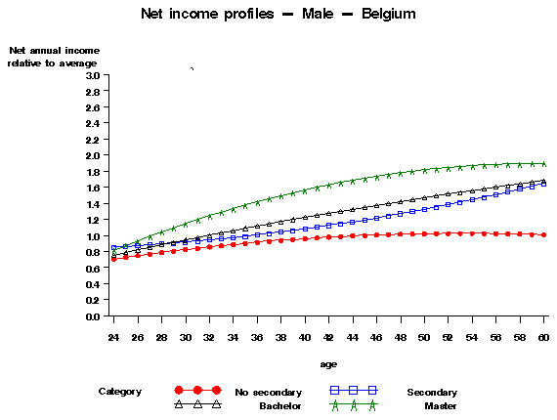 | 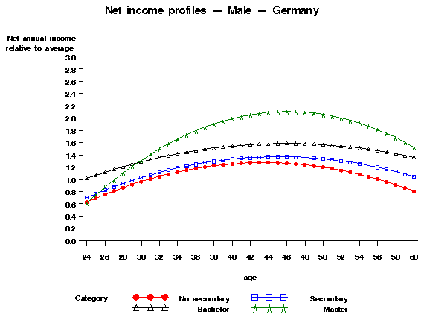
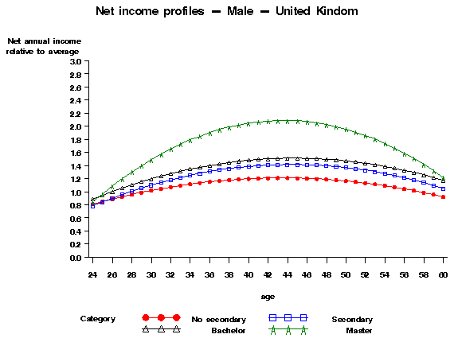

Graph 2 – Annual net income functions/profiles. Breakdown by degree. Females. All regions (1=total population, all ages, average income)
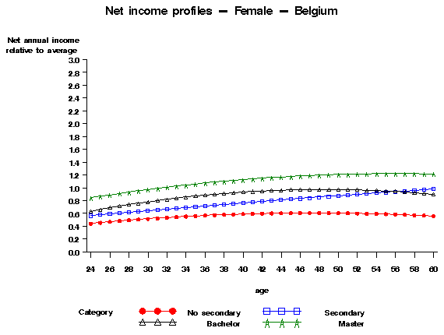 | 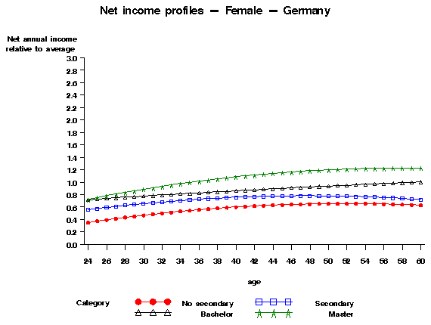

Table 3 – Present value of lifetime (24-65) net income estimated at the age of 24. in EUR. Breakdown by country, education level, gender and region

Country | Gender | Region | Highest degree obtained
Country | Gender | Region | Less than  secondary | Secondary | Hicher Education  (Bachelor) | Higher Education  (Master)
Belgium | Female | Wallonia & Brussels | 419,978 | 565,221 | 669,357 | 804,842
Belgium | Female | Flanders | 403,004 | 578,869 | 625,045 | 832,310
Belgium | Male | Wallonia & Brussels | 690,404 | 888,250 | 847,211 | 1,096,633
Belgium | Male | Flanders | 676,380 | 848,462 | 962,819 | 1,121,024
Germany | Female | East | 516,126 | 599,269 | 682,692 | 849,727
Germany | Female | West | 468,835 | 605,562 | 749,238 | 901,750
Germany | Male | East | 864,345 | 923,025 | 1,220,946 | 1,365,637
Germany | Male | West | 873,676 | 981,504 | 1,188,522 | 1,373,691
United Kingdom | Female | All except G. London | 454,893 | 544,194 | 663,286 | 968,123
United Kingdom | Female | Greater London | 449,160 | 566,464 | 743,815 | 1,048,364
United Kingdom | Male | All except G. London | 864,519 | 996,717 | 1,063,618 | 1,369,549
United Kingdom | Male | Greater London | 884,847 | 934,262 | 1,063,980 | 1,236,351
Assumptions: τ=0.02. r=0.04

Table 4 – Relative present value of lifetime (24-65) net income estimated at the age of 24. Breakdown by education level. gender and region (1= category with maximal lifetime net earnings)

Country | Gender | Region | Highest degree obtained
Country | Gender | Region | Less than  secondary | Secondary | Hicher Education  (Bachelor) | Higher Education  (Master)
Belgium | Female | Wallonia & Brussels | 0.37 | 0.50 | 0.60 | 0.72
Belgium | Female | Flanders | 0.36 | 0.52 | 0.56 | 0.74
Belgium | Male | Wallonia & Brussels | 0.62 | 0.79 | 0.76 | 0.98
Belgium | Male | Flanders | 0.60 | 0.76 | 0.86 | 1.00
Germany | Female | East | 0.38 | 0.44 | 0.50 | 0.62
Germany | Female | West | 0.34 | 0.44 | 0.55 | 0.66
Germany | Male | East | 0.63 | 0.67 | 0.89 | 0.99
Germany | Male | West | 0.64 | 0.71 | 0.87 | 1.00
United Kingdom | Female | All except G London | 0.33 | 0.40 | 0.48 | 0.71
United Kingdom | Female | Greater London | 0.33 | 0.41 | 0.54 | 0.77
United Kingdom | Male | All except G London | 0.63 | 0.73 | 0.78 | 1.00
United Kingdom | Male | Greater London | 0.65 | 0.68 | 0.78 | 0.90
Assumptions: τ=0.02. r=0.04

Graph 3 – Current average income tax (ie. taxes as % of gross income) according to level of gross income (ie. tax progressivity)
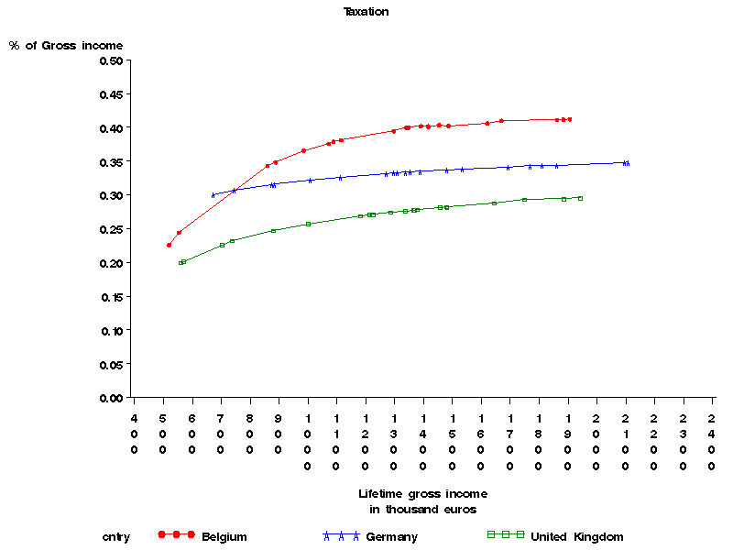

Graph 4 – Probability that higher education graduates pay their income-contingent instalment according to age
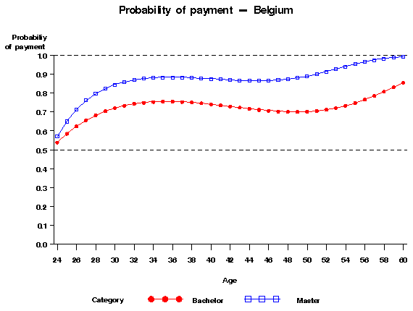 | 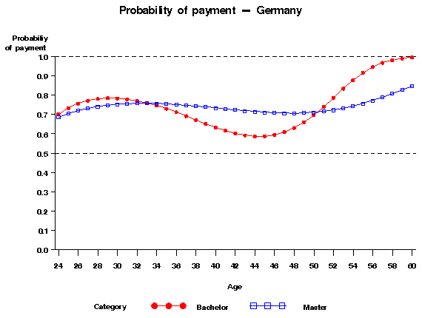
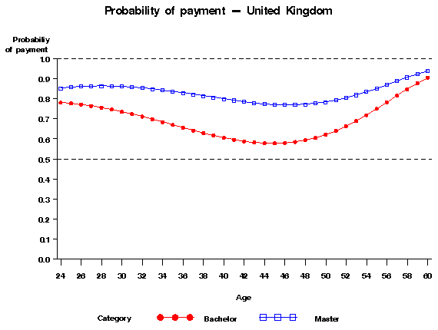

Table 5 – Sensitivity of the marginal (ie, per year of study) private rate of return (PRR) to different values of human capital investment (INV) – Reference = lifetime income of invidual (male or female) with upper-secondary degree
Cumulated  investment (INV) in EUR | Belgium | Germany | UK
0 € | 0.047 | 0.088 | 0.068
1,000 € | 0.046 | 0.088 | 0.068
2,000 € | 0.046 | 0.088 | 0.067
3,000 € | 0.045 | 0.087 | 0.067
4,000 € | 0.045 | 0.087 | 0.066
5,000 € | 0.045 | 0.087 | 0.066
6,000 € | 0.044 | 0.086 | 0.065
7,000 € | 0.044 | 0.086 | 0.065
8,000 € | 0.043 | 0.086 | 0.065
9,000 € | 0.043 | 0.085 | 0.064
10,000 € | 0.043 | 0.085 | 0.064
11,000 € | 0.042 | 0.085 | 0.063
12,000 € | 0.042 | 0.084 | 0.063
13,000 € | 0.041 | 0.084 | 0.062
14,000 € | 0.041 | 0.084 | 0.062
15,000 € | 0.041 | 0.083 | 0.062
16,000 € | 0.040 | 0.083 | 0.061
17,000 € | 0.040 | 0.083 | 0.061
18,000 € | 0.039 | 0.082 | 0.060
19,000 € | 0.039 | 0.082 | 0.060
20,000 € | 0.039 | 0.082 | 0.059

Graph 5 -- Present value of contribution (C_{k}) for a 5,000 EUR investment, according to the present value of income (Y_{k}) over the duration of the contrat (D=20). Breakdown by instrument of higher education finance
Graph 6 - Present value of contribution for a 5,000 EUR investment in percentage of net income (C_{k}/Y_{k}), according to the present value of income (Y_{k}) over the duration of the contrat (D=20). Breakdown by instrument of higher education finance.
Table 6 – Finance by Income-Contingent Loans (ICL). The cost of ensuring income-contingency

Country | Current value of a  1000 € tranche  investment*  INV (1+r)⁵ | Yearly instalment with risk of default  Ω | Yearly instalment  with no risk of default  Ωrf | Risk premium  Ω/Ωrf - 1 | Interest rate charged with no risk of default  a | Interest rate charged with risk of default  b | Interest rate risk premium  b-a
Belgium | 1,217 | 110.89 | 83.39 | 0.33 | 4.00% | 6.59% | 2.59%
Germany | 1,217 | 114.04 | 83.39 | 0.37 | 4.00% | 6.80% | 2.80%
UK | 1,217 | 110.39 | 83.39 | 0.32 | 4.00% | 6.55% | 2.55%
*Duration= 20 years

Table 7 – Human capital contracts (HCC): 5,000€ investment. Percentage of income over the duration of contract (24-44) committed depending on degree of pooling among graduates

Country | Category (k) |  | Percentage of net annual income  committed* (θ) | Cost of  pooling  a/b | Adjutment factor to avoid  adverse selection  λ= θ_{Master}/θ_{Bachelor}:
Belgium | All graduates pooled | a | 1.35%
Belgium | Graduate Master | b | 1.20% | 1.13 | 0.79
Belgium | Graduates Bachelor | c | 1.51%
Germany | All graduates pooled | a | 0.98%
Germany | Graduate Master | b | 0.97% | 1.02 | 0.90
Germany | Graduates Bachelor | c | 1.08%
UK | All graduates pooled | a | 1.04%
UK | Graduate Master | b | 0.87% | 1.19 | 0.74
UK | Graduates Bachelor | c | 1.17%
* Duration of contract (D)= 20 years

Table 8 – Human capital contracts (HCC): 5,000€ investment. Percentage of income over the duration of contract (24-44) committed depending on degree of pooling among male and female Master graduates

Country | Category (k) |  | Percentage of net annual income committed* (θ) | Cost of pooling  a/c | Adjustment factor to avoid  adverse selection  λ= θ_{Male}/θ_{Female}
Belgium | Male & female pooled | a | 1.20%
Belgium | Female only | b | 1.35% | 1.11 | 0.80
Belgium | Male only | c | 1.08%
Germany | Male & female pooled | a | 0.97%
Germany | Female only | b | 1.26% | 1.21 | 0.63
Germany | Male only | c | 0.80%
United Kingdom | Male & female pooled | a | 0.87%
United Kingdom | Female only | b | 1.05% | 1.15 | 0.72
United Kingdom | Male only | c | 0.76%
* Duration of contract (D)= 20 years

We would like to thank L. Jacquet , M. Spritsma, F. Waltenberg, P. Poutvaara, participants of the EALE/SOLE 05 conference, of the CEE seminar at LSE, H. Glennerster and anonymous referees for their helpful comments and suggestions on preliminary versions of this text. All remaining errors and omissions are ours. This research benefited from the ARC convention 02/07-274 (French-Speaking Community of Belgium) and the grant PAI P5/10 (Belgian Federal Government).
* Corresponding author. Economics Department, IRES, Université Catholique de Louvain, 3 place Montesquieu, B-1348 Belgium email : vandenberghe@ires.ucl.ac.be. Fax : + 32 10 47 39 45
* * European Investment Bank, Luxembourg. email: debandeo@eib.org
Terminology as regards to student loans is not yet totally stabilized. Some authors like Palacios (2004) would rather talk of loans with income-forgiveness.
Chapman (2004) explains that the mechanism implemented in Australia from 1989 onwards is essentially a ICL system with risk shifting in the sense that the government covers the cost of non-repayment.
We assume hereafter that INV corresponds to a cumulated amount covering all years of study.
Some authors like Jacobs (2002) model private finance mechanisms as substitutes to public finance. Although very sensitive when it comes to policy-making, this distinction does not fundamentally affect the results of the modelling exercise.
The preference for the present is captured by the return on risk-free and long-term bonds.
The empirical evidence on the elasticity of higher education demand to tuition fees is still debated. Jacobs (2002) reports that estimates for the Netherlands suggest that enrolment is hardly price-responsive. Empirical evidence is mixed in the US as well (Heckman & Carneiro, 2003).
Dale & Krueger (1999) report an elasticity of income to higher education spending of less than 0.1 that is not statistically significant, particularly when they allow for self-selection.
For a discussion about the prevalence of credit constraints among prospective higher education students, see Chapman (2005).
It seems that traditional estimates of the return of higher education investment have underestimated the level of income heterogeneity among graduates. In the US, there is growing evidence that changes in wage inequality are increasingly concentrated in the very top end of the wage distribution, and observed among highly-educated workers (Lemieux, 2006).
We will discuss this particular point in greater detail in section 6, when examining the problem of adverse selection.
Strictly speaking we, should assume than non-graduates start paying taxes before the age of 24. However this more realistic modelling option would not fundamentally change our results.
We refer here to cumulated investment over the whole period of study.
Interest rates throughout this paper should essentially be seen as a discount factor reflecting economic agents' preference for the present, and not as a parameter of ICL or HCC.
This particular threshold has an economic justification that can be traced back to the seminal work of Friedman (1955): private contributions should only be levied on the fraction of total income that can be ascribed to college or university attendance.
The notion of type and how it is built is developed in section 3.
Consortium of Household Panels for European Socio-Economic Research, Luxembourg that get it data for Germany and the UK from the German Socio-Economic panel (GSOEP) and the British Household Panel Survey (BHPS).
PSBH and CHER always define earnings and income as ‘last year income’
See appendix for a presentation of how they are estimated.
The first two categories of education form what we call the non-graduates, while the two other the graduates.
Flanders for Belgium, Landers of the former western republic for Germany, and Greater London for the UK.
Unfortunately, our data do not provide the actual labour market experience.
The shift from income/experience to income/age function is immediate. We simply use the relation between age and potential labour experience (i.e., a ≡ theoretical graduation age + e)
This is done by pooling all observations available.
In the case of Belgium or Germany, but also the Netherlands (Jacobs, 2002), this might be a lower bound. Long-term statistics of hourly wage growth suggest actual rates can reach 3%.
Experience-specific.
Again, the shift from income/experience to income/age function is immediate i.e., a ≡ theoretical graduation age + e.
The current situation.
Referring to what is done in the empirical literature on the EU (e.g., de la Fuente, 2003) this is a fairly conservative assumption.
And consequently by higher taxes.
Remember that these simulations ignore the possible positive effect of spending on subsequent income.
5,000 EUR represent 10 (Germany) to 13% (Belgium, the UK) of the 2002 cumulative expenditure per student over the average duration of tertiary studies (0ECD, 2004)
Equivalent to conventional loans from a distributional point of view.
We will discuss this point further in the next section.
Full insurance protection should compensate graduates for the loss of earnings itself, by providing replacement income.
The logical consequence of payments indexed on ability to pay highlighted in section 5.
ICL as specified here, requires from graduates to make payments only when their annual income is above the average income of someone who did not attend higher education. M. Friedman's seminal work (Friedman,1955) suggests indeed that private contribution should be indexed on the fraction of income that can be imputed to higher education.
Mainly university programs
Eurostat for the EU member states.

