**Malaria Eradication in Colonial Taiwan: The Long-term Effect**

**on Human Capital Formation**

Shiyung Liu

Academia Sinica

[liumike@gate.sinica.edu.tw](mailto:liumike@gate.sinica.edu.tw)

******VERY PRELIMINARY. DO NOT CITE******

**Introduction**

This paper estimates the effect of *in-utero* and *neonatal* health shocks through exposure to malaria on educational achievement. Since these stages of life are critical for the development of human organs, the immune system, physiological functions, and cognitive ability, early health shocks can cause more serious consequences than in those that occur in later stages of life. These long-term effects include health outcomes and educational achievement (Holding and Snow 2001 Barker 1992; Bleakley 2010; Lucas 2010; Cutler et al. 2010),). Our methodology exploits what we view to be a natural experiment that impacted children born between 1901 and 1941 in colonial Taiwan. During the colonial period 1895-1945, malaria was endemic in Taiwan and was once the top-ranking cause of death. Anti-malaria policy was initiated by the Japanese in the 1910s and ended with the eruption of World War II (Ku 2009; Liu 2009). Over the intervening years there were exogenous changes in antimalaria policy imposed by the Japanese occupiers that led to both spatial and intertemporal variations in exposure to malaria and to consequent variation in malaria death rates. We argue that these anti-malaria policy changes were uncorrelated with policies directly targeting education, and thus variation in the policies provide a valid instrument for estimating the impact of malaria exposure risk on education.

**Historical Background of Colonial Taiwan**

3.1. *Geography and Climates of Taiwan*

Lying off the southeastern coast of China, Taiwan is an elongated, mountainous island, stretching about 240 miles from north to south, and 90 miles from east to west at its widest point. The east and west parts are separated by the *Central Mountain Range* that runs roughly from north to south. Two thirds of the island is mountains, while most of the arable lands are located on the west plain. Its territory also includes several small island groups, e.g. the Pescadores, Quemoy, around the main island. With the Tropic of Cancer passing through its belly, Taiwan’s climates characterize with subtropical to tropical temperatures with excessive humidity. Typhoons and earthquakes are commonly experienced every year.

3.2. *Malaria and Anti-malaria Policy in Colonial Taiwan*

When the Japanese occupied Taiwan in 1895, far more Japanese succumbed to illness than in battles (Ting 2007).[1] The colonizers soon realized that their major enemy was not the indigenous Taiwanese but the unfavorable environment full of infectious diseases, of which the deadliest was malaria.[2] Malaria remained the top-ranking cause of death in Taiwan in the early stage of the Japanese ruling period. For example, during 1906-1909 an average of more than 10,000 residents in a population of only 3 million, including both the native Taiwanese and the Japanese settlers, died of malaria each year.

In the 1900s, several anti-malaria pilot programs were launched in a few scattered places, mostly where the Japanese lived. In 1911, the *Governor-General*—head of the colonial government in Taiwan—convened a meeting on anti-malaria policy and decided to enact a series of anti-malaria laws in 1913. According to the laws, anti-malaria districts were gradually created throughout the island.[3] Meanwhile, local police and a local self-policing system, called the *Hoko*, were called upon to carry out a *human-targeted* measure *within* the anti-malaria districts.[4] Residents and visitors in the districts were rounded up to take blood tests and, if found to carry plasmodium, were forced to take *quinine*—the most effective medicine to cure malaria at the time but which had to be imported—for 18 days under the supervision of a policeman.[5] One of the drawbacks of this approach is that it only applied to human beings in the anti-malaria districts and ignored the malaria vector—mosquitoes—at large.[6] Hence, it was not effective in cutting off the transmission of malaria via mosquitoes that fed off infected humans.

Soon after the “human approach” was implemented, to the surprise of many at the time, malaria death rates soared to an almost uncontrollable extent in the mid-1910s and many blamed it on the ineffectiveness of the “human approach.” As a result, the colonial government was urged to shift its anti-malaria policy to target at mosquitoes by cleaning up the environment.[7] In response, the colonial government promulgated in 1919 a series of anti-mosquito laws aiming to *eradicate* malaria. In general, the anti-mosquito laws required residents within *and outside* anti-malaria districts to remove weeds in the ditches, drain ponds, cover up puddles and swamps with earth etc. Local police and the local self-policing system were again assigned the duty of mobilizing the populace to destroy mosquitoes. To further encourage elimination of mosquitoes, a region judged to have done exemplary work was awarded with a medal and designated as an anti-malaria model area. Blood tests and quinine treatments continued to be carried out in this stage.

The combination of both the “mosquito approach” and the “human approach” in the 1920s and 1930s proved to be more effective in suppressing malaria; figure 1 shows that malaria death rates fell significantly across the four regions.[8] Moreover, regional gaps in the malaria death rates across regions virtually disappeared in the 1930s. However, the outbreak of World War II forced the anti-malaria work to stop and malaria was not completely eradicated in Taiwan until the early 1960s (Department of Health, Taiwan 1991).

3.3. *Education in Colonial Taiwan*

Education was considered by the Japanese as an instrument to assimilate the Taiwanese, and an extensive primary education system was gradually established throughout the entire colonial period. [9] At the same time, and perhaps ironically, the Japanese also implemented a segregation policy in education, which separated the Japanese children from their Taiwanese counterparts.[10] Elementary school for Taiwanese children was called *common school*. Common schools offered modern courses such as arithmetic, basic sciences, Japanese, etc.

Throughout the entire colonial period, common schools increased only gradually (Zimmer, Liu, Hermalin and Chuang 1998). Figure 2 shows the slow increase in common schools in four regions of Taiwan. Note that the trends remained almost flat in the 1920s and 1930s. Figure 3 shows the enrollment in common schools. Corresponding to the increase in common schools, there was also an increase in enrollment around 1920. But, then the enrollment remained constant before it turned to grow exponentially in the 1930s. The exponential growth in the 1930s does not seem to be explained by the number of common schools.

Post-primary education was very limited for the Taiwanese. (Tsurumi, 1979; Lo, 2002) A few vocational schools, including normal schools, were founded after 1919, and one university was finally established in 1928 mainly, to accommodate the Japanese youth on the island. Only one medical school existed throughout the entire colonial period. The few Taiwanese who obtained secondary or higher education generally received training in medicine or teaching

3.4. *Agricultural Production in Colonial Taiwan*

Agriculture was the most important industry in colonial Taiwan (Wu 1991). Among the most important agricultural products were rice, sugar cane and tea. While rice was grown almost everywhere on the island, sugar cane was mostly grown in the south and tea mostly in the north. Figure 4 shows the per capita output of these three products combined and evaluated in 1929 prices in the four regions of Taiwan. As shown, the agrarian economy grew steadily throughout the whole colonial period.

**Data**

We use two samples from a longitudinal survey of the elderly in Taiwan called *Survey of Health and Living Status of the Middle-aged and the Elderly in Taiwan*. The first sample was drawn in 1989 and consists of people born between 1893 and 1929 (sample A hereafter). The second one was drawn in 1996 and consists of people born between 1930 and 1946 (sample B hereafter). We use data only for those individuals who were born between 1901 and 1941, which is the period for which we have malaria death information for this period. There are no Japanese in the sample, and we exclude observations for individuals who migrated from mainland China and other countries (mainly after 1949). [11] Our final samples consist of 3,022 individuals in sample A and 1,553 individuals in sample B.

The elderly survey offers rich information in demographics, education, residence, employment history, health care utilization, and various health outcomes, e.g. self-reported general health, chronic conditions, death date and cause, etc. For sample A, we know the exact township code of birthplace, but for sample B we know only where the household was registered in the 1990s.[12] Our best choice is to use this household registration information to link individuals in sample B to the malaria death rates in the colonial period. As mentioned previously, a matching of the current household registration and birthplace of individuals in sample A shows that in the 1980s 85% of still lived in the prefecture (by the 1920 division) where they were born. This suggests that the migration problem should be of less concern for sample B, because it is a more recent sample, with less exposure to the “risk” of migration.

4.2. *Descriptive Statistics*

Table 1 summarizes the characteristics of the samples by four cohorts. The cohorts are divided in accordance with the change in anti-malaria policy, i.e. 1920, and changes in administrative divisions, i.e. 1909 and 1920. We use two measures of malaria death rate. One is the malaria deaths per 1,000 people at birthplace in the year of birth. The other is the average malaria deaths per 1,000 people at birthplace in the birth year and the year before. The inclusion of the year before birth is meant to fully capture the in-utero risk for births that occurred early in the year. As shown, malaria deaths drop from more than 3 deaths per 1,000 people in 1901-1908 to less than 1 death in 1930-1941. The drop is most significant in the 1920s and 1930s.

In terms of sex and ethnicity, the older cohorts in sample A tend to have more women, reflecting the biological fact that women live longer than men. In both samples, about 78% are *Minnan* (southern Chinese) people, 20% *Hakka* people and 2% other ethnic groups.

In terms of own education, younger cohorts have more years of schooling than older cohorts. However, while the increase is large at the primary education level, the increase in post-primary education is small. This observation is consistent with the education policy in the colonial period that only limited post-primary education was offered to the Taiwanese.

Comparing across generations, there is a positive correlation between fathers’ and children’s education, although fathers generally had less schooling than children. It is interesting to note that a significant proportion of fathers received “zero” years of schooling but were literate. This is likely because fathers went to the traditional Chinese schools where they learnt to read and write Chinese and studied Chinese classics.[13] Yet, traditional Chinese schools are not considered as formal education in the elderly survey. On the other hand, one can also find that as the agricultural income increased over time, more and more fathers were farmer.

The geographical distribution of birthplaces is similar among the three cohorts in sample A. Yet, recall that we do not know the exact birthplace for sample B. The listed geographic distribution for sample B is actually their registered household locality in the 1990s. A noticeable distinction in the distribution of household registration locality in sample B is that it has slightly higher proportions of people clustered in *Taipei* and *Kaohsiung*, which are home to the two big metropolitan areas in northern and southern Taiwan respectively. This tendency is also observed in sample A if we look at their household registration locality. Yet, again, the majority of them still resided in the same prefecture where they were born.

**7. Conclusions**

In this paper, we will estimate the effect of in-utero and neonatal risk of exposure to malaria on education for a cohort born in the colonial period in Taiwan. In particular, we use malaria death rate as a measure of the exposure risk, while we recognize that it may underestimate the true exposure risk because not all malaria patients end up with death. Our statistical results suggest that if malaria deaths were to decrease by one death per 1,000 people in the colonial period, it would on average increase the probability of receiving any schooling by 2 percentage points and the years of schooling by .14 years.

**References**

Barker, D. (1992). “The fetal origins of diseases of old age.” *European Journal of Clinical Nutrition*, 46 (s): 3-9.

Bleakley, H. (2010). “Malaria eradication in the Americas: a retrospective analysis of childhood exposure.” *American Economic Journal: Applied Economics*, 2: 1-45.

Cutler, D., W. Fung, M. Kremer, M. Singhal and T. Vogl. (2010). “Early-life malaria exposure and adult outcomes: evidence from malaria eradication in India.” *American Economic Journal: Applied Economics*, 2: 72-94.

Department of Health, the Executive Yuan, Republic of China. (1991). *Malaria eradication in Taiwan*. Taipei, Taiwan.

Holding, P., and R. Snow (2001). “Impact of plasmodium falciparum malaria on performance and learning: review of the evidence.” *American Journal of Tropical Medicine and Hygiene*, 64: 68-75.

Ku, Y. (2009). “Anti-malaria policy and its consequences in colonial Taiwan.” In *Disease, Colonialism, and the State*, edited by K. Yip. Hong Kong: Hong Kong University Press.

Liu, S. (2009). “The theory and practice of malariology in colonial Taiwan.” In *Disease, Colonialism, and the State*, edited by K. Yip. Hong Kong: Hong Kong University Press.

Lo, M. (2002). *Doctors within borders*. London: University of California Press.

Lucas, A. (2010). “Malaria eradication and educational attainment: evidence from Paraguay and Sri Lanca.” *American Economic Journal: Applied Economics*, 2: 46-71.

Ting, K. (2007). “The public hygiene of the area of Yunlin County during the Japanese ruling period of Taiwan.” *Journal of Living Sciences*, 11: 195-243. (in Chinese)

Tsurumi, E. (1979). “Education and assimilation in Taiwan under the Japanese rule, 1895-1945.” *Modern Asian Studies*, 13 (4): 617-641.

Wu, T. (2001). “An estimation of Taiwan’s gross domestic product: 1910-1950.” *Taiwan Economic Review*, 19(2): 127-175. (in Chinese)

Yearly Statistics Books of the Office of the Governor-General from 1895 to1945. <http://tcsd.lib.ntu.edu.tw/main_browse.php>.

Zimmer, Z., X. Liu, A. Hermalin, and Y. Chuang. (1998). “Educational attainment and transitions in functional status among older Taiwanese.” *Demography*, 35(3): 361-375.

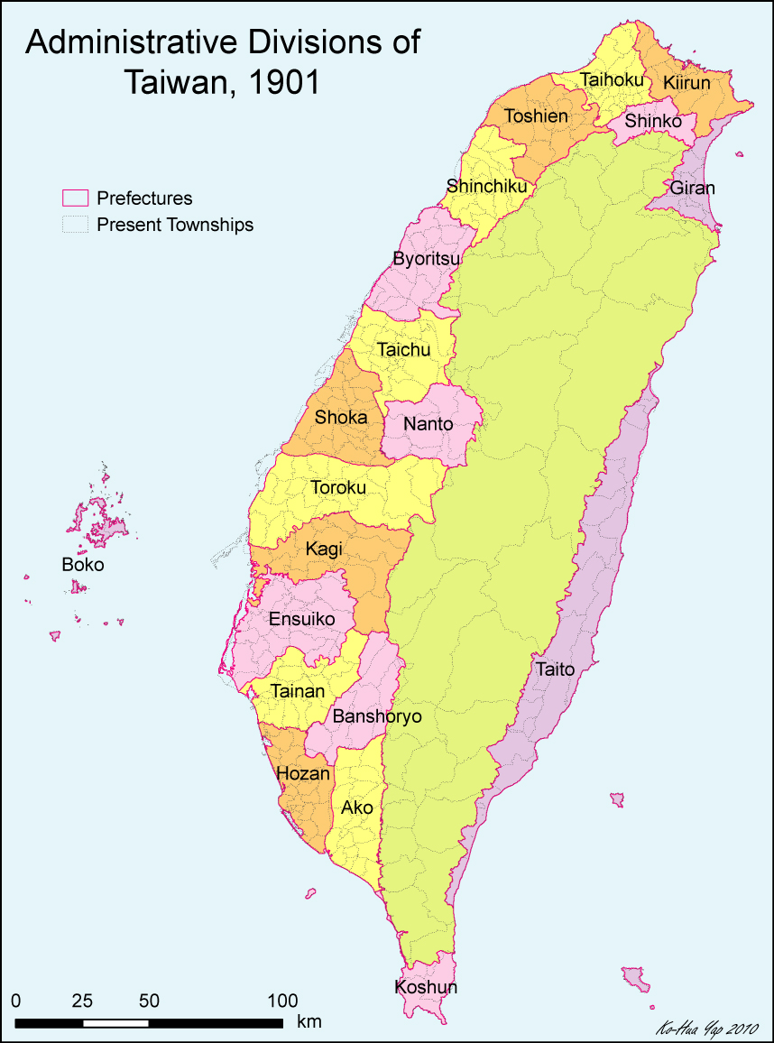

Map 1. Administrative Divisions of Taiwan: 1901-1908

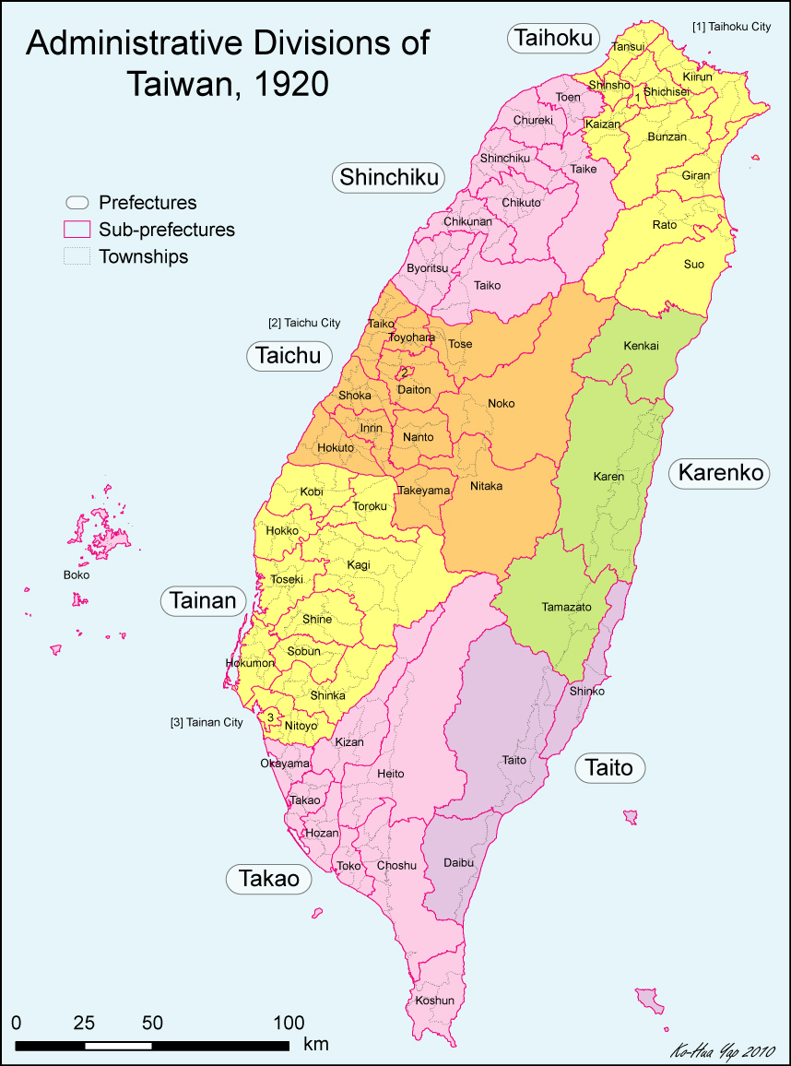

Map 2. Administrative Divisions of Taiwan: 1920-1945

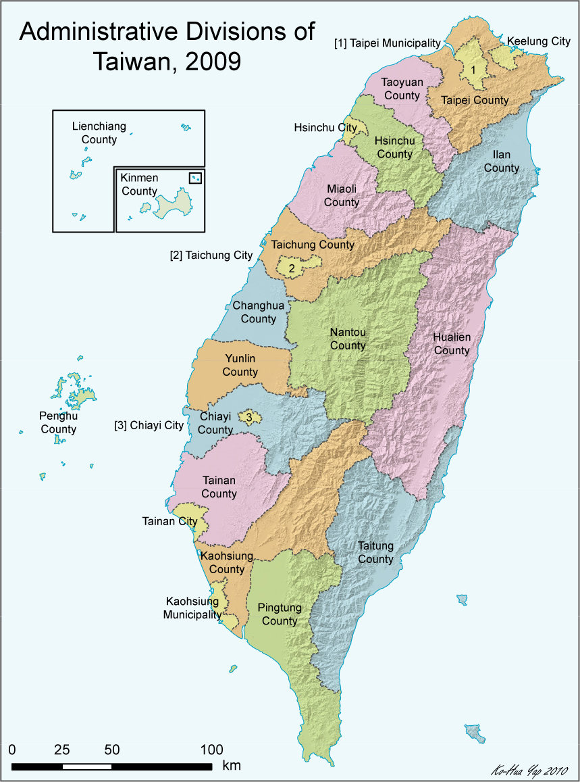

Map 3. Administrative Divisions of Taiwan: Present

**Figure 1. Malaria deaths per 1,000 people**



Source: *Yearly Statistics Books of the Office of the Governor-General*

**Figure 2. Number of common schools**



Source: *Yearly Statistics Books of the Office of the Governor-General*

**Figure 3. Enrollment in common schools (1,000 pupils)**



Source: *Yearly Statistics Books of the Office of the Governor-General*

**Figure 4. Production of Rice, Sugar Cane and Tea Per Capita (in 1929 value)**



Source: *Yearly Statistics Books of the Office of the Governor-General*

**Figure 5. Hospitals and clinics per 10,000 people**



Source: *Yearly Statistics Books of the Office of the Governor-General*

**Figure 6. Private and public hospitals and clinics**



Source: *Yearly Statistics Books of the Office of the Governor-General*

**Figure 7. Share of local prefecture government’s health expenditure on preventing infectious diseases**



Source: *Yearly Statistics Books of the Office of the Governor-General*

1. In 1895, for example, only 164 Japanese soldiers died in battle, while 4,642 died of illness (Ting 2007).
2. For example, in 1902 when the population was about 3 million, the number of malaria deaths was 13,444, while the next three biggest infection deaths were plague (1,853), dysentery (754) and cholera (613) (Yearly Statistics Book of the Office of the Governor-General, 1902). It is interesting to note that the Japanese first devoted their efforts in fighting plague and cholera, instead of malaria, during the first decade of their ruling in Taiwan.
3. In fact, some anti-malaria districts already existed prior to 1913 and most of them were located in urban areas and natural resources development sites where the Japanese lived. During the entire colonial period, anti-malaria districts increased from 12 in 1911, to 70 in 1921, 155 in 1931 and 180 in 1941.
4. Since the policy only targeted at human beings, Ku (2009) thus calls this the “human approach.”
5. On average, it takes about 14 days for plasmodium to reproduce within the human body. Hence, plasmodium would be killed completely if the human host takes enough quinine during the incubation period.
6. Ku (2009) points out that since the “human approach” was only applied to anti-malaria districts, the proportion of population that took blood tests never exceeded 10% during the entire colonial period. As another example, in his report written in 1923, Shimomura Hachigoro, a Japanese hygiene technician, criticized that the anti-malaria policy in Tainan, a prefecture in the South, only targeted at 60,000 people living in the anti-malaria districts and excluded the other 900,000 residents outside the districts.
7. Ku (2009) dubs this the “mosquito approach.”
8. For convenience, I divide Taiwan into four regions based on the administrative divisions in 1920 (Map 3). In particular, the *North* region includes *Taihoku* and *Shinchiku*; the *Middle* region includes *Taichu*; the *South* region includes *Tainan* and *Takao*; the *East* includes *Karenko* and *Taito*.
9. The colonial government implemented a segregation policy in education until the very end of its ruling. Children of different ethnicity went to different schools. Schools for the Japanese generally were of better quality and more resources, while those for the Taiwanese and the aborigines were inferior (Tsurumi 1977).
10. The segregation policy was not abolished until 1941.
11. These people account for about 24% an 8% of sample A and B respectively.
12. The household registration system in Taiwan is originated in the colonial period and has been continued till present. A household registration record typically includes information regarding residence address, name, birth dates, and parents’ names for all members in the household. Proper registration is required for obtaining national ID card and passport.
13. Traditional Chinese schools were very different from the modern concept of schools in both its curriculum and years of schooling. In the colonial period, traditional Chinese schools were quickly replaced with common schools.